QUERY   
Thursday, May 30, 2024 8:38 AM

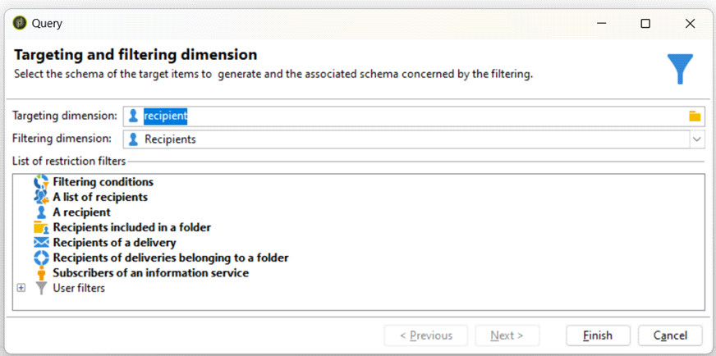

Setting the Condition for Query

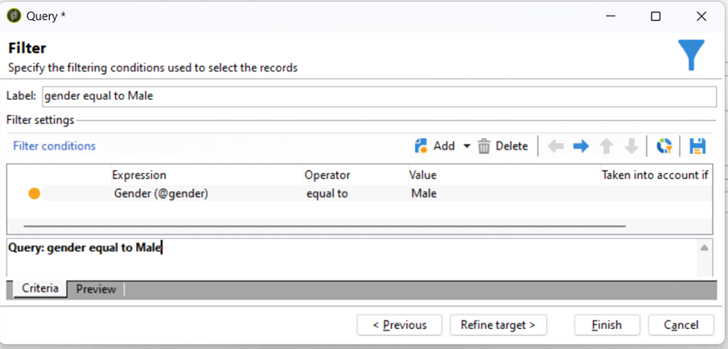

Targeting Page 1

Previewing the Data

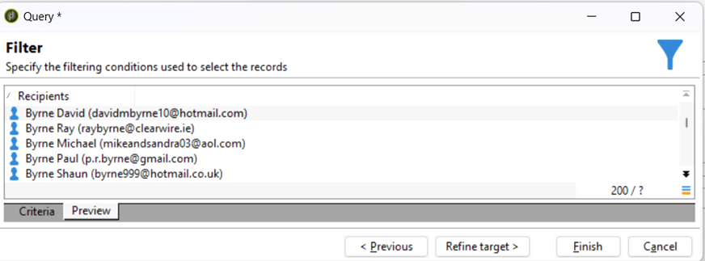

**Pre-defined** Custom User Filters can be Created

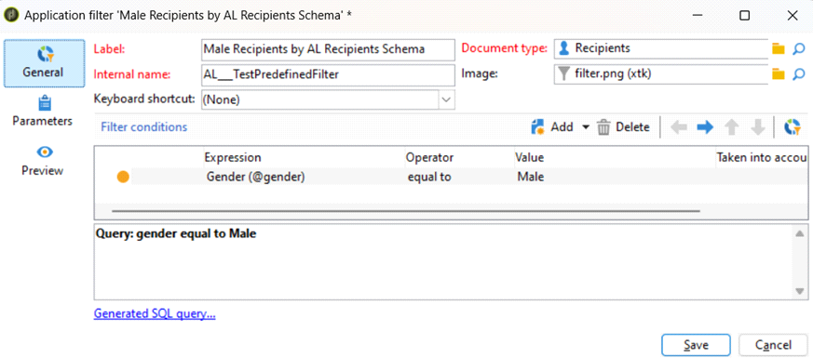

Targeting Page 2

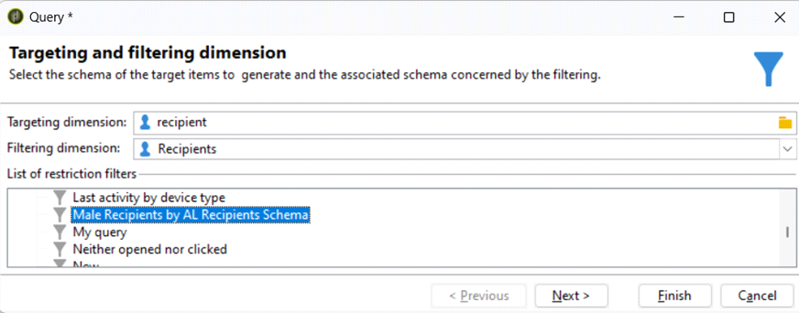

**Query Add Data**

Add Data in the Query

|  |  |
| --- | --- |
| Data of the Filtering Dimensions | Data Linked to the Filtering Dimensions |
|  |  |

**Temporary Schema**

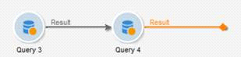

Targeting Page 3

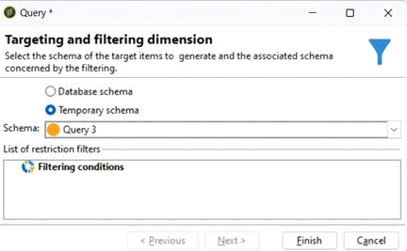

From <[https://capgemini-my.sharepoint.com/personal/amit-](https://capgemini-my.sharepoint.com/personal/amit-umedali_lakhani_capgemini_com/Documents/Documents/ACC%20Certification%20Preparation/2.%20Customization.docx)

[umedali_lakhani_capgemini_com/Documents/Documents/ACC%20Certification%20Preparation/2.%](https://capgemini-my.sharepoint.com/personal/amit-umedali_lakhani_capgemini_com/Documents/Documents/ACC%20Certification%20Preparation/2.%20Customization.docx)

[20Customization.docx](https://capgemini-my.sharepoint.com/personal/amit-umedali_lakhani_capgemini_com/Documents/Documents/ACC%20Certification%20Preparation/2.%20Customization.docx)>

Targeting Page 4

READ LIST   
Thursday, May 30, 2024 8:37 AM

List can be associated with different schema, and then they can be filtered using Edit Query

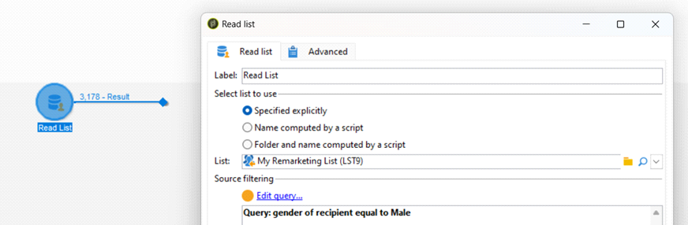

From <[https://capgemini-my.sharepoint.com/personal/amit-](https://capgemini-my.sharepoint.com/personal/amit-umedali_lakhani_capgemini_com/Documents/Documents/ACC%20Certification%20Preparation/2.%20Customization.docx)  
[umedali_lakhani_capgemini_com/Documents/Documents/ACC%20Certification%20Preparation/2.% 20Customization.docx](https://capgemini-my.sharepoint.com/personal/amit-umedali_lakhani_capgemini_com/Documents/Documents/ACC%20Certification%20Preparation/2.%20Customization.docx)>

Targeting Page 5

UNION / INTERSECTION   
Thursday, May 30, 2024 8:35 AM

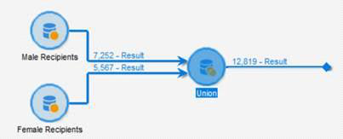

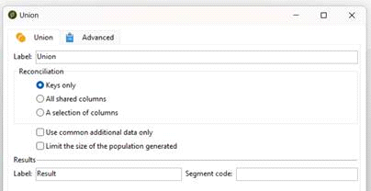

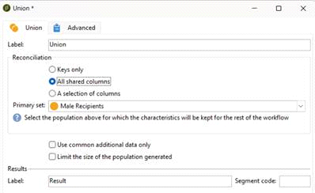

Targeting Page 6

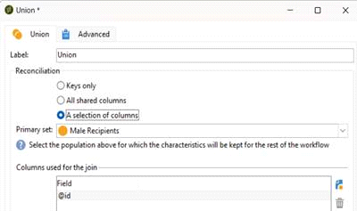

From <[https://capgemini-my.sharepoint.com/personal/amit-](https://capgemini-my.sharepoint.com/personal/amit-umedali_lakhani_capgemini_com/Documents/Documents/ACC%20Certification%20Preparation/2.%20Customization.docx)  
[umedali_lakhani_capgemini_com/Documents/Documents/ACC%20Certification%20Preparation/2.% 20Customization.docx](https://capgemini-my.sharepoint.com/personal/amit-umedali_lakhani_capgemini_com/Documents/Documents/ACC%20Certification%20Preparation/2.%20Customization.docx)>

Targeting Page 7

EXCLUSION

Thursday, May 30, 2024 8:35 AM

Count: 1703

Removing all those recipients from the List which are present in the Query

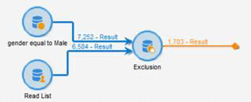

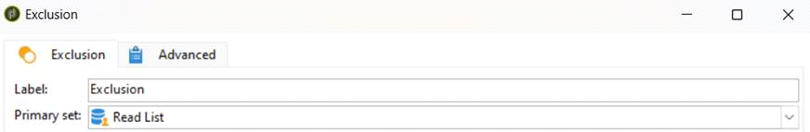

Count: 5663

Removing all those recipients from the Query which are present in the List

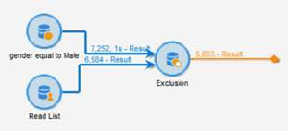

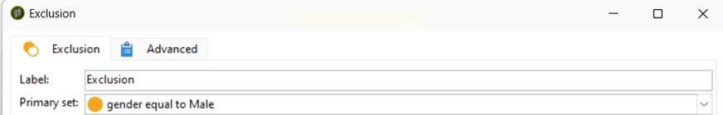

From <[https://capgemini-my.sharepoint.com/personal/amit-](https://capgemini-my.sharepoint.com/personal/amit-umedali_lakhani_capgemini_com/Documents/Documents/ACC%20Certification%20Preparation/2.%20Customization.docx)

[umedali_lakhani_capgemini_com/Documents/Documents/ACC%20Certification%20Preparation/2.%](https://capgemini-my.sharepoint.com/personal/amit-umedali_lakhani_capgemini_com/Documents/Documents/ACC%20Certification%20Preparation/2.%20Customization.docx)

[20Customization.docx](https://capgemini-my.sharepoint.com/personal/amit-umedali_lakhani_capgemini_com/Documents/Documents/ACC%20Certification%20Preparation/2.%20Customization.docx)>

Targeting Page 8

SPLIT

Thursday, May 30, 2024 8:22 AM

Split the Population according to the Condition into multiple outbound transitions. Each Outbound Transitions may or may not have overlapping population according to the Transitions

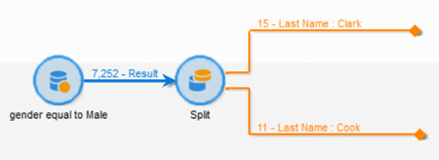

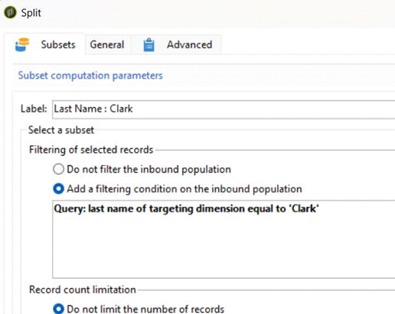

Targeting Page 9

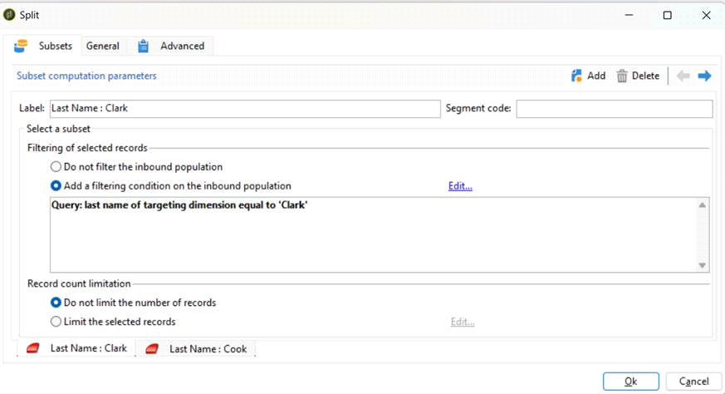

Targeting Page 10

ENRICHMENT   
Thursday, May 30, 2024 8:23 AM

Query + Enrichment

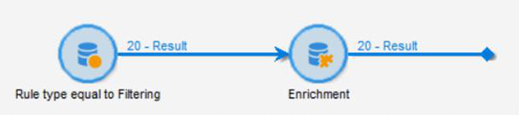

Added a Conditions

1. Rule Type = Filtering

2. Added Complimentary Information

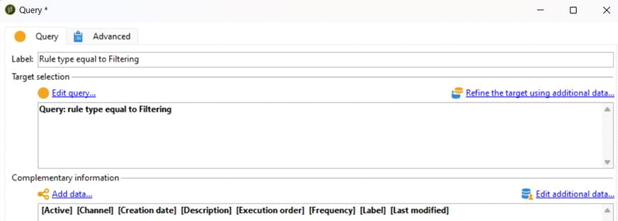

**Output Preview will only provide Abstract Data**

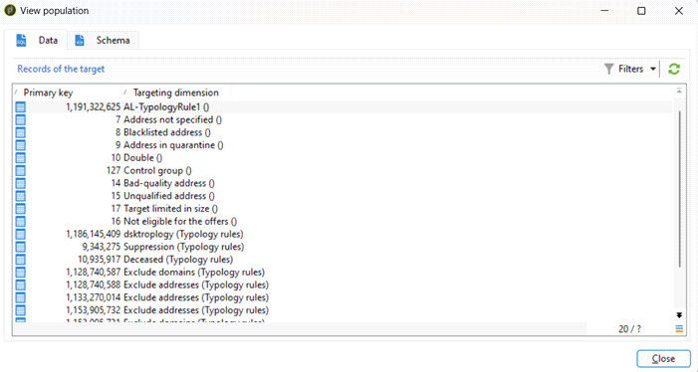

Targeting Page 11

**Output Preview will provide Expanded Data**

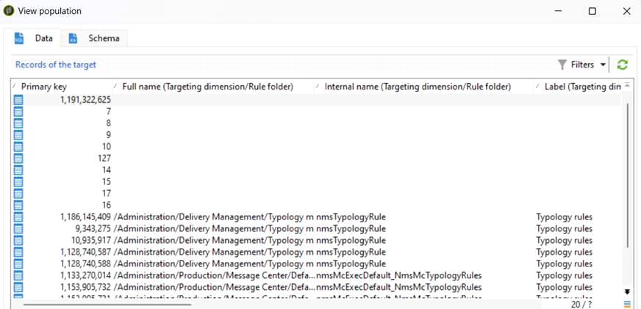

**Added More Complimentary Information in Enrichment Activity**

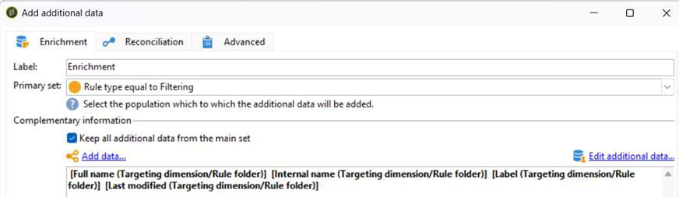

More Columns Added (Seen in Display the Target

Also Temporary Schema is Obtained.

Targeting Page 12

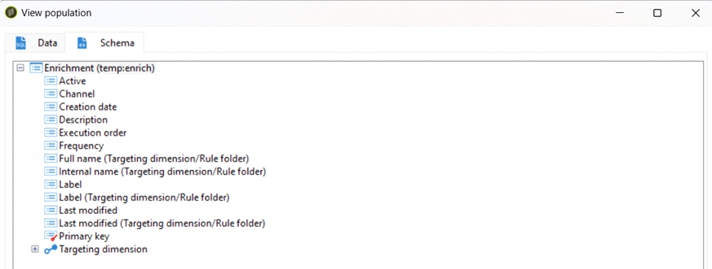

Targeting Page 13

INCREMENTAL QUERY   
Thursday, May 30, 2024 8:26 AM

Similar to Query

Everytime it runs, according to **scheduler**, Incremental Data will be fetched into the system (i.e. New Data)

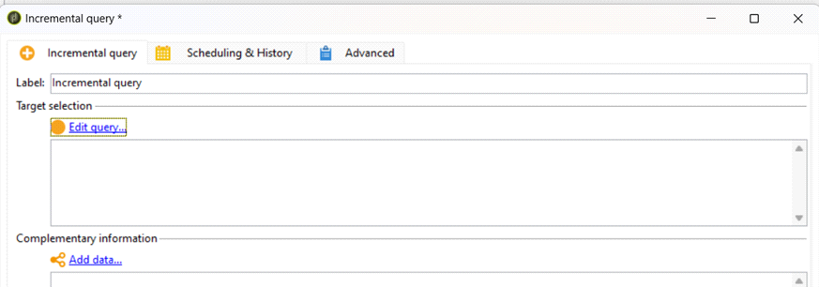

Targeting Page 14

DEDUPLICATION   
Thursday, May 30, 2024 12:19 PM

Targeting Page 15

LIST   
Thursday, May 30, 2024 8:42 AM

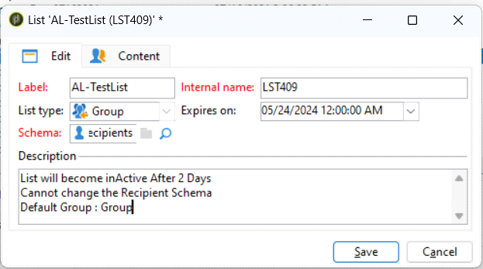

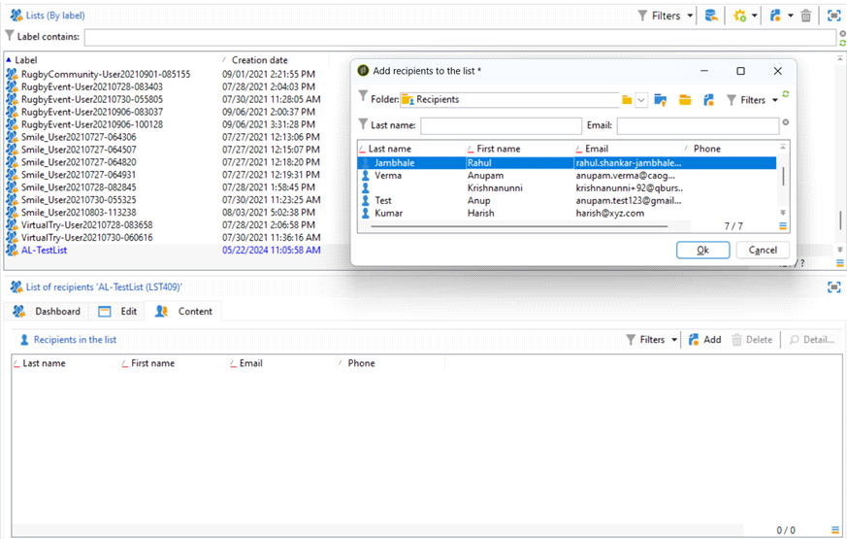

Targeting Page 16

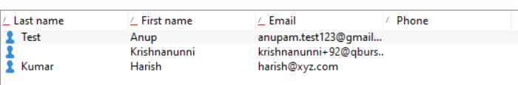

CREATING A LIST THROUGH WORKFLOW

(List is not working due to some unknown reason – Population Not Found)

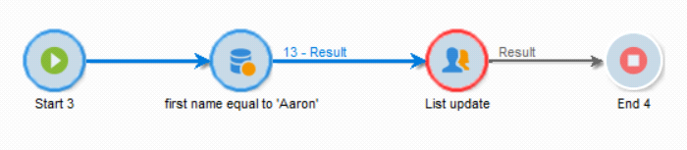

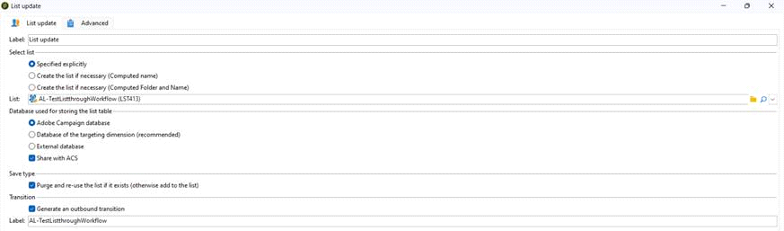

ADD RECIPIENT TO THE LIST DIRECTLY

Targeting Page 17

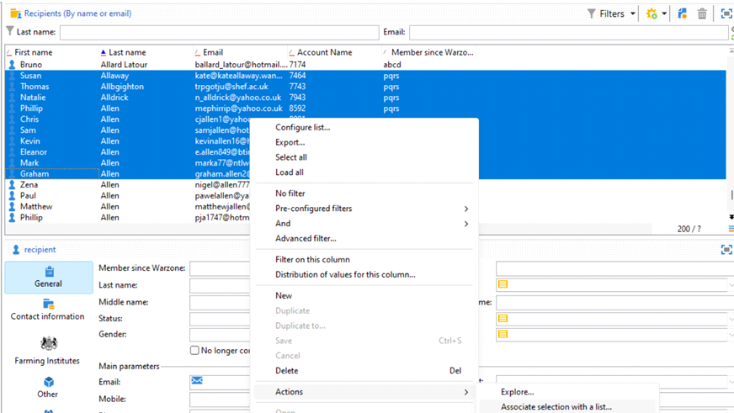

From <[https://capgemini-my.sharepoint.com/personal/amit-](https://capgemini-my.sharepoint.com/personal/amit-umedali_lakhani_capgemini_com/Documents/Documents/ACC%20Certification%20Preparation/2.%20Customization.docx)

[umedali_lakhani_capgemini_com/Documents/Documents/ACC%20Certification%20Preparation/2.%](https://capgemini-my.sharepoint.com/personal/amit-umedali_lakhani_capgemini_com/Documents/Documents/ACC%20Certification%20Preparation/2.%20Customization.docx)

[20Customization.docx](https://capgemini-my.sharepoint.com/personal/amit-umedali_lakhani_capgemini_com/Documents/Documents/ACC%20Certification%20Preparation/2.%20Customization.docx)>

Targeting Page 18

START / END   
Thursday, May 30, 2024 12:20 PM

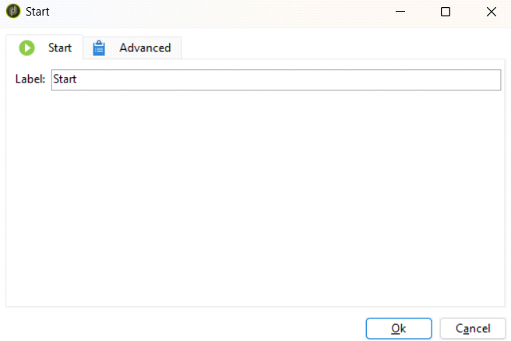

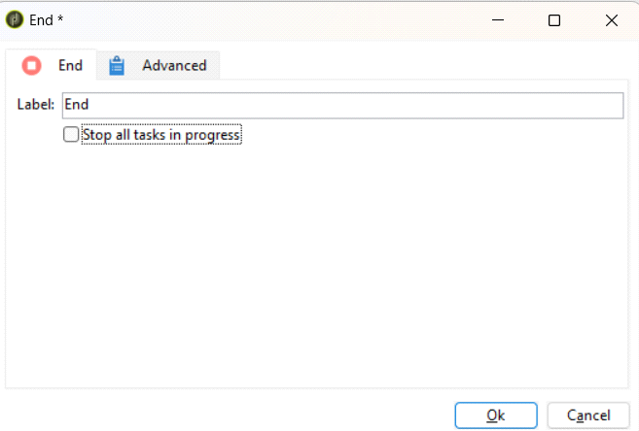

Flow Control Page 19

FORK   
Thursday, May 30, 2024 12:20 PM

Population from Inbound transition will travel through all Outbound Transitions

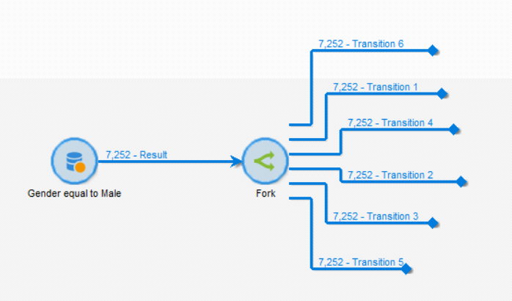

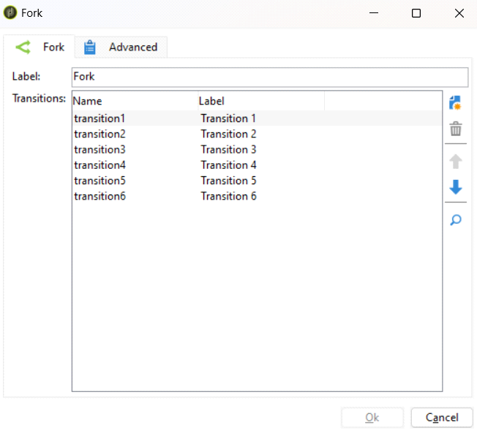

Flow Control Page 20

AND-JOIN   
Thursday, May 30, 2024 12:20 PM

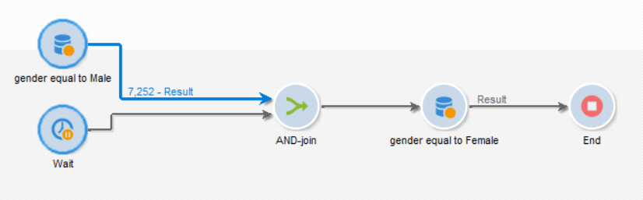

And-Join will not start until all Inbound Transitions are Completed

**After 20 Seconds of Wait,**

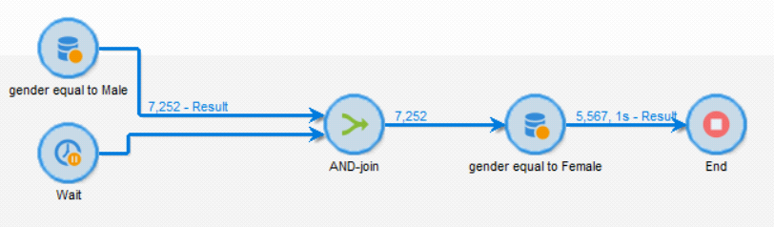

Not Sure the use of Primary Set

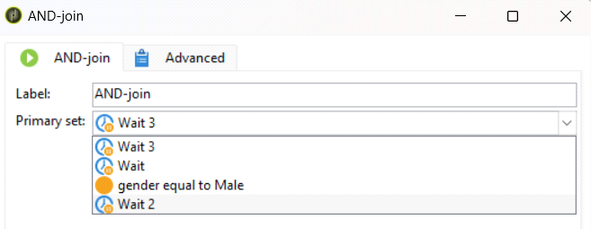

Flow Control Page 21

SCHEDULER   
Thursday, May 30, 2024 12:20 PM

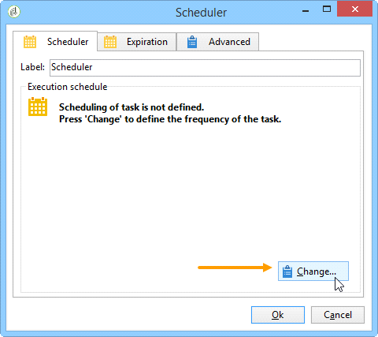

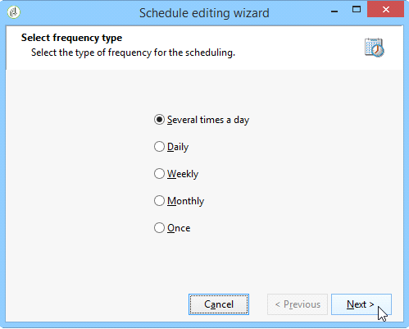

Flow Control Page 22

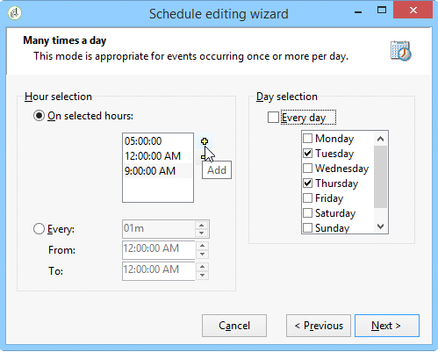

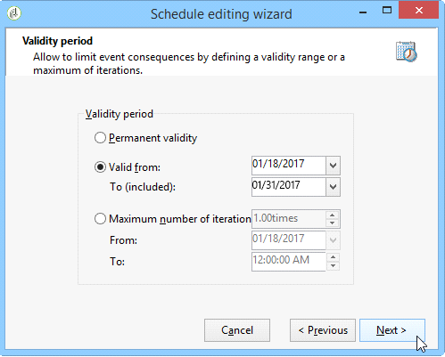

Flow Control Page 23

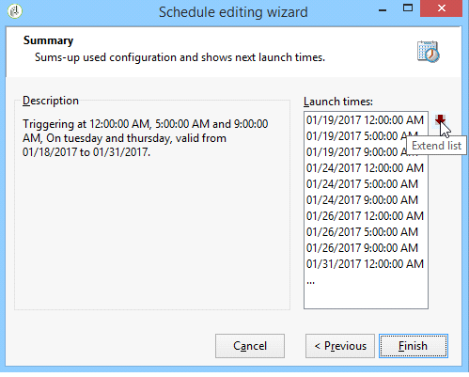

Flow Control Page 24

TEST

Thursday, May 30, 2024 8:41 AM

Declare Variable In Previous Activity and Use Them in Test Activity

Instance Vatiable   
instance.vars.m = 5;   
logInfo(instance.vars.m);

Event Variable   
vars.p = 10;

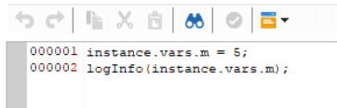

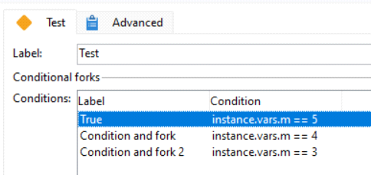

Flow Control Page 25

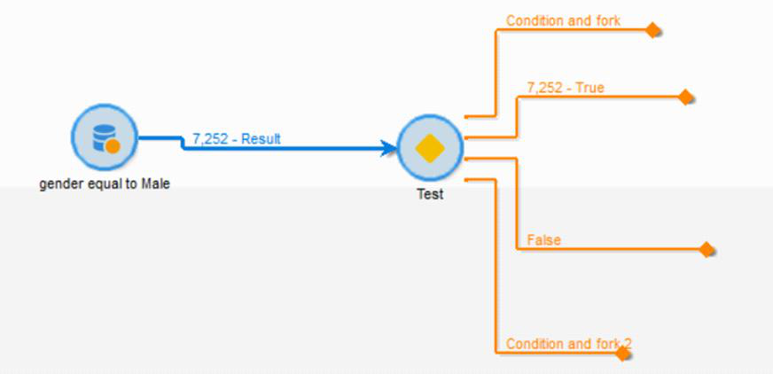

From <[https://capgemini-my.sharepoint.com/personal/amit-](https://capgemini-my.sharepoint.com/personal/amit-umedali_lakhani_capgemini_com/Documents/Documents/ACC%20Certification%20Preparation/2.%20Customization.docx)

[umedali_lakhani_capgemini_com/Documents/Documents/ACC%20Certification%20Preparation/2.%](https://capgemini-my.sharepoint.com/personal/amit-umedali_lakhani_capgemini_com/Documents/Documents/ACC%20Certification%20Preparation/2.%20Customization.docx)

[20Customization.docx](https://capgemini-my.sharepoint.com/personal/amit-umedali_lakhani_capgemini_com/Documents/Documents/ACC%20Certification%20Preparation/2.%20Customization.docx)>

Flow Control Page 26

WAIT   
Thursday, May 30, 2024 12:22 PM

Wait - Suspend the execution of the Workflow for the specified Time Duration

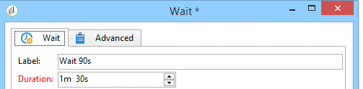

Flow Control Page 27

TIME CONSTRAINT   
Thursday, May 30, 2024 12:22 PM

Workflow Execution will not move forward, until Execution Time is not in the Time Constraint Range Current Execution Time : **02.22 PM**

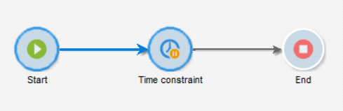

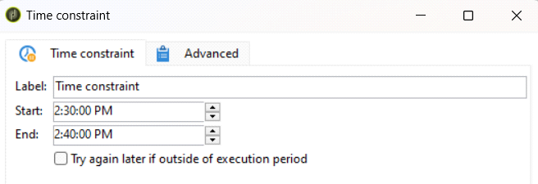

Flow Control Page 28

SUB-WORKFLOW   
Thursday, May 30, 2024 8:40 AM

**Calling an External Workflow from Main Workflow**

**Main Workflow**

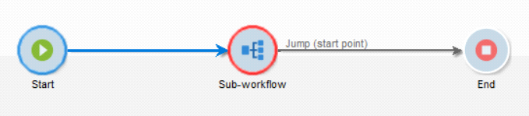

**Sub Workflow**

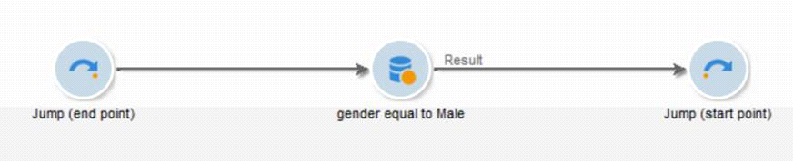

**Connection in Sub – Workflow Activity**

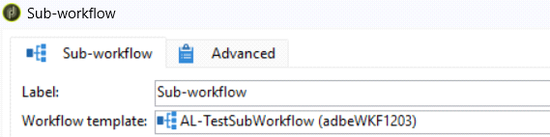

**Synchronous Operation**

**Ease of Access**

From <[https://capgemini-my.sharepoint.com/personal/amit-](https://capgemini-my.sharepoint.com/personal/amit-umedali_lakhani_capgemini_com/Documents/Documents/ACC%20Certification%20Preparation/2.%20Customization.docx)  
[umedali_lakhani_capgemini_com/Documents/Documents/ACC%20Certification%20Preparation/2.% 20Customization.docx](https://capgemini-my.sharepoint.com/personal/amit-umedali_lakhani_capgemini_com/Documents/Documents/ACC%20Certification%20Preparation/2.%20Customization.docx)>

Flow Control Page 29

START JUMP / END JUMP   
Thursday, May 30, 2024 8:39 AM

Improve the Readability of the Workflow   
Split bigger workflow into smaller ones and connect them using jumps Jump No. should match for successful connections

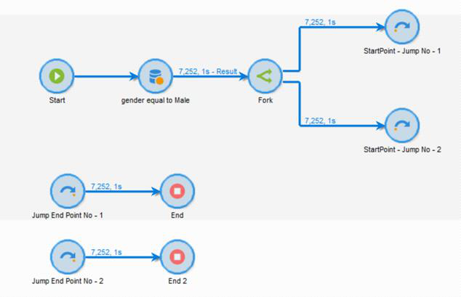

|  |  |
| --- | --- |
|  |  |

From <[https://capgemini-my.sharepoint.com/personal/amit-](https://capgemini-my.sharepoint.com/personal/amit-umedali_lakhani_capgemini_com/Documents/Documents/ACC%20Certification%20Preparation/2.%20Customization.docx)  
[umedali_lakhani_capgemini_com/Documents/Documents/ACC%20Certification%20Preparation/2.% 20Customization.docx](https://capgemini-my.sharepoint.com/personal/amit-umedali_lakhani_capgemini_com/Documents/Documents/ACC%20Certification%20Preparation/2.%20Customization.docx)>

Flow Control Page 30

EXTERNAL SIGNAL   
Thursday, May 30, 2024 12:23 PM

Flow Control Page 31

APPROVAL   
Thursday, May 30, 2024 8:39 AM

**Either by Group / Operators**

**Group = Collection of Operators**

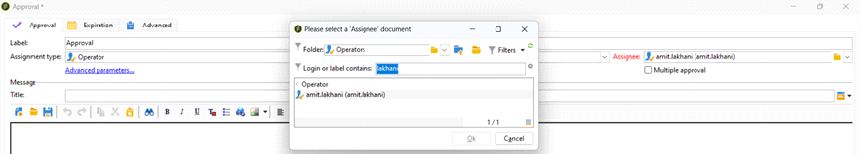

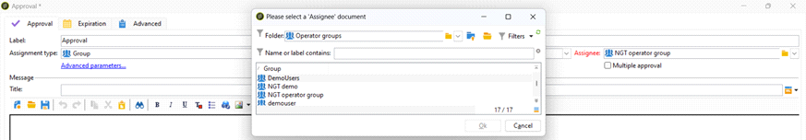

**PENDING APPROVAL**

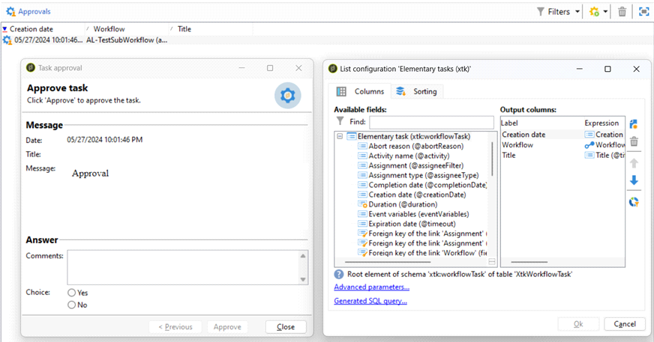

Flow Control Page 32

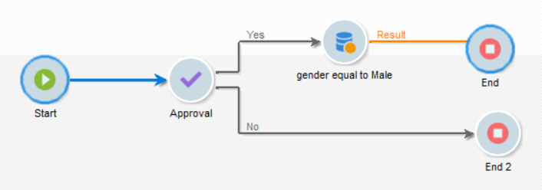

From <[https://capgemini-my.sharepoint.com/personal/amit-](https://capgemini-my.sharepoint.com/personal/amit-umedali_lakhani_capgemini_com/Documents/Documents/ACC%20Certification%20Preparation/2.%20Customization.docx)

[umedali_lakhani_capgemini_com/Documents/Documents/ACC%20Certification%20Preparation/2.%](https://capgemini-my.sharepoint.com/personal/amit-umedali_lakhani_capgemini_com/Documents/Documents/ACC%20Certification%20Preparation/2.%20Customization.docx)

[20Customization.docx](https://capgemini-my.sharepoint.com/personal/amit-umedali_lakhani_capgemini_com/Documents/Documents/ACC%20Certification%20Preparation/2.%20Customization.docx)>

Flow Control Page 33

ALERT   
Thursday, May 30, 2024 8:39 AM

**ALERT WILL BE SENT TO OPERATOR / GROUP**   
**NO ACKNOWLEDGEMENT REQUIRED**

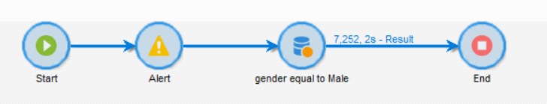

From <[https://capgemini-my.sharepoint.com/personal/amit-](https://capgemini-my.sharepoint.com/personal/amit-umedali_lakhani_capgemini_com/Documents/Documents/ACC%20Certification%20Preparation/2.%20Customization.docx)  
[umedali_lakhani_capgemini_com/Documents/Documents/ACC%20Certification%20Preparation/2.% 20Customization.docx](https://capgemini-my.sharepoint.com/personal/amit-umedali_lakhani_capgemini_com/Documents/Documents/ACC%20Certification%20Preparation/2.%20Customization.docx)>

Flow Control Page 34

DATA LOADING   
Thursday, May 30, 2024 12:17 PM

Loading of File into the Adobe Server

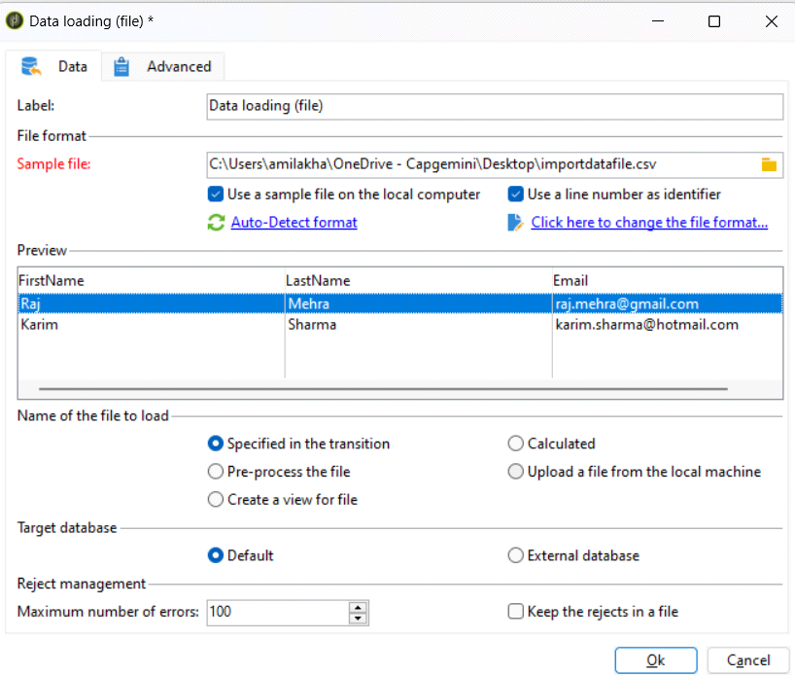

Actions Page 35

DATA EXTRACTION   
Thursday, May 30, 2024 3:13 PM

You can extract data from a workflow table in an external file using the **Data extraction (file)** activity.

**Approx 7250 records will be downloaded for 3 chosen Columns**

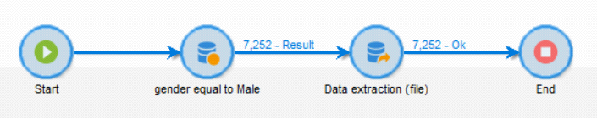

Specify the path of Download

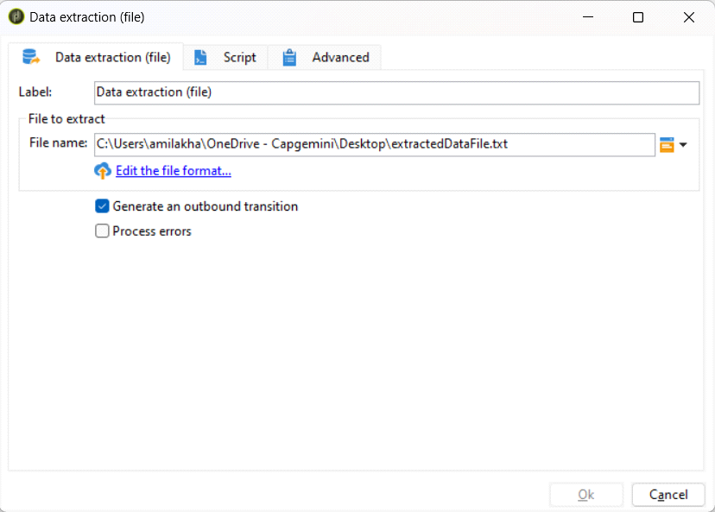

Edit the File Format   
Choose the Columns for Downloading

Actions Page 36

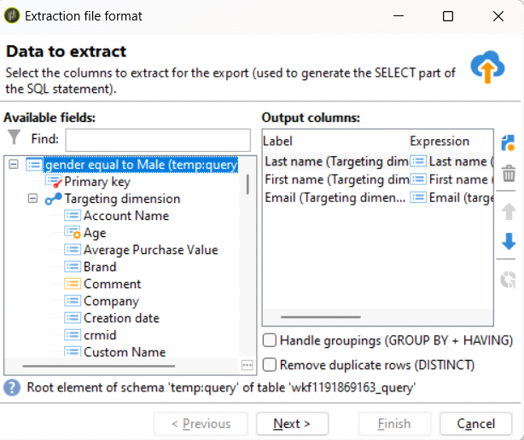

Sorting

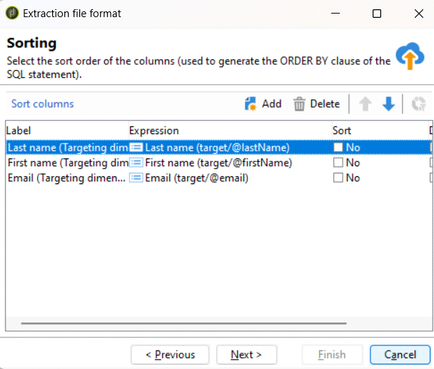

Destination Format

Actions Page 37

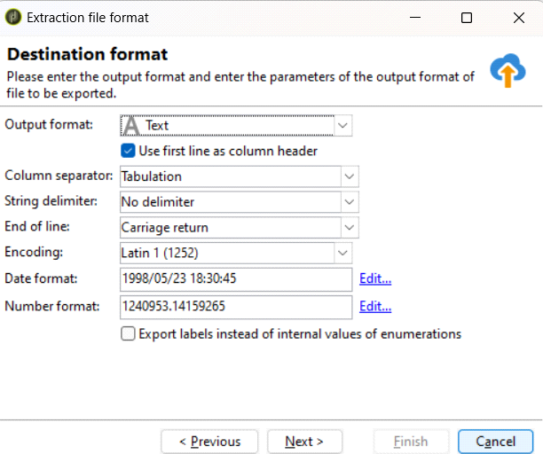

Data Formatting

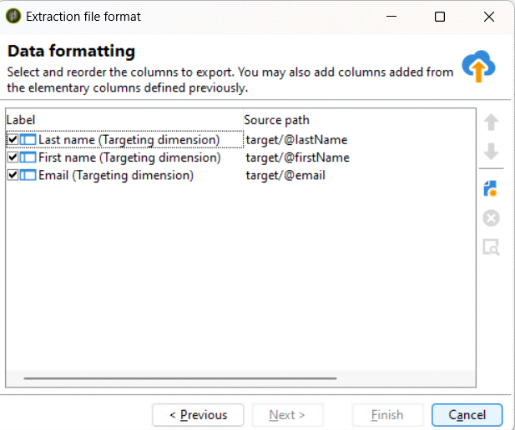

Actions Page 38

SQL CODE / JAVASCRIPT CODE   
Thursday, May 30, 2024 3:13 PM

**SQL Code**

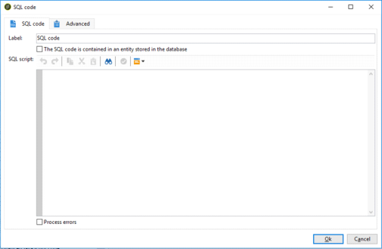

**SQL Codes**

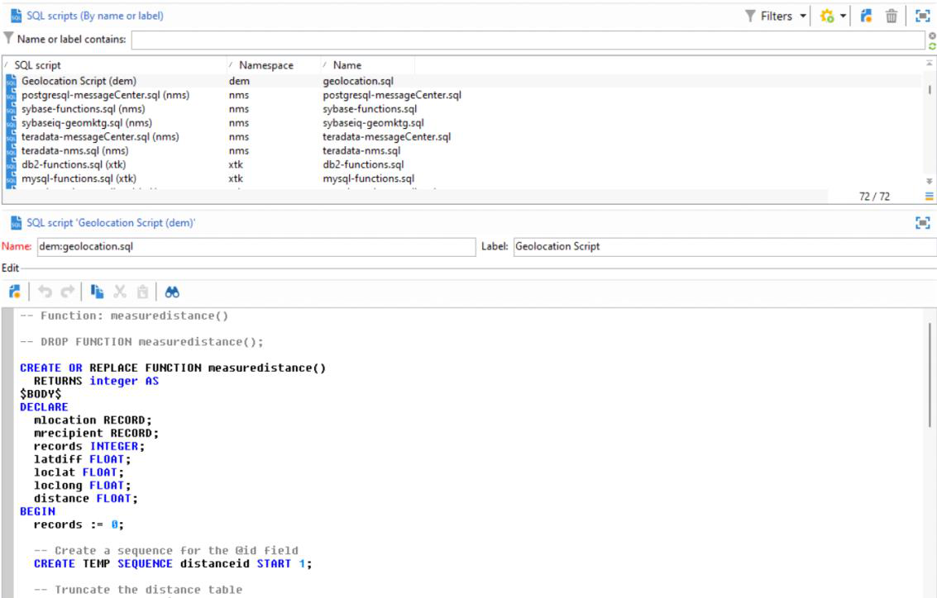

********************************************************************************** ******   
**Javascript Code**

Actions Page 39

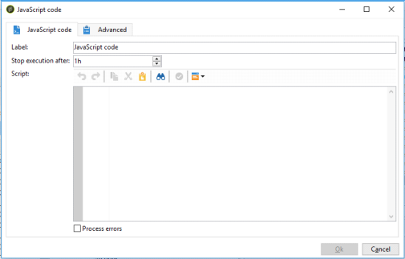

**Advanced Javascript Code**

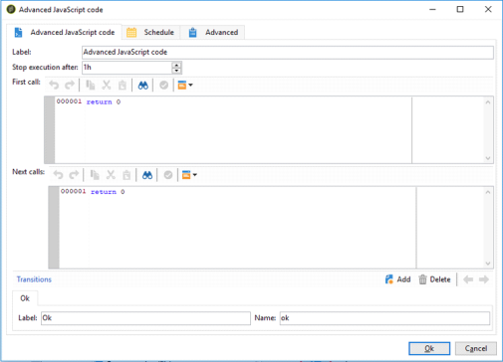

**Javascript Codes**

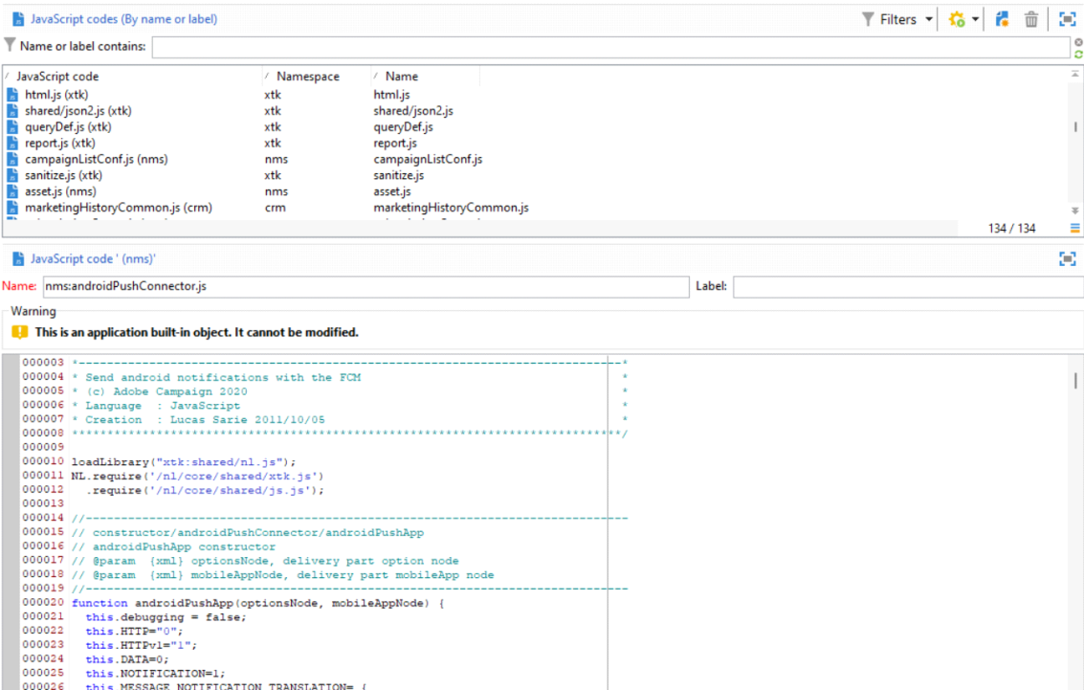

**Javascript Templates**

Actions Page 40

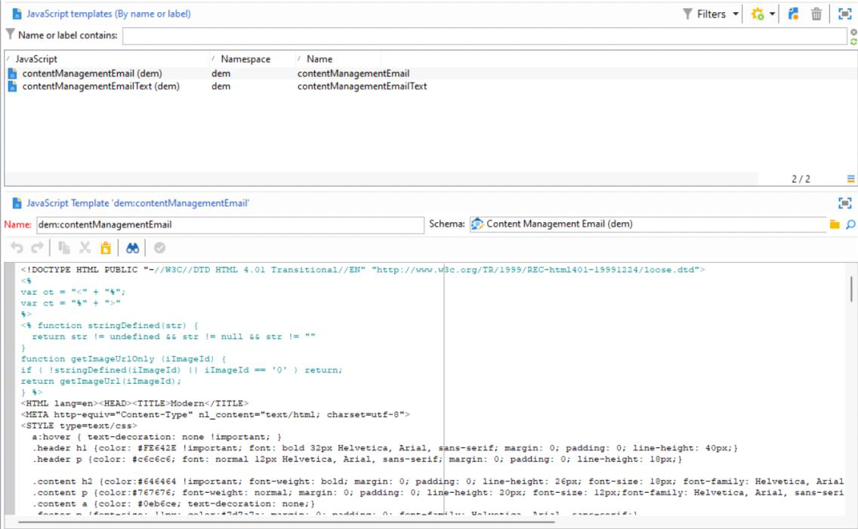

Actions Page 41

Export / Import (V4 Compatibility) Saturday, June 1, 2024 4:12 PM

Actions Page 42

nlserver module   
Saturday, June 1, 2024 4:12 PM

Actions Page 43

File Collector   
Thursday, May 30, 2024 12:18 PM

Events Page 44

File Transfer   
Saturday, June 1, 2024 4:13 PM

File Download - Download files from mentioned S3 Bucket Path

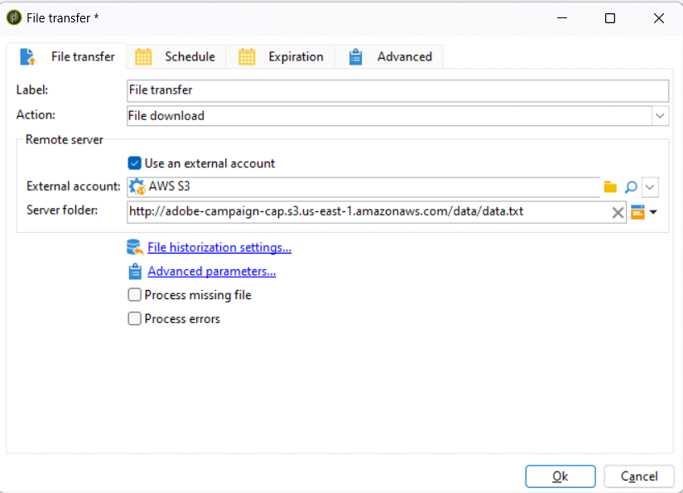

File Upload - Upload the Files to the mentioned S3 Bucket Path

Events Page 45

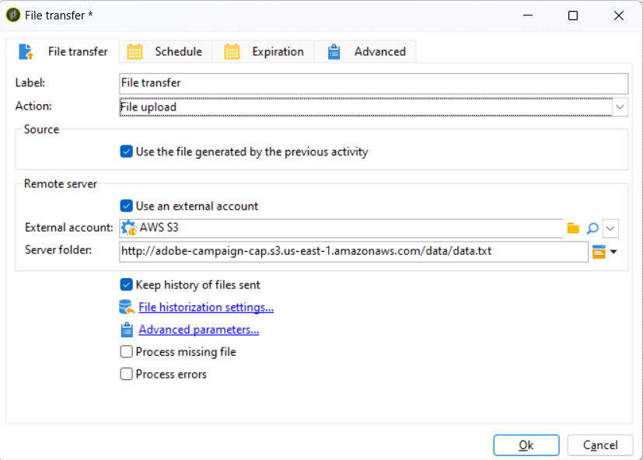

File Exists - Check whether files are present at the mentioned S3 Bucket Path

Events Page 46

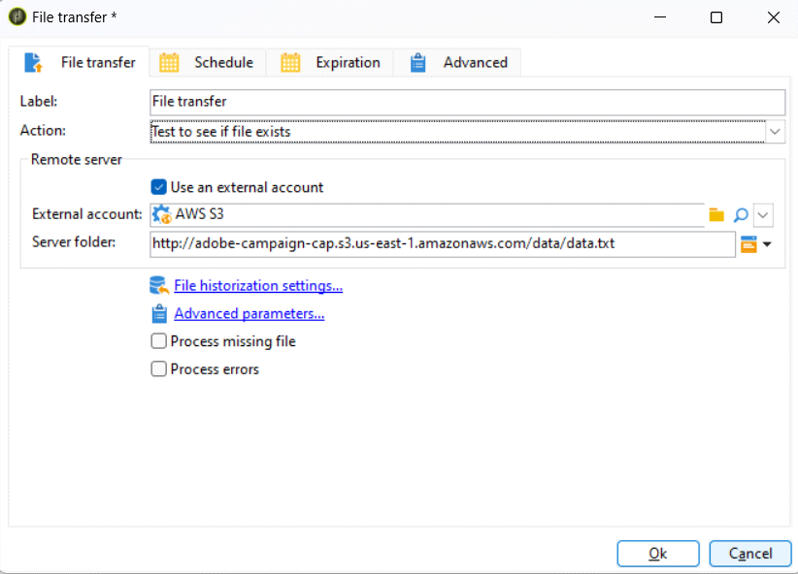

File Listing - Provides a Count of Files in the mentioned S3 Bucket Path

Events Page 47

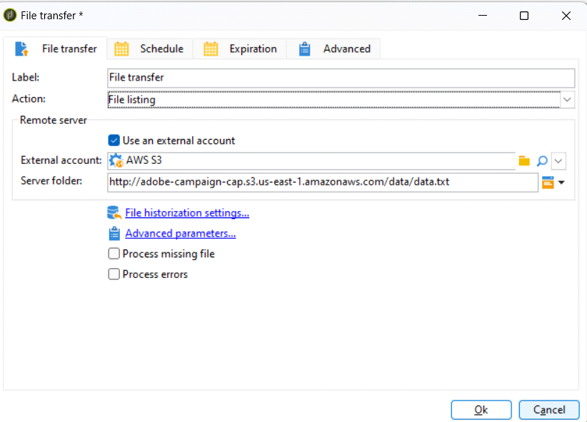

Events Page 48

Web Download   
Saturday, June 1, 2024 4:13 PM

Events Page 49

Inbound Emails   
Saturday, June 1, 2024 4:13 PM

Events Page 50

Inbound SMS   
Saturday, June 1, 2024 4:14 PM

Events Page 51

CAMPAIGNS   
Thursday, May 30, 2024 8:46 AM

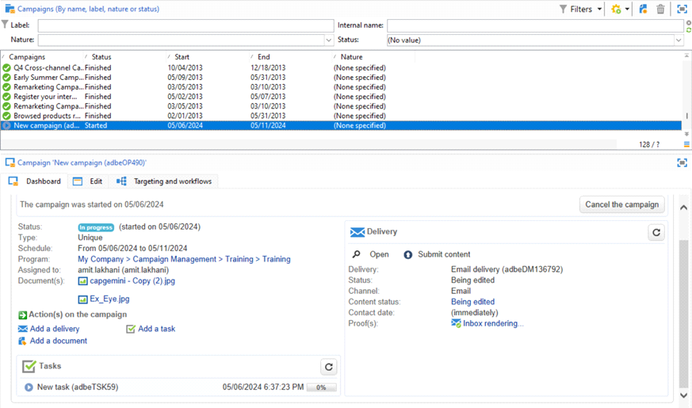

From <[https://capgemini-my.sharepoint.com/personal/amit-](https://capgemini-my.sharepoint.com/personal/amit-umedali_lakhani_capgemini_com/Documents/Documents/ACC%20Certification%20Preparation/1.%20System%20configuration.docx)  
[umedali_lakhani_capgemini_com/Documents/Documents/ACC%20Certification%20Preparation/1.%20System% 20configuration.docx](https://capgemini-my.sharepoint.com/personal/amit-umedali_lakhani_capgemini_com/Documents/Documents/ACC%20Certification%20Preparation/1.%20System%20configuration.docx)>

Others Page 52

SCRIPTING

Thursday, May 30, 2024 8:46 AM

**GET INFORMATION IN THE SCRIPT IN ANY SCRIPTS OF ANY ACTIVITY**

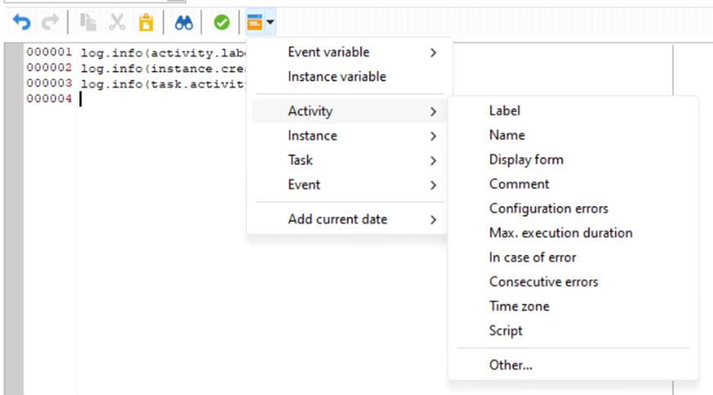

Activity -> Javascript Code Details   
Instance -> Workflow Details   
Task -> XTK Task   
Event -> XTK Event   
Add Current Data -> Different Date Format   
logInfo(‘Message’);

From <[https://capgemini-my.sharepoint.com/personal/amit-](https://capgemini-my.sharepoint.com/personal/amit-umedali_lakhani_capgemini_com/Documents/Documents/ACC%20Certification%20Preparation/1.%20System%20configuration.docx)  
[umedali_lakhani_capgemini_com/Documents/Documents/ACC%20Certification%20Preparation/1.%20System% 20configuration.docx](https://capgemini-my.sharepoint.com/personal/amit-umedali_lakhani_capgemini_com/Documents/Documents/ACC%20Certification%20Preparation/1.%20System%20configuration.docx)>

Others Page 53

OPTIONS   
Thursday, May 30, 2024 8:47 AM

**CREATE OPTIONS FROM UI – Global Variable**

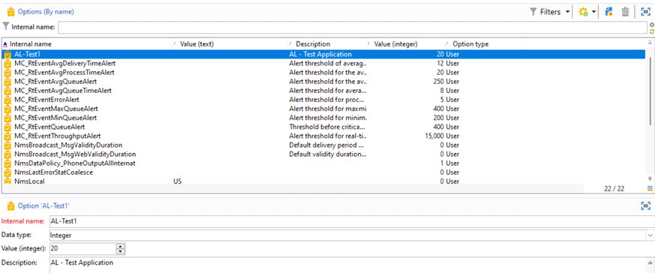

**SET AND GET VALUE USING OPTIONS**

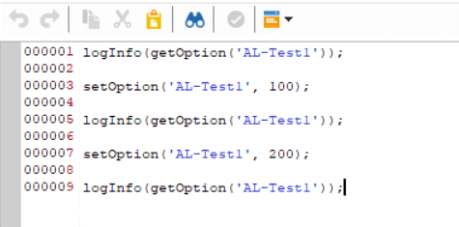

From <[https://capgemini-my.sharepoint.com/personal/amit-](https://capgemini-my.sharepoint.com/personal/amit-umedali_lakhani_capgemini_com/Documents/Documents/ACC%20Certification%20Preparation/1.%20System%20configuration.docx)

[umedali_lakhani_capgemini_com/Documents/Documents/ACC%20Certification%20Preparation/1.%20System% 20configuration.docx](https://capgemini-my.sharepoint.com/personal/amit-umedali_lakhani_capgemini_com/Documents/Documents/ACC%20Certification%20Preparation/1.%20System%20configuration.docx)>

Others Page 54

EXTERNAL ACCOUNTS   
Thursday, May 30, 2024 8:47 AM

**EXTERNAL ACCOUNTS**   
**EMAIL ROUTING**

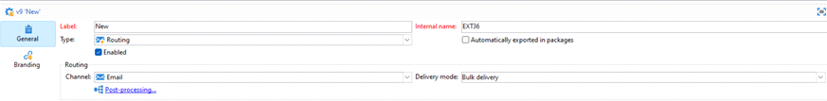

**MOBILE (SMS) ROUTING**

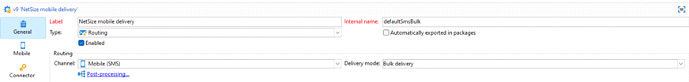

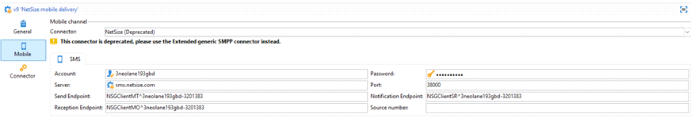

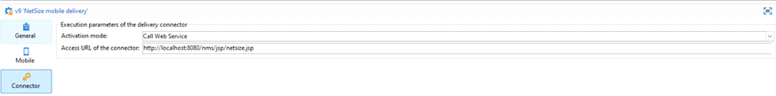

PHONE ROUTING

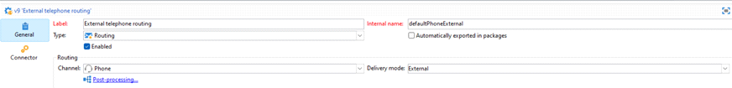

DIRECT MAIL ROUTING

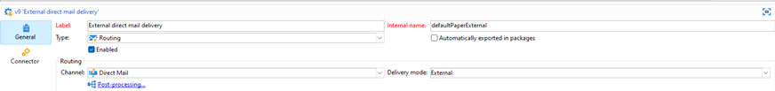

AGENCY ROUTING

Others Page 55

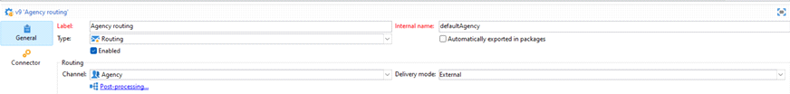

FACEBOOK ROUTING

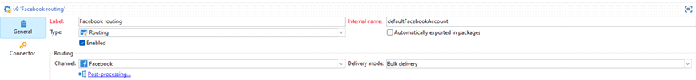

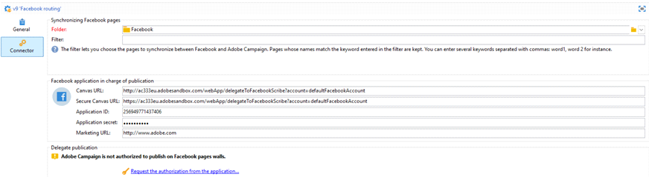

TWITTER ROUTING

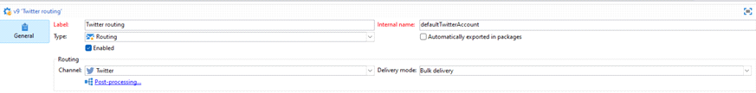

IOS ROUTING

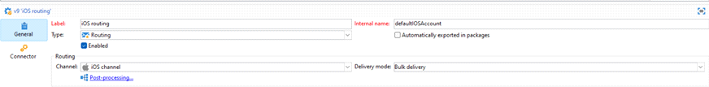



ANDROID ROUTING

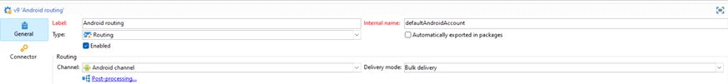

Others Page 56



LINE ROUTING

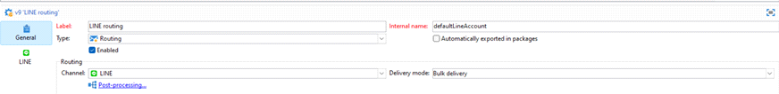

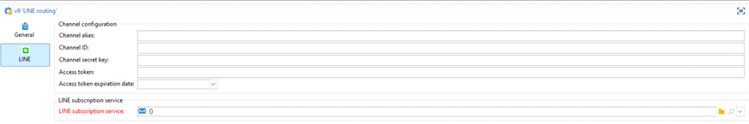

OTHER ROUTING

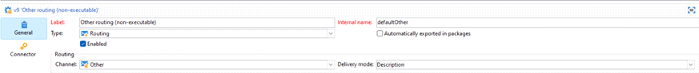

BOUNCE MAIL

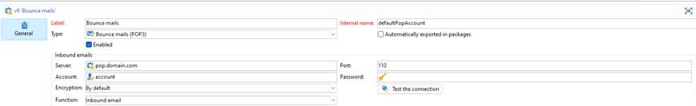

HTTP

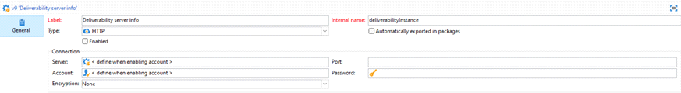

EXTERNAL DATABASE

Others Page 57

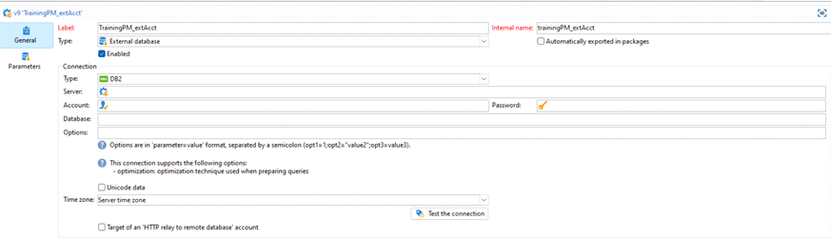

EXTERNAL DATABASE

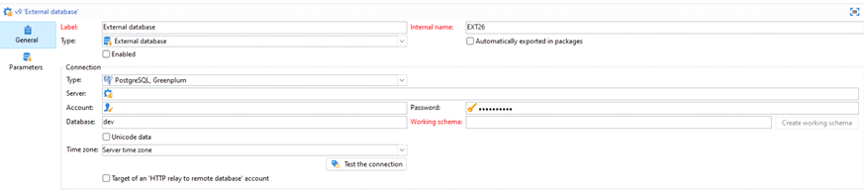

WEB ANALYTICS



FACEBOOK CONNECT

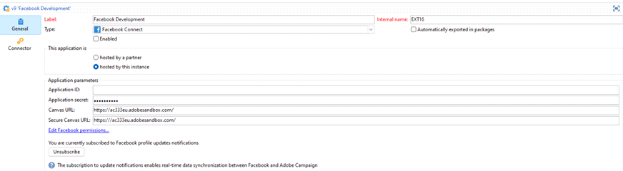

MESSAGE CENTER AGENT

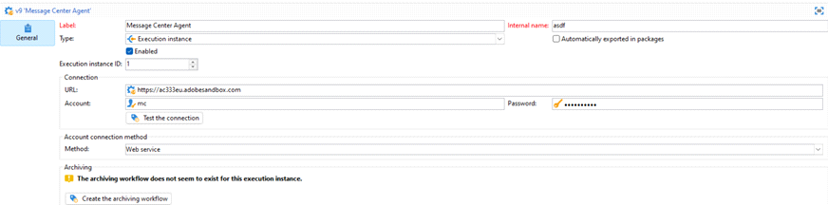

AEM

Others Page 58

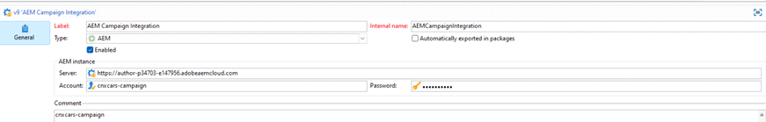

ADOBE EXPERIENCE CLOUD

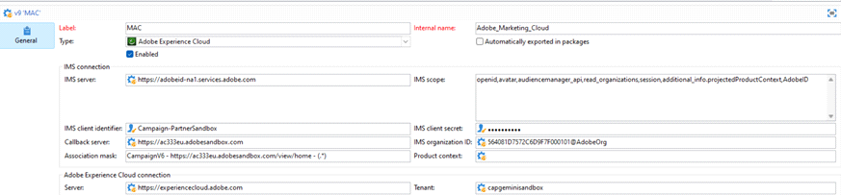

SFTP

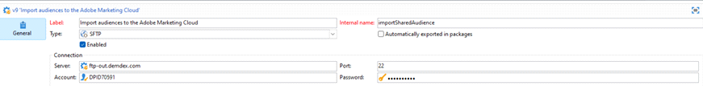

AWS S3

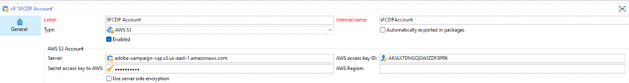

AZURE

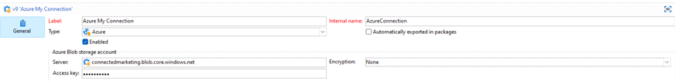

MICROSOFT DYNAMIC CRM

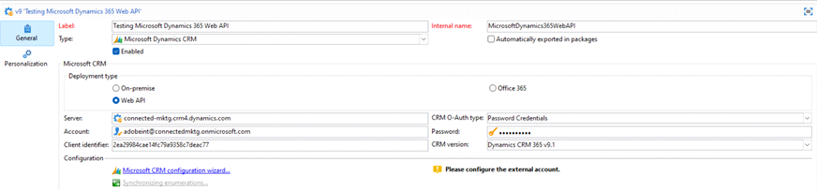

Others Page 59

ORACLE ON DEMAND

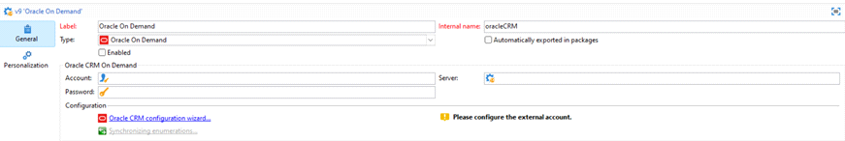

SALESFORCE CRM

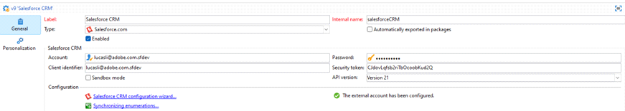

EXTERNAL ACCOUNT IN A WORKFLOW

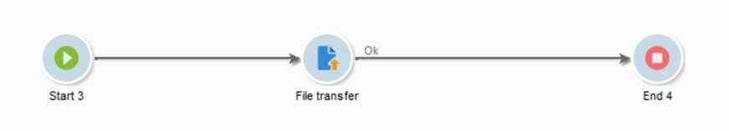

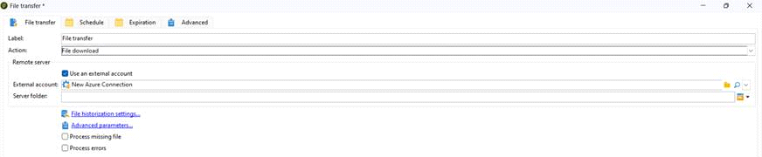

From <[https://capgemini-my.sharepoint.com/personal/amit-](https://capgemini-my.sharepoint.com/personal/amit-umedali_lakhani_capgemini_com/Documents/Documents/ACC%20Certification%20Preparation/1.%20System%20configuration.docx)  
[umedali_lakhani_capgemini_com/Documents/Documents/ACC%20Certification%20Preparation/1.%20System% 20configuration.docx](https://capgemini-my.sharepoint.com/personal/amit-umedali_lakhani_capgemini_com/Documents/Documents/ACC%20Certification%20Preparation/1.%20System%20configuration.docx)>

Others Page 60

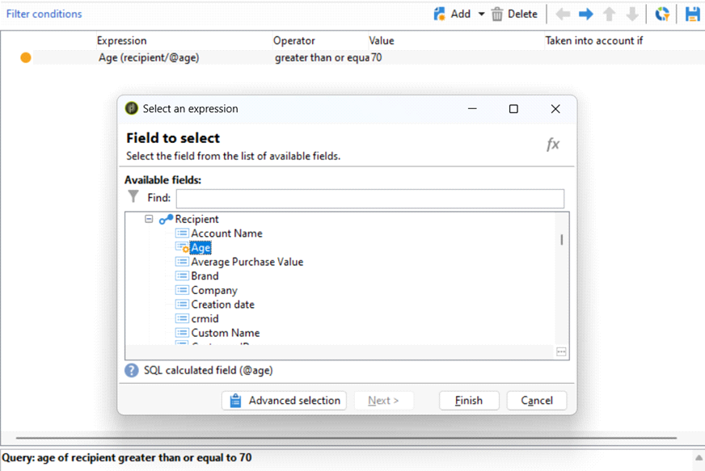

TYPOLOGY & TYPOLOGY RULES

|  |  |
| --- | --- |
| Thursday, May 30, 2024 | 8:48 AM |

|  |  |  |  |
| --- | --- | --- | --- |
| **Aspect** | **Filtering Typologies** | **Pressure Typologies** | **Control Typologies** |
| **Purpose** | Target the right audience | Manage message frequency | Ensure compliance and quality |
| **Functionality** | Include/exclude recipients based on criteria | Set limits on message frequency | Validate campaign configurations |
| **Examples** | Excluding unsubscribed recipients | Limiting emails to three per week | Ensuring all fields are populated |
| **Usage Phase** | Target preparation | Delivery preparation | Throughout campaign setup and execution |
| **Goal** | Optimize recipient targeting | Prevent over-communication | Ensure campaign accuracy and compliance |

TYPOLOGY – GROUP OF TYPOLOFY RULES   
TYPOLOGY RULES – FILTERING THE DIMENSIONS / SCHEMA / DATA   
CAPACITY   
CONTROL   
FILTERING   
OFFER PRESENTATION   
PRESSURE

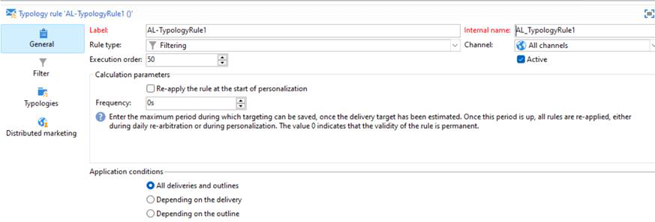

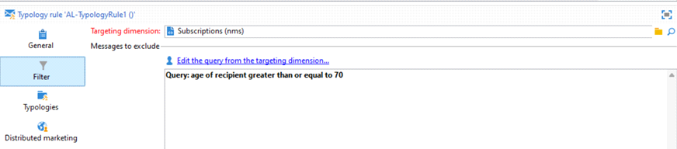

Others Page 61



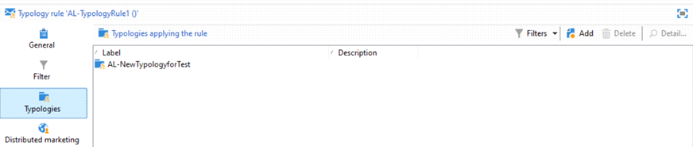

SETTING OF TYPOLOGY IN DELIVERY

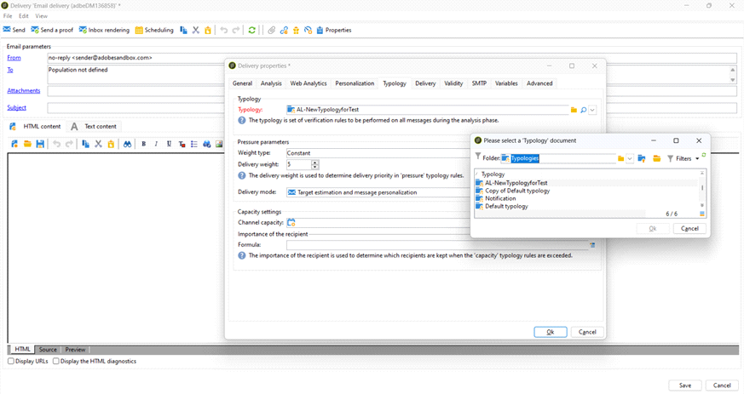

Others Page 62

PRESSURE TYPOLOGY RULES   
Limiting the number of message to a Individual Recipient, in order to avoid Spamming

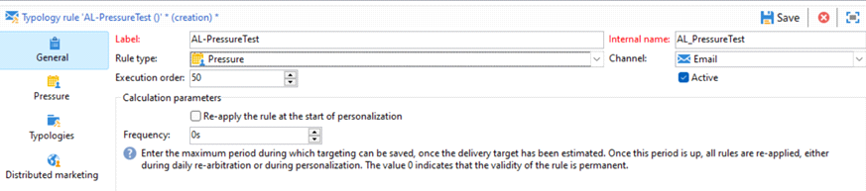

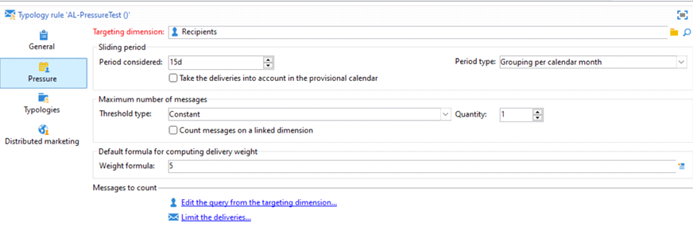

CONTROL RULES   
Control rules ensure messages meet quality standards before being sent. Key checks include:

No special characters in email addresses.

Labels on all tracking URLs in emails.

Proper format for tracking URLs in emails.

SMS messages are the correct size.

Delivery time is sufficient to send all emails.   
Error if more than 100 recipients in a test group.   
Final email delivery is scheduled on time.

Every email includes an unsubscribe link.

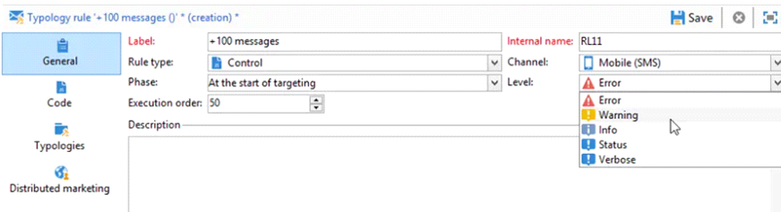

Others Page 63

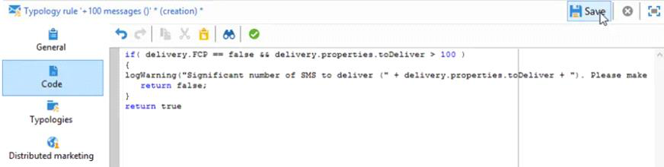

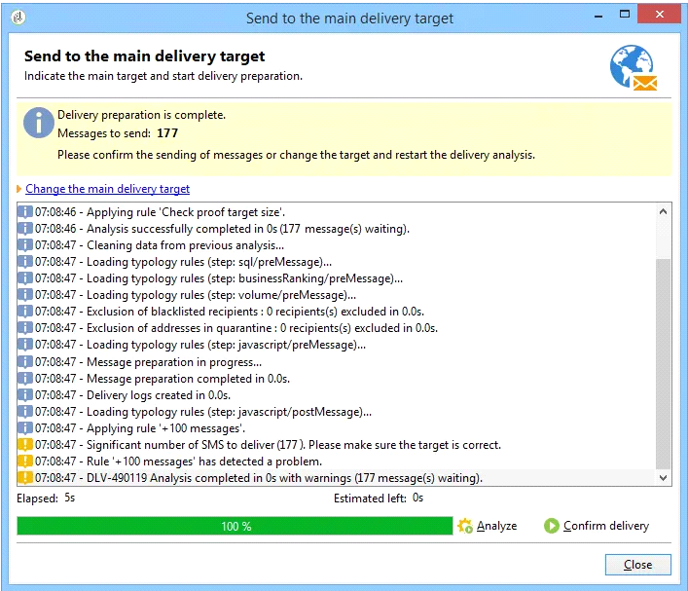

From <[https://capgemini-my.sharepoint.com/personal/amit-umedali_lakhani_capgemini_com/Documents/Documents/ACC%20Certification%20Preparation/1.%20System%](https://capgemini-my.sharepoint.com/personal/amit-umedali_lakhani_capgemini_com/Documents/Documents/ACC%20Certification%20Preparation/1.%20System%20configuration.docx)

[20configuration.docx](https://capgemini-my.sharepoint.com/personal/amit-umedali_lakhani_capgemini_com/Documents/Documents/ACC%20Certification%20Preparation/1.%20System%20configuration.docx)>

Others Page 64

SEED ADDRESS   
Thursday, May 30, 2024 3:21 PM

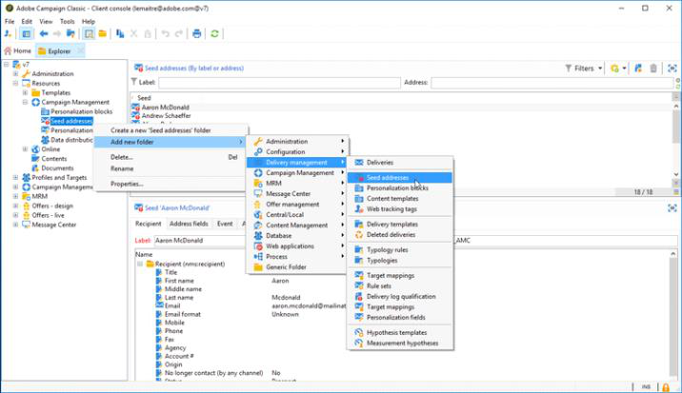

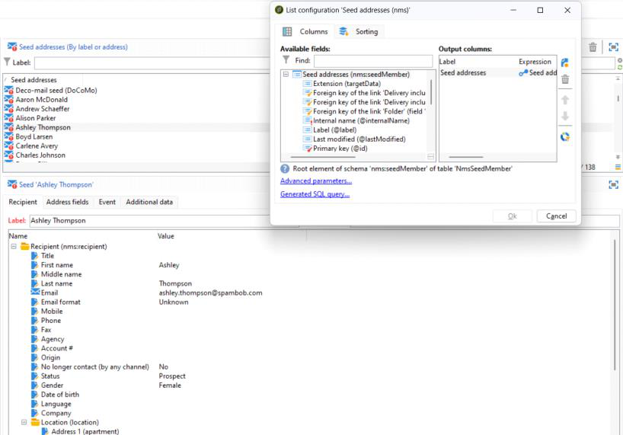

**********************************************************************************   
**********************************************************************************   
******************

New Delivery

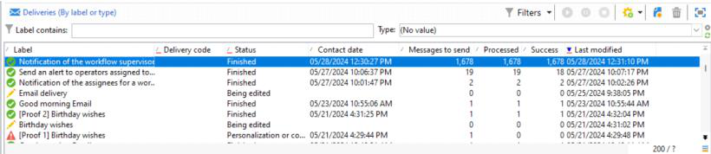

Others Page 65

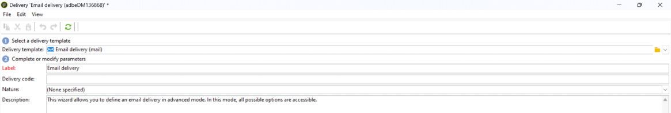

Click To

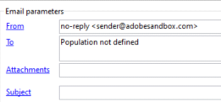

Click **Import Seed Templates**, and **select Seed Address**

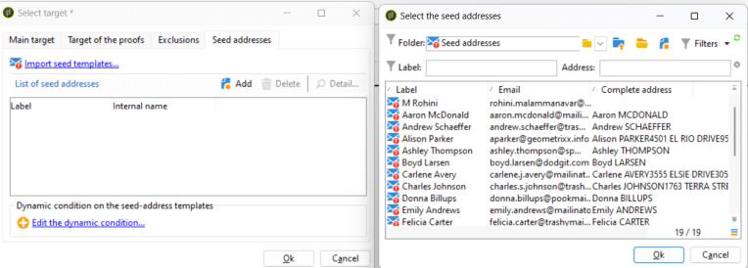

Populated Seed Address

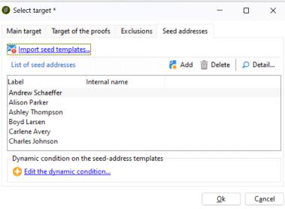

**Click Send a Proof**

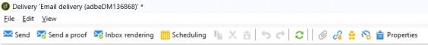

Why Seed Address is Used

•**Seed Addresses**: Seed addresses are email addresses that belong to the developer or their team   
members. These addresses are not typically used by real recipients but are included in the mailing   
list for monitoring purposes.

•**Monitoring Usage**: When the developer sends emails to the mailing list, they also include the seed   
addresses in the recipient list. If any emails are received at these seed addresses, it indicates that   
someone other than the authorized sender (the developer or their team) is using the mailing list.

•**Detection of Unauthorized Use**: If emails are received at the seed addresses that were not sent by   
the developer or their team, it suggests that the mailing list may have been shared with or accessed   
by unauthorized third parties. This could be due to various reasons such as a security breach,   
unauthorized access to the mailing list, or sharing of the list without permission

Others Page 66

ALLOWING AN IP RANGE   
Thursday, May 30, 2024 3:37 PM

<https://experience.adobe.com/#/controlpanel/instances>  
Or   
<https://experience.adobe.com/#/@subway/controlpanel/instances?tid=subway&tab=whitelist>



Add New IP Range

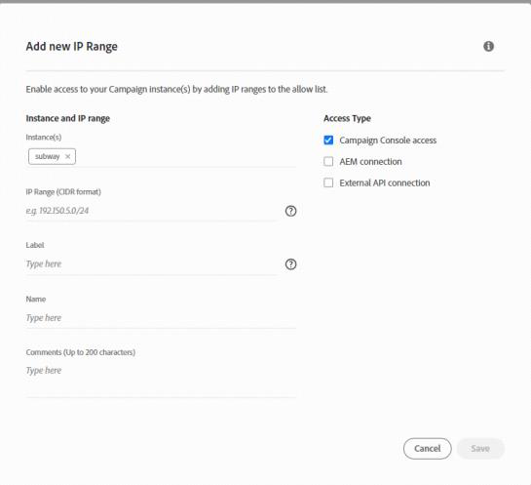

Others Page 67

CAMPAIGN WORKFLOW HEATMAP Thursday, May 30, 2024 3:37 PM

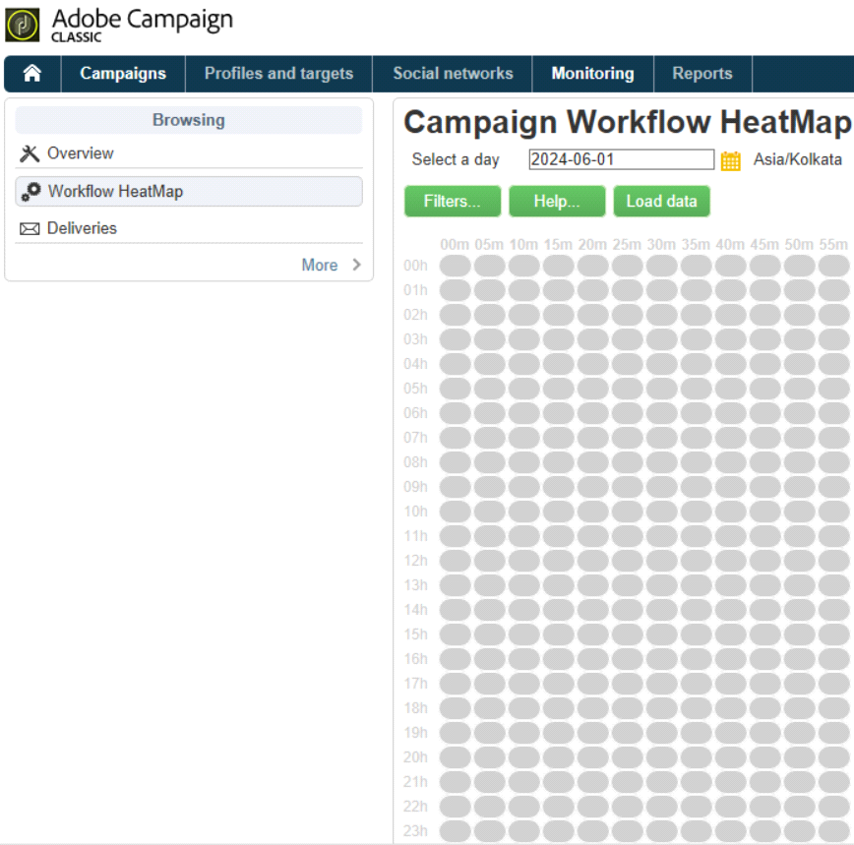

Filters

Others Page 68

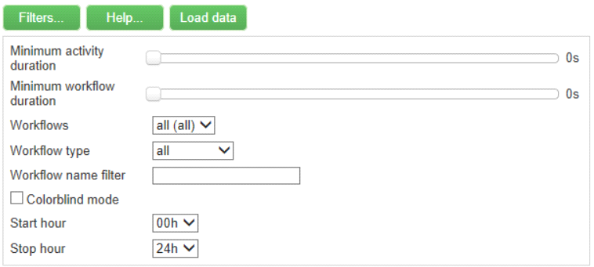

Help

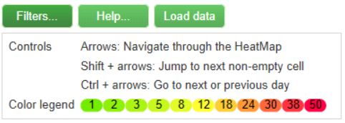

Dates Selection

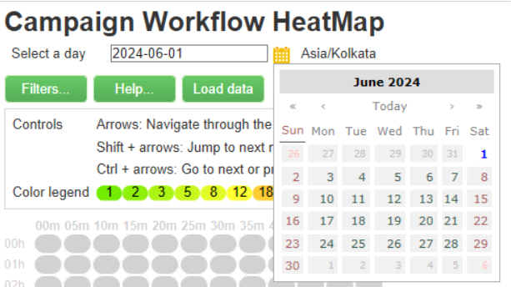

Others Page 69

FILTERS   
Thursday, May 30, 2024 3:38 PM

Others Page 70

DATABASE CLEANUP WORKFLOW   
Thursday, May 30, 2024 3:38 PM

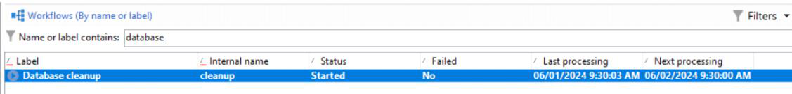

Workflow is Scheduled to run Everyday @ 04.00 AM

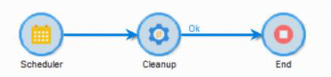

Cleanup - nlserver Module

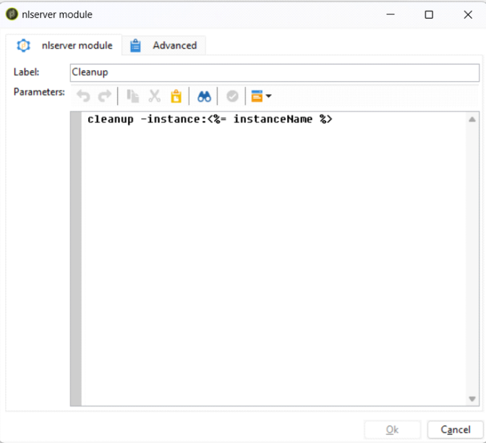

Others Page 71

FORM RENDERING   
Thursday, May 30, 2024 3:39 PM

Others Page 72

PI   
Thursday, May 30, 2024 3:40 PM

Others Page 73

REST API CALL / SOAP API Call Thursday, May 30, 2024 3:40 PM

Others Page 74

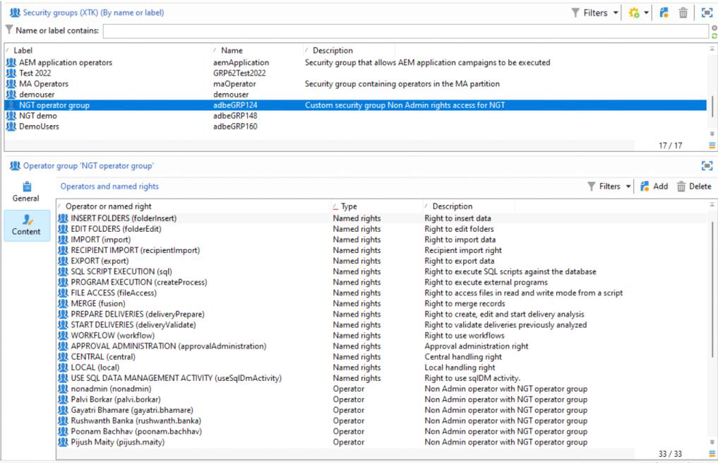

NAMED RIGHTS / SECURITY GROUP / OPERATOR /   
OPERATOR GROUPS   
Thursday, May 30, 2024 3:41 PM

**Named Rights - They are the Rights / Permissions, which can be associated to a Security Group**

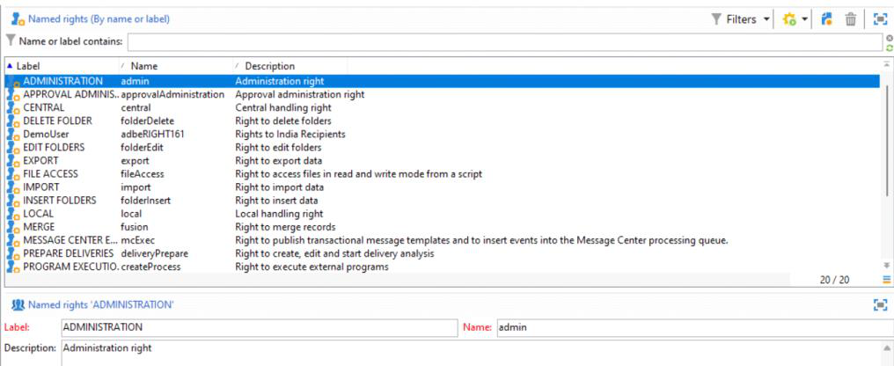

**Operators - Users who Use / Operates the System**

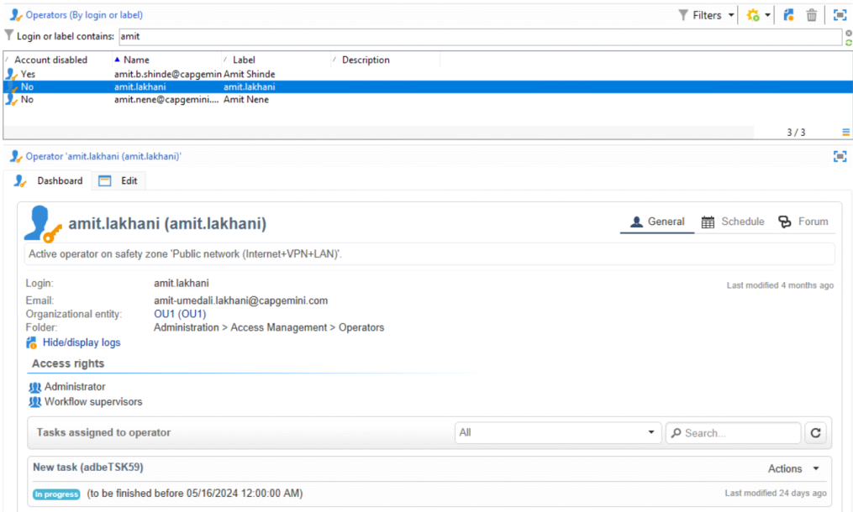

**Operator Group / Security Group**   
**Security Group Associates Operator with the Named Rights**

**Operators <---------------- Security Group ----------------> Named Rights**

Others Page 75



**Eg - Palvi Borkar (Operator) has Merge (fusion) Rights**

**Click Add**   
**How to add Operators or Named Rights to a Security Group**

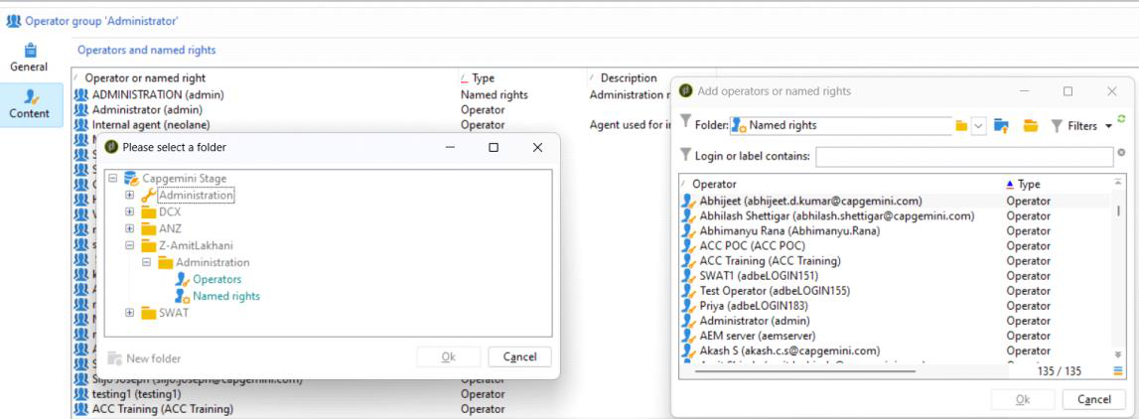

**Note : Operators and Named Rights details are stored in the same schema**

Others Page 76

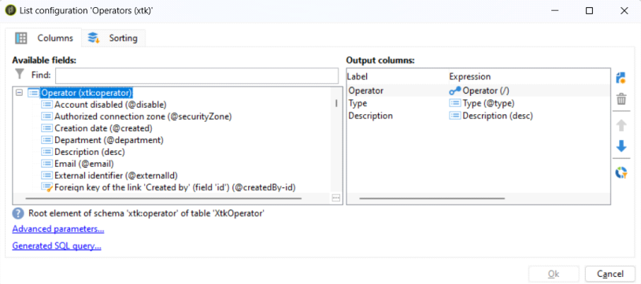

**List all the Named Rights in Adobe Campaign Classic**

**1. ADMINISTRATION**: Users with this right have full access to the instance. They can create, edit, delete, and execute any object within Adobe Campaign, such as workflows, deliveries, and scripts. **2. APPROVAL ADMINISTRATION**: Users with this right can set up approval steps within workflows and deliveries. They can assign operators or operator groups to approve these steps.

**3. CENTRAL**: This right is for central management, particularly relevant for Distributed Marketing. **4. DELETE FOLDER**: Users with this right can delete folders from the explorer view.

**5. EDIT FOLDERS**: Users with this right can modify folder properties, such as internal name, label, associated image, and sub-folder order.

**6. EXPORT**: Users can export data from Adobe Campaign instances into a file on a server or local machine using the EXPORT workflow activity.

**7. FILES ACCESS**: This right grants read and write access for files via a script, allowing users to read/write files on a server.

**8. IMPORT**: Users with this right can import data into any table. There's also a specific right for importing recipients into the recipient table.

**9. INSERT FOLDERS**: Users with this right can create new folders in the folder tree within the explorer view.

**10. LOCAL**: This right is for local management, particularly relevant for Distributed Marketing. **11. MERGE**: Users with this right can merge selected records, particularly useful for handling duplicate recipients.

**12. PREPARE DELIVERIES**: Users with this right can create, edit, and save deliveries. They can also initiate the delivery analysis process.

**13. PRIVACY DATA RIGHT**: This right pertains to collecting and deleting privacy data.

**14. PROGRAM EXECUTION**: Users with this right can execute commands in various programming languages.

**15. RECIPIENT IMPORT**: Users with this right can import recipients from a local file into the recipient table.

**16. SQL SCRIPT EXECUTION**: This right allows users to execute SQL commands directly on the database. **17. START DELIVERIES**: Users with this right can approve previously analyzed deliveries to resume their execution.

**18. USE SQL DATA MANAGEMENT ACTIVITY**: This right enables users to write SQL scripts using the SQL Data Management activity to create and populate work tables.

**19. WORKFLOW**: Users with this right can execute workflows. Without this right, users cannot start, stop, or restart workflows.

**20. WEBAPP**: This right allows users to use web applications.

List all Default Operator Groups / Security Groups

•**Administrator**: Operators in this group have full access to the instance and are responsible for setting up and managing the platform. They can execute, create, edit, and delete various objects such as workflows, deliveries, and scripts.

•**Delivery Operators**: This group manages deliveries, including creating and preparing them. They have rights to create, edit, and start delivery analysis, as well as approve previously analyzed deliveries.

•**Campaign Managers**: Operators in this group oversee marketing campaigns and have access to related objects like plans, programs, workflows, and budgets. However, they cannot start deliveries.•**Content Contributors**: Members can access Content folders for Content management but do not receive additional rights.

•**Access to Reports**: Reserved for external operators to enable access to reporting features like Reports, Scheduling, and Forum icons.

•**Workflow Execution**: This group assigns operators the right to manage workflows unrelated to campaigns.

•**Workflow Supervisors**: Operators receive email notifications for alerts concerning campaign workflows.

**Local/Central Management**: These groups facilitate Distributed Marketing.•  
•**Offer Managers**: Operators can create and maintain offers. They also have rights to insert and edit folders within the Adobe Campaign tree.

Others Page 77

Others Page 78

ENUMERATIONS   
Thursday, May 30, 2024 5:37 PM

**Open Enumerations**   
Enumerations where items can be added though UI or through Forms

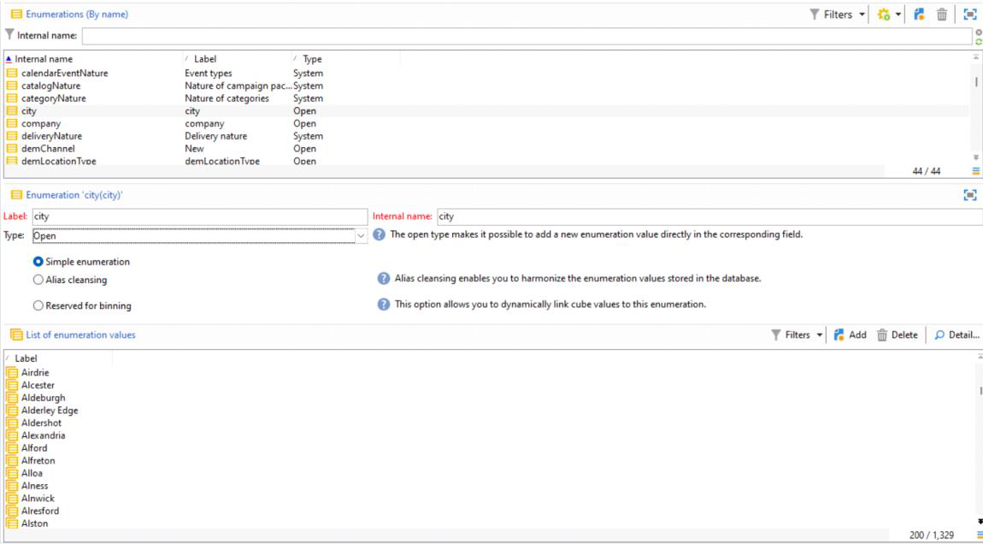

**While Updating the Recipient data using UI, I am adding a new customized item in City**   
**Enumerations**   
**Adding custom items In City Enumerations - Saving the Data**



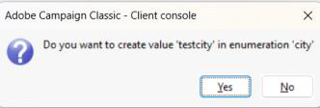

**Result**

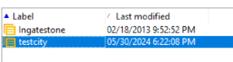

**Closed Enumerations**

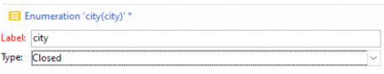

**Not allowed to change the City from Recipient Menu**

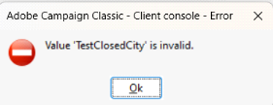

**Open OR Closed ---> Items can be added from parent Folder**   
**Administration > Platform > Enumerations**

**ALIAS CLEANSING**   
**Managing / Manipulating the Existing Items in the Enumerations**

Others Page 79

**Idea :**   
**ABCD is wrong entry in City Enumeration Database**   
**I wish to provide an Alias Name for the same**

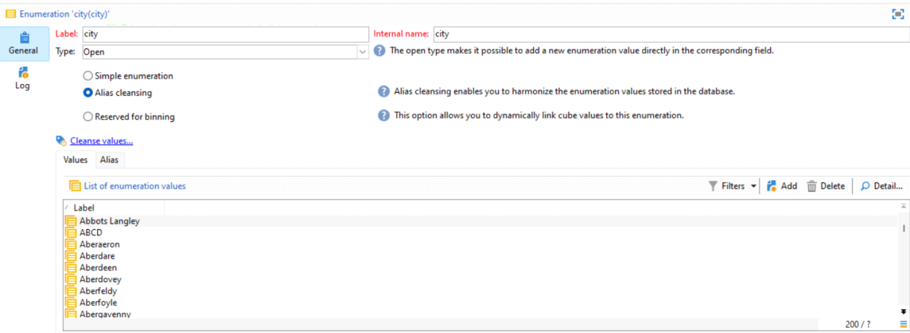

Go to **ALIAS Tab**   
**Click Add**

I am replacing the item **ABCD** with **AL-Testing**

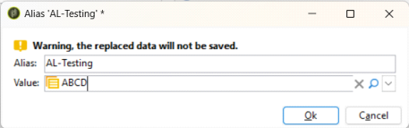

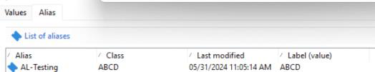

**Click Cleanse Value**

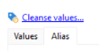

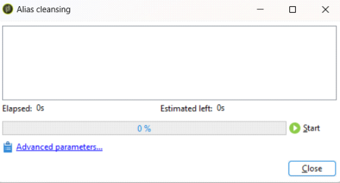

**Click Start…**  
**Done**

**Daily Technical Workflow of Adobe will Perform Alias Operation on our data**

Others Page 80

STRING GROUPS   
Thursday, May 30, 2024 6:23 PM

String Groups - List of strings under one Group

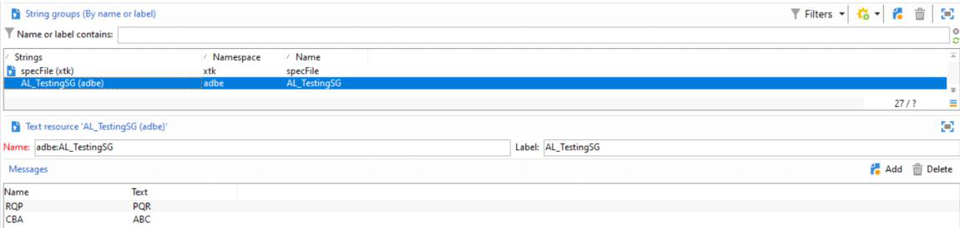

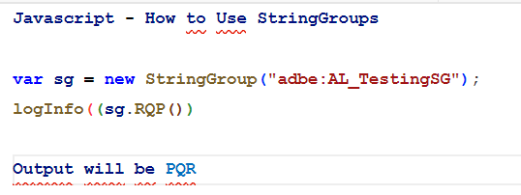

Others Page 81

COUNTERS   
Friday, May 31, 2024 11:23 AM

Counters - Global Counter, which can be Incremented or Decremented for Persistence

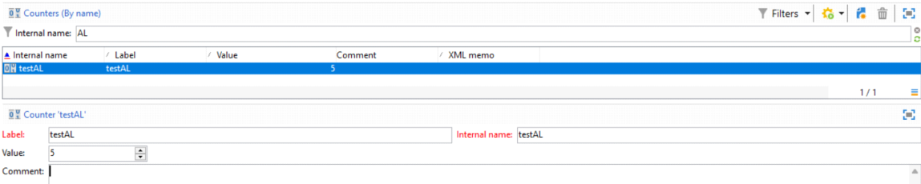

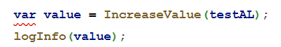

Others Page 82

Configure PUSH Channel / SMS Channel Saturday, June 1, 2024 12:45 PM

Others Page 83

DEPLOYMENT WIZARD SETTINGS   
Saturday, June 1, 2024 12:53 PM

**Go to Deployment Wizard**

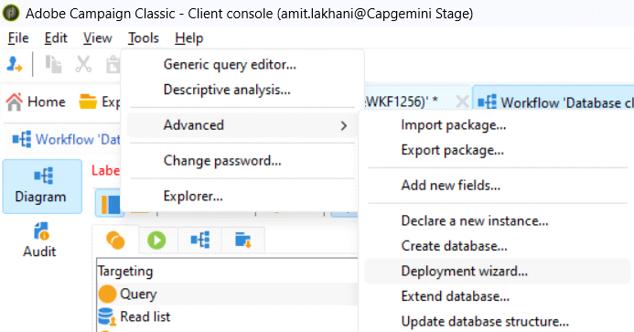

**General Parameters**

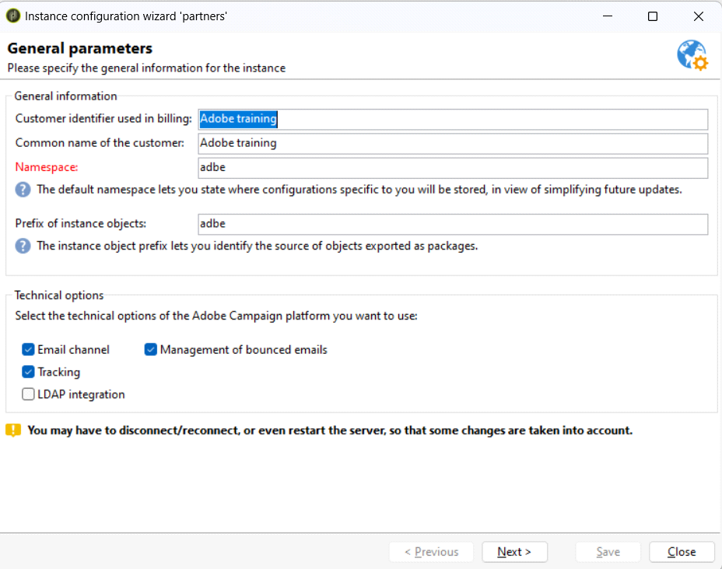

Others Page 84

**Message Center**

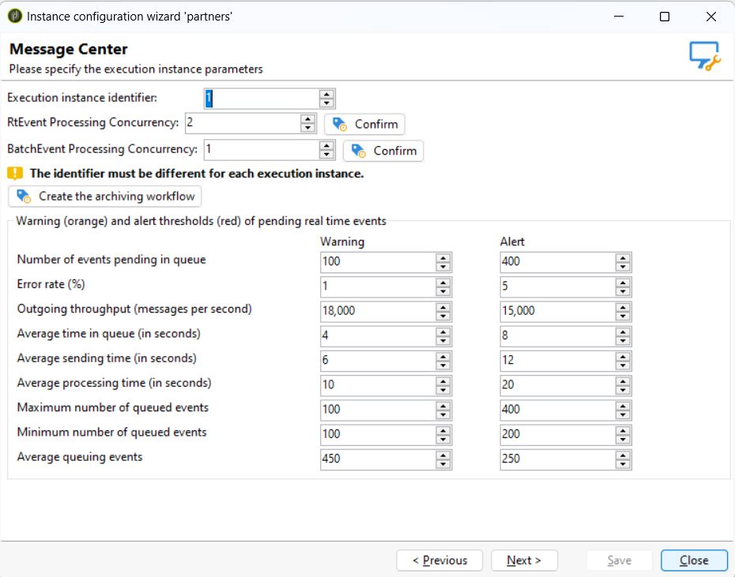

Email Channel

Others Page 85

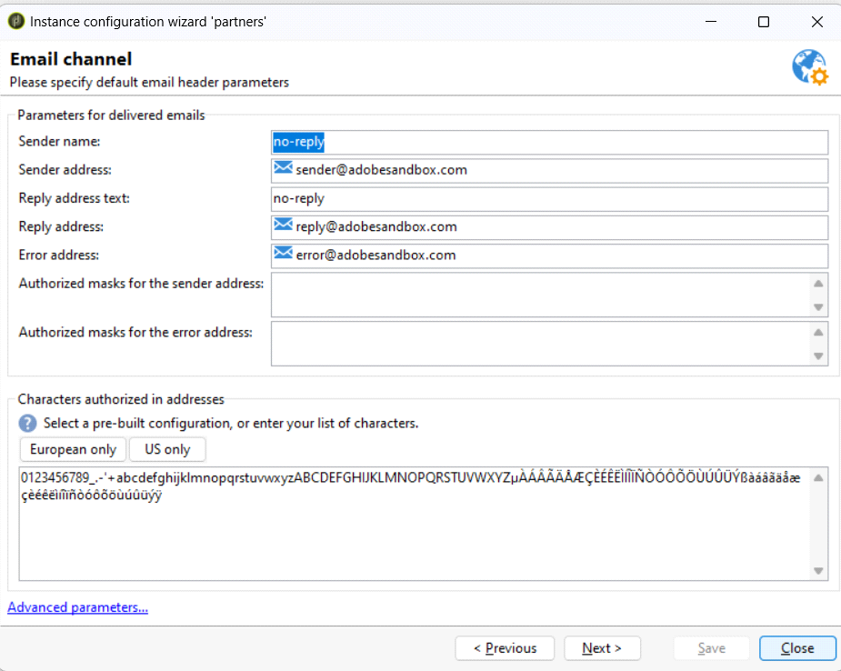

Management of Bounced Email

Others Page 86

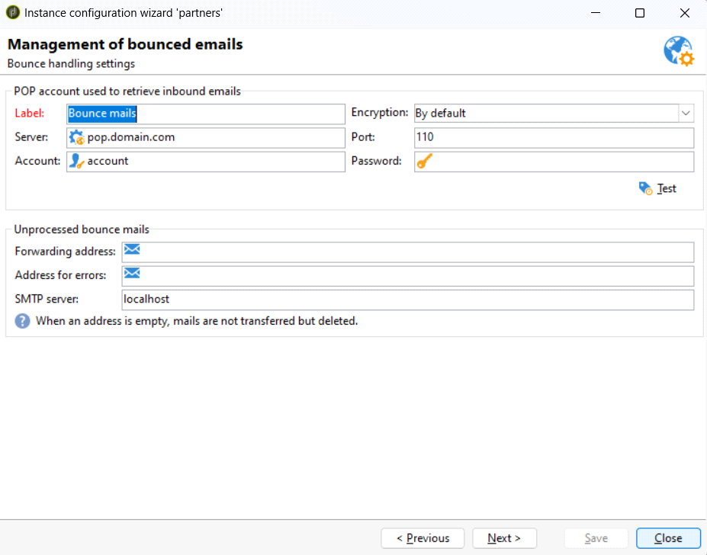

Tracking Configuration

Others Page 87

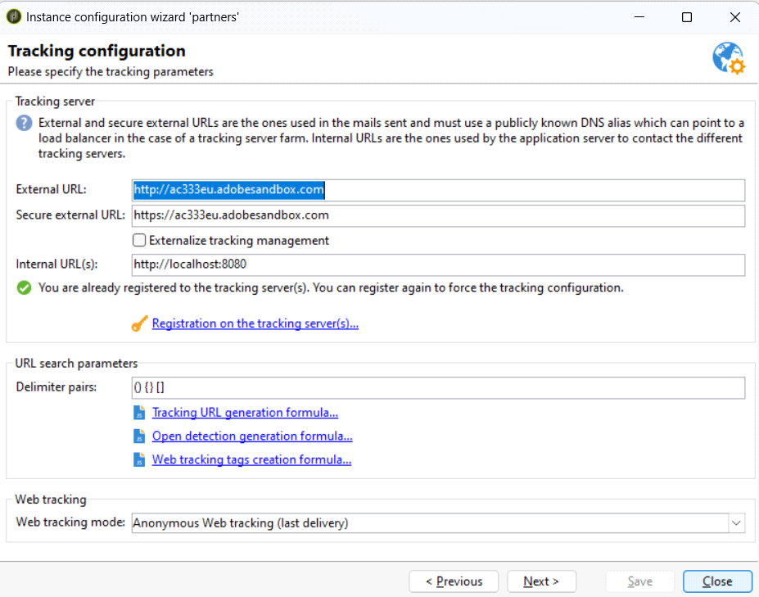

Mobile Channel

Others Page 88

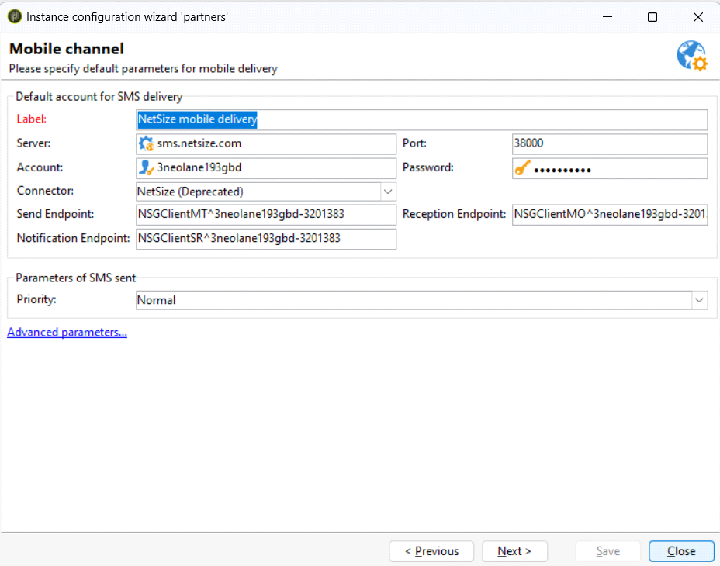

Direct Mail Channel

Others Page 89

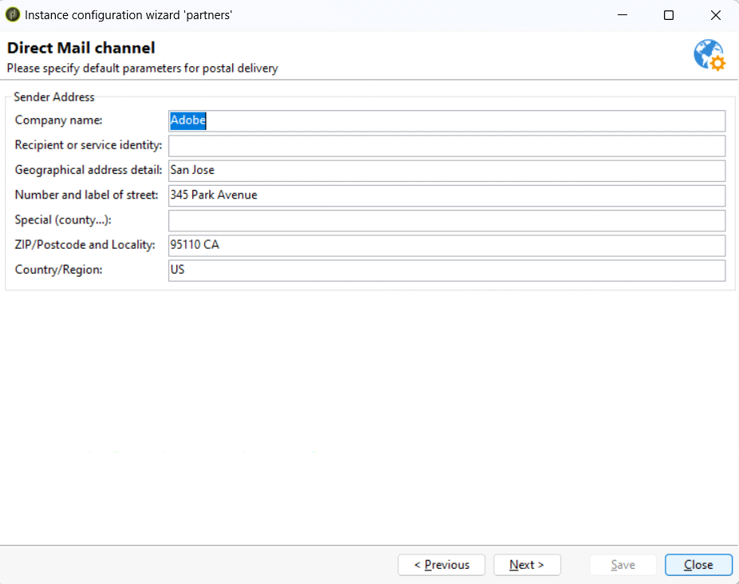

Regional Settings

Others Page 90

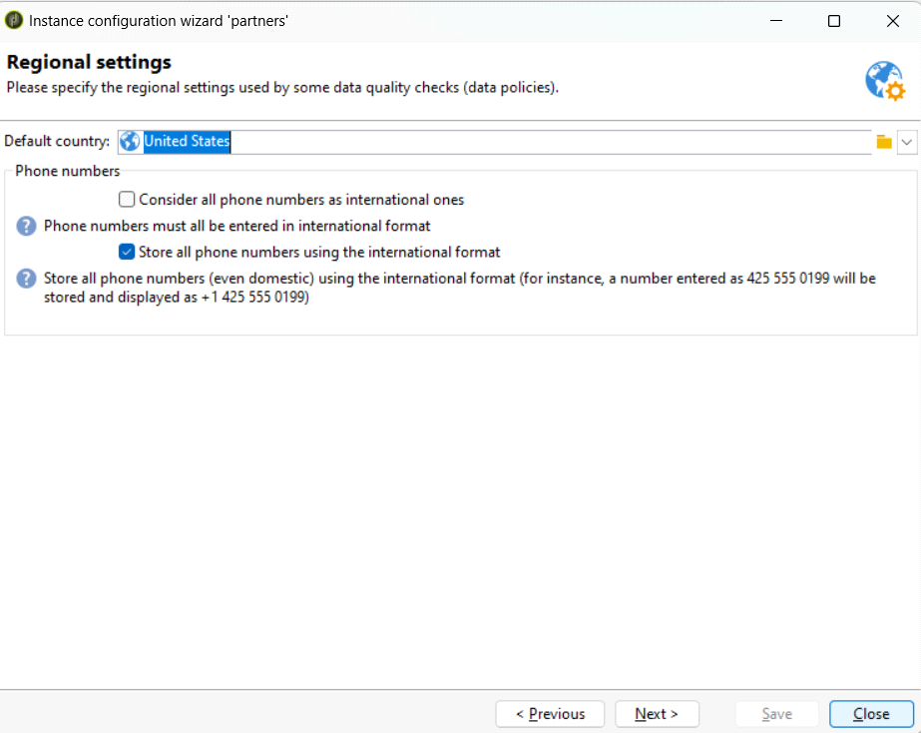

Access from the Internet

Others Page 91

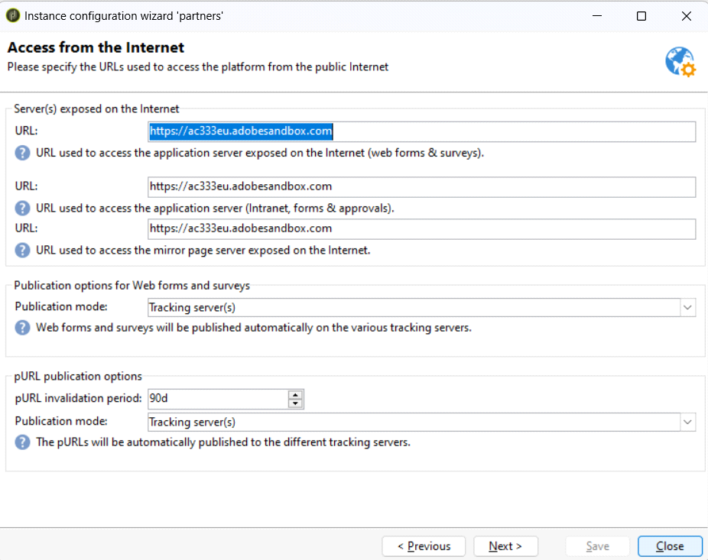

Public Resource Management

Others Page 92

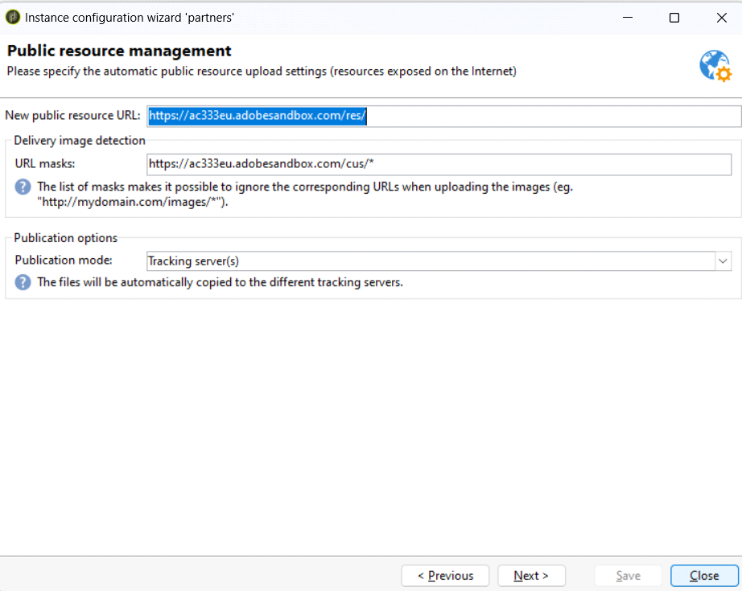

Purge Data

Others Page 93

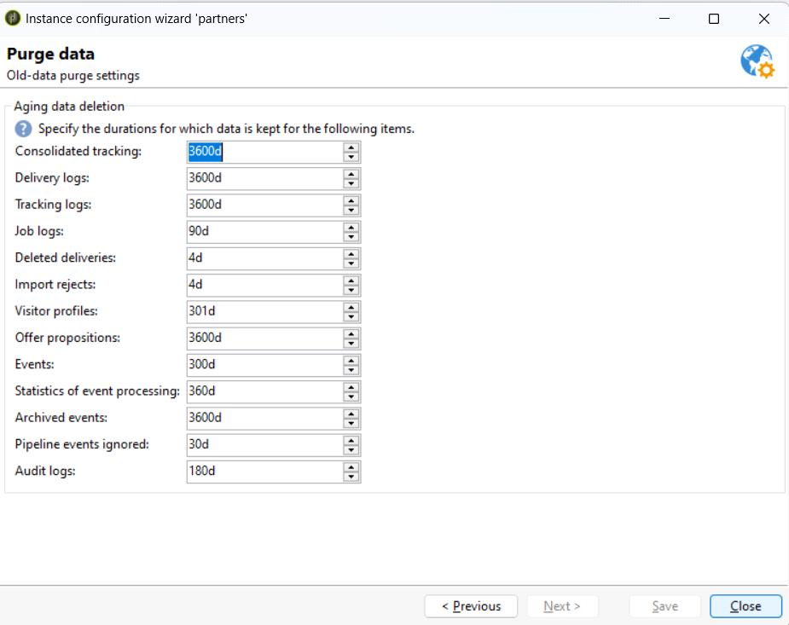

Others Page 94

Transactional Messaging / Real Time / Batch / Archived Events

Saturday, June 1, 2024 1:05 PM

Others Page 95

Context Variable (CTX)   
Saturday, June 1, 2024 1:07 PM

Others Page 96

Reconciliation   
Saturday, June 1, 2024 1:58 PM

Others Page 97

Add a Group of Users in a Separate IP for On Premises

Server - Configure Security Zone in Config.xml

Monday, June 3, 2024 10:14 AM



1. Create security zones in serverConf.xml or config-<instance>.xml.

2. Navigate to Administration > Platform > Enumerations, select the Security zone system   
enumeration, and add the name of the zone defined in the serverConf.xml file.

3. Select the operator to link a security zone to, go to the Access rights tab, click Edit access parameters, and select a zone from the Authorized connection zone.

From <[https://adobe.gmetrix.net/Tests/QuestionFeedback.aspx?resultId=152946429&questionId=453561](https://adobe.gmetrix.net/Tests/QuestionFeedback.aspx?resultId=152946429&questionId=453561&objectivepasspercentage=0)   
[&objectivepasspercentage=0](https://adobe.gmetrix.net/Tests/QuestionFeedback.aspx?resultId=152946429&questionId=453561&objectivepasspercentage=0)>

**Steps to follow according to AI**

**Create security zones in serverConf.xml or config-<instance>.xml**:

**Navigate to Administration > Platform > Enumerations, select the Security zone system**   
**enumeration, and add the name of the zone defined in the serverConf.xml file**:

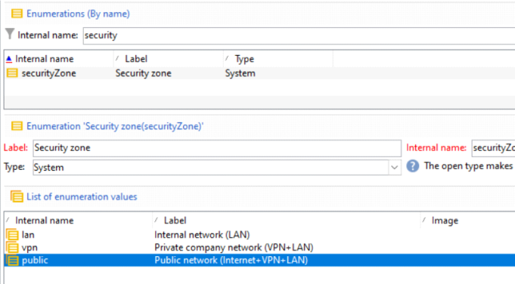

**Select the operator to link a security zone to, go to the Access rights tab, click Edit access**   
**parameters, and select a zone from the Authorized connection zone**:

**Steps**   
**Go to Operators**   
**Edit Tab**   
**Access Right Tab**

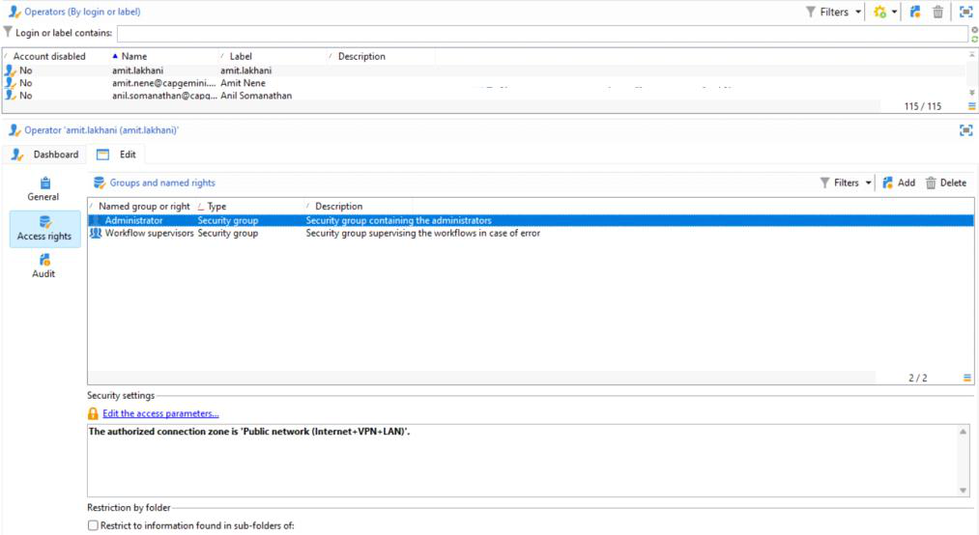

Others Page 98

**Click Edit the Access Parameter - Select the Security Zone**

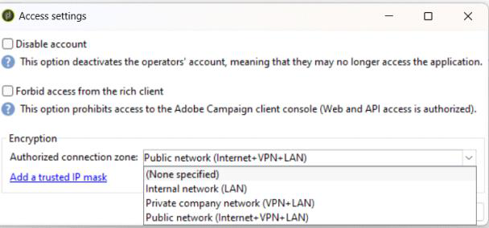

Others Page 99

Difference between File Transfer and Data Extraction

|  |  |
| --- | --- |
| Monday, June 3, 2024 | 10:27 AM |

|  |  |  |
| --- | --- | --- |
| **Aspect** | **File Transfer** | **Data Extraction** |
| Purpose | Moving files from one location to another | Retrieving specific data from a source |
| Functionality | Transfers files as they are | Extracts and formats data according to defined criteria |
| Source | Typically from a local system or network | Usually from a database or data repository |
| Destination | Can be any destination, including local or remote locations | Typically processed within the same system or sent to another system for further processing |
| Data Manipulation | Does not involve data manipulation, only moving files | Involves selecting and formatting specific data according to criteria |
| Format Conversion | Does not involve conversion of data formats | May involve conversion of data formats (e.g., from database format to CSV) |
| Trigger | Can be scheduled or initiated manually | Often triggered by a scheduled task or in response to an event |
| Example Use Case | Uploading a report to a remote server | Extracting customer data from a database for analysis |
| Tool Examples | Secure File Transfer Protocol (SFTP), File Transfer Protocol (FTP) | SQL queries, ETL (Extract, Transform, Load) tools |

Others Page 100

PostEvent -  
How to trigger a External Signal from Javascript

Monday, June 3, 2024 10:34 AM

How to trigger a External Signal of a workflow from Javascript

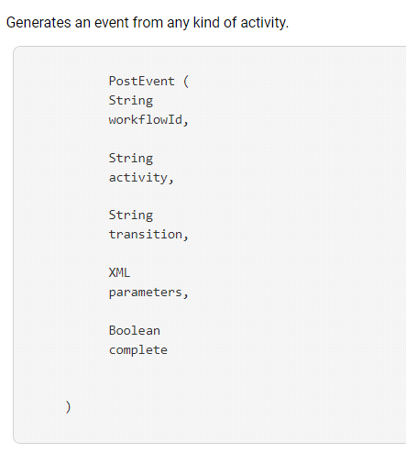

**Sample Script**

var Key = "GOLD FISH";

xtk.workflow.PostEvent("TestBatchFileExt", "signal", "", Key, false);

Others Page 101

Dates Terminologies

|  |  |
| --- | --- |
| Monday, June 3, 2024 | 10:43 AM |

|  |  |
| --- | --- |
| **Terminology** | **Description** |
| **ToDate(@created)** | Converts a value to a date format. |
| **@created** | Represents a field storing the creation date or timestamp of a record. |
| **DaysAgo(7)** | Calculates the date that occurred 7 days ago from the current date. |
| **DateOnly(@created )** | Extracts only the date part from a date-time value, removing the time component. |
| **on or before** | Specifies a condition where the date is on or before a certain point in time. |
| **after** | Specifies a condition where the date is after a certain point in time. |

Others Page 102

Delivery related Workflows

|  |  |
| --- | --- |
| Monday, June 3, 2024 | 10:49 AM |

|  |  |
| --- | --- |
| **Workflow Name** | **Description** |
| Tracking (tracking) | Responsible for tracking and recording delivery-related events such as opens, clicks, and bounces. |
| Recipient Delivery Logs (recipientDeliveryLogs) | Manages logs of delivery-related activities for individual recipients. |
| Delivery Tracking (deliveryTracking) | Focuses specifically on tracking the delivery progress of emails and other messages. |
| Delivery Indicators (deliveryIndicators) | Handles updating and managing delivery-related indicators and metrics. |
| Delivery Optimization (deliveryOptimization) | Used to optimize the delivery process, ensuring messages are sent efficiently and effectively. |
| Delivery Notifications (deliveryNotifications) | Manages notifications related to the delivery process, such as delivery confirmations or alerts. |
| Delivery Scheduling (deliveryScheduling) | Handles the scheduling of deliveries, allowing users to specify the timing and frequency of deliveries |

Others Page 103

OOTB / Technical Workflow of Adobe Campaign Classic

|  |  |
| --- | --- |
| Monday, June 3, 2024 | 10:58 AM |

|  |  |
| --- | --- |
| **Delivery:** |  |
|  |  |
| **Workflow Name (Internal) - Workflow Name** | **Description** |
| aliasCleansing - Alias Cleansing | Standardizes enumeration values. Triggered daily at 3am. |
| billing - Billing | Sends system activity report to 'billing' operator by email. Triggered monthly on 25th. |
| forecasting - Forecasting | Analyzes deliveries saved in provisional calendar. Triggered every day at 1am. |
| cleanup - Database Cleanup | Deletes obsolete data from the database. Triggered daily at 4am. |
| refreshDeliverability - Refresh for Deliverability | Manages bounce emails qualification rules and domain lists. Triggered nightly. |
| offerNotification - Offer Notification | Deploys approved offers onto the online environment, as well as every category contained in the offer catalog. |
| cleanupPausedWorkflows - Paused Workflows Cleanup | Analyzes paused workflows and triggers warnings and notifications when they have been paused for too long. |
|  |  |
| **Social Marketing:** |  |
|  |  |
| **Workflow Name (Internal) - Workflow Name** | **Description** |
| statsTwitter - Calculation of Twitter Statistics | Calculates statistics linked to retweets and visits on Twitter. |
| syncFacebookFans - Synchronizing Facebook Fans | Imports Facebook fans into Adobe Campaign daily at 7am. |
| syncFacebook - Synchronizing Facebook Pages | Synchronizes Facebook pages with Adobe Campaign daily at 7am. |
| syncTwitter - Synchronizing Twitter Pages | Imports X followers into Adobe Campaign daily at 7am. |
|  |  |
| **Privacy Data Protection Regulation:** |  |
|  |  |
| **Workflow Name (Internal) - Workflow Name** | **Description** |
| collectPrivacyRequests - Collect Privacy Requests | Generates recipient’s data stored in Adobe Campaign for download. |
| deletePrivacyRequestsData - Delete Privacy Requests Data | Deletes the recipient’s data stored in Adobe Campaign. |
| cleanupPrivacyRequests - Privacy Request Cleanup | Erases access request files that are older than 90 days. |
|  |  |
| **Web Analytics Connectors:** |  |
|  |  |
| **Workflow Name (Internal) - Workflow Name** | **Description** |
| webAnalyticsPurgeWebEvents - Event Purge | Deletes every event from the database field according to the period configured in the Lifespan field. |
| webAnalyticsFindConverted - Identification of Converted Contacts | Indexes site visitors who have completed their purchase after a re-marketing campaign. |
| webAnalyticsGetWebEvents - Recovery of Web Events | Downloads segments on internet user behavior on a given site, puts them into the Adobe Campaign database, and launches the re -marketing workflow. |
| webAnalyticsSendMetrics - Sending of Indicators and Campaign Attributes | Sends email campaign indicators from Adobe Campaign to Adobe Experience Cloud Suite via the Adobe® Analytics connector. |
|  |  |
| **Mobile App Channel:** |  |
|  |  |
| **Workflow Name (Internal) - Workflow Name** | **Description** |
| mobileAppOptOutMgt - NMAC opt-out management | Updates notification unsubscriptions on mobile devices. Triggered every 6 hours between 1am and midnight. |
|  |  |
| **Offer Engine:** |  |
|  |  |
| **Workflow Name (Internal) - Workflow Name** | **Description** |
| agg_nmspropositionrcp_full - Full Aggregate Calculation | Updates the Full aggregate for the Offer proposition cube. Triggered every day at 6am. |
| propositionSynch - Proposition Synchronization | Synchronizes propositions between the marketing instance and the execution instance used for interactions. |
|  |  |
| **Transactional Message Control:** |  |
|  |  |
| **Workflow Name (Internal) - Workflow Name** | **Description** |
| mcSynch_<external_account_name> - Message Center Workflow | Manages various operations related to message center. |
| agg_messageCenter_full - MessageCenter Full Aggregate Calculation | Updates the Full aggregate for the Message center cube. Triggered every day at 3am. |
| batchEventsProcessing - Processing Batch Events | Puts batch events into a queue before associating them with a message template. |
| rtEventsProcessing - Processing Real Time Events | Puts real-time events into a queue before associating them with a message template. |
| updateEventsStatus - Update Event Status | Assigns status to events. |
|  |  |
| **Transfer to Mid-sourcing:** |  |
|  |  |
| **Workflow Name (Internal) - Workflow Name** | **Description** |
| defaultMidSourcingDlv - Mid-sourcing Delivery Counters | Collects count information for deliveries on the mid-sourcing server. Triggered every ten minutes by default. |
| defaultMidSourcingLog - Mid-sourcing Delivery Logs | Collects delivery logs on the mid-sourcing server. Triggered every hour by default. |
|  |  |
| **Marketing Resource Management:** |  |
|  |  |
| **Workflow Name (Internal) - Workflow Name** | **Description** |
| newsgroupMgt - Discussion Forum Processes | Manages the delivery of notifications from discussion forums. Triggered when an approval signal is received. |
| assetMgt - Marketing Resource Notifications | Manages notifications linked to the approval and publication of marketing resources. |
|  |  |
| **LINE Channel:** |  |
|  |  |
| **Workflow Name (Internal) - Workflow Name** | **Description** |
| deleteBlockedLineUsersV2 - Delete Blocked LINE Users | Ensures that the LINE V2 users’ data is deleted after they have blocked the LINE official account for 180 days. |
| updateLineV2AccessToken - LINE V2 Access Token Update | Refreshes the access token to LINE V2. |
| MIDToUserIDMigration - MID to LineUserID Migration | Generates the LINE V2 users’ ID for migration from LINE V1 to LINE V2. |

Others Page 104

Schemas   
Thursday, May 30, 2024 3:11 PM

How to's Page 105

ADDING A INPUT FORM   
Thursday, May 30, 2024 8:43 AM

CONFIGURATION -> INPUT FORM



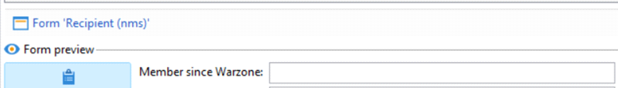

UPDATE COLUMN DATA THROUGH UI IN BULK

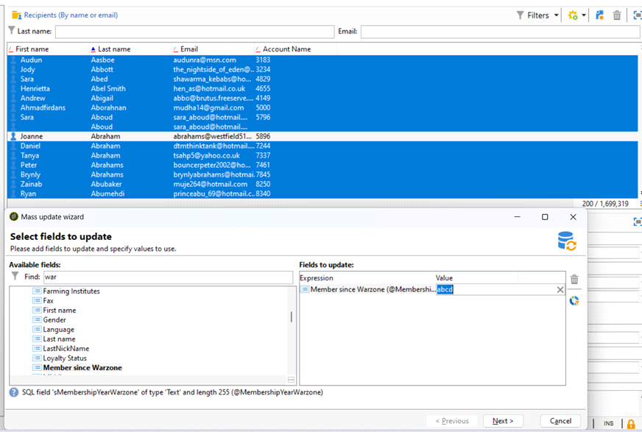

How to's Page 106

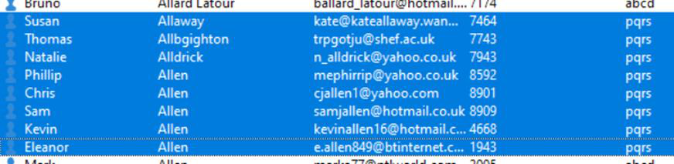

From <[https://capgemini-my.sharepoint.com/personal/amit-](https://capgemini-my.sharepoint.com/personal/amit-umedali_lakhani_capgemini_com/Documents/Documents/ACC%20Certification%20Preparation/2.%20Customization.docx)

[umedali_lakhani_capgemini_com/Documents/Documents/ACC%20Certification%20Preparation/2.%](https://capgemini-my.sharepoint.com/personal/amit-umedali_lakhani_capgemini_com/Documents/Documents/ACC%20Certification%20Preparation/2.%20Customization.docx)

[20Customization.docx](https://capgemini-my.sharepoint.com/personal/amit-umedali_lakhani_capgemini_com/Documents/Documents/ACC%20Certification%20Preparation/2.%20Customization.docx)>

How to's Page 107

MASS UPDATE OF DATA THROUGH UI

Thursday, May 30, 2024 3:32 PM

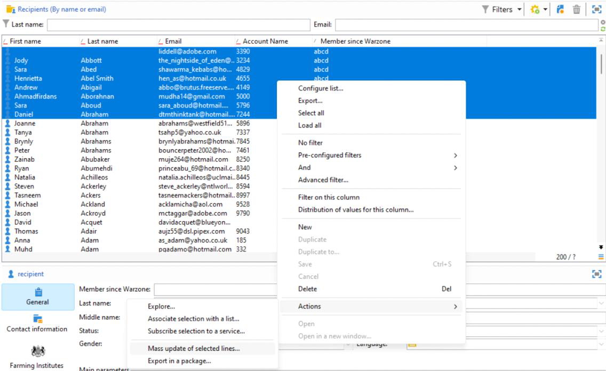

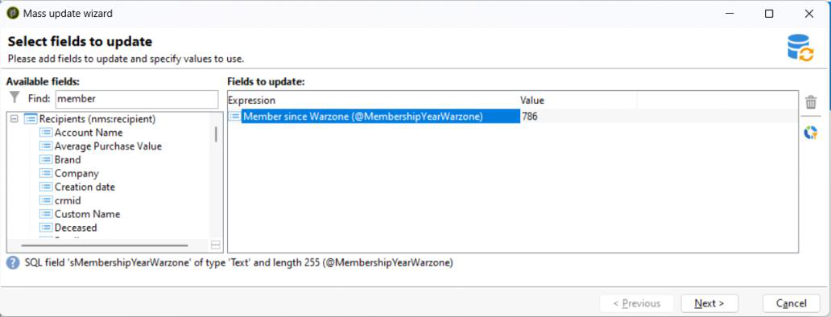



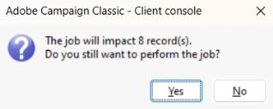

How to's Page 108

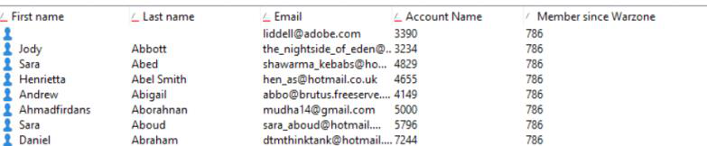

How to's Page 109

How to Add Context Menu Here Saturday, June 1, 2024 10:09 AM

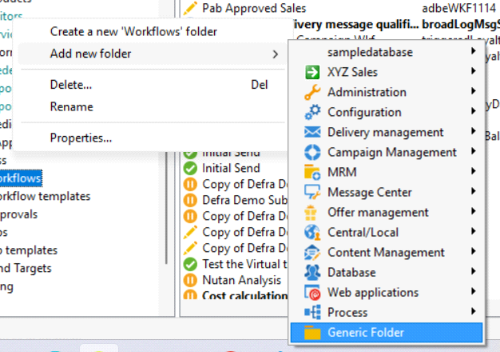

How to's Page 110

How to create a Folder into View

Saturday, June 1, 2024 1:09 PM

View - A view is a specific folder which does not contain any data but displays data that is physically stored in other folders of the same type.

From <<https://experienceleague.adobe.com/en/docs/campaign/campaign-v8/config/configuration/folders-and-views>>

Go to Properties

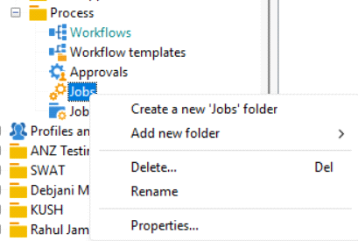

Go to Restriction Tab   
This Folder is a View : Yes   
Set the Conditions

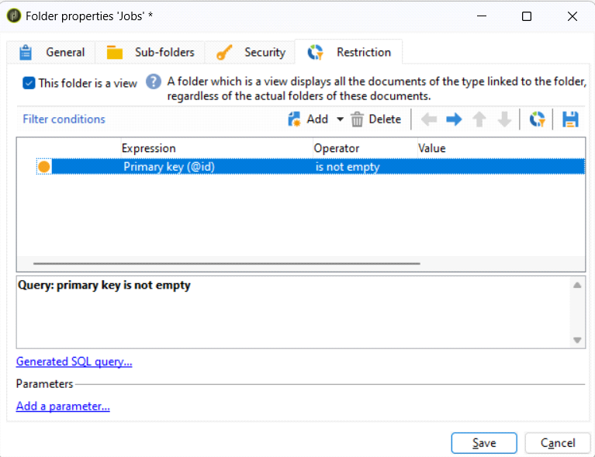

Click Save

How to's Page 111

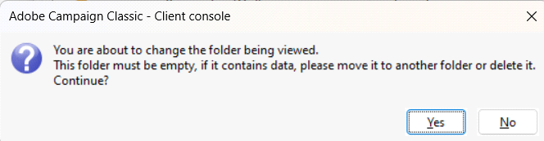

Yes   
Done

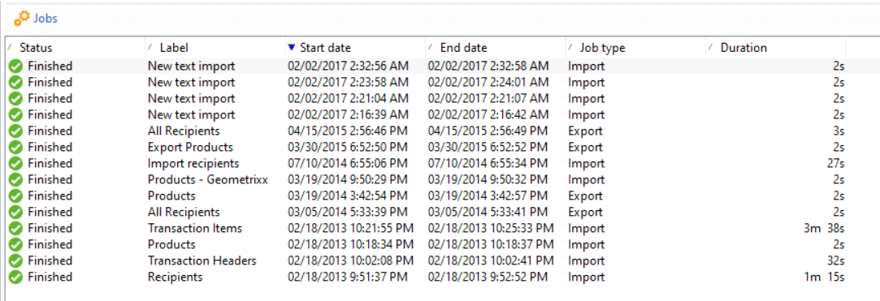

How to's Page 112

Create a new Database   
Saturday, June 1, 2024 5:22 PM

Create Database

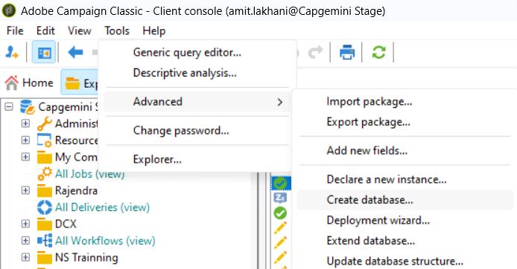

Selecting the Database Engine

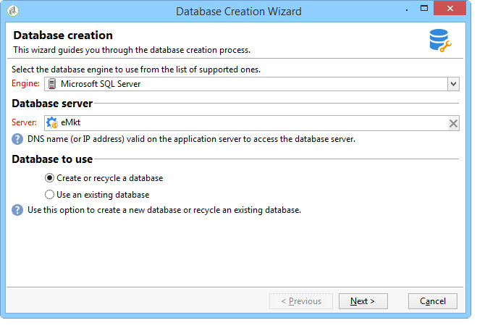

Connecting to the Database

How to's Page 113

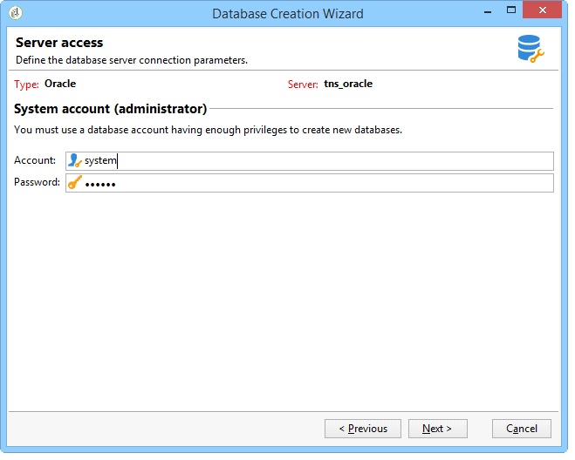

Additional Configurations

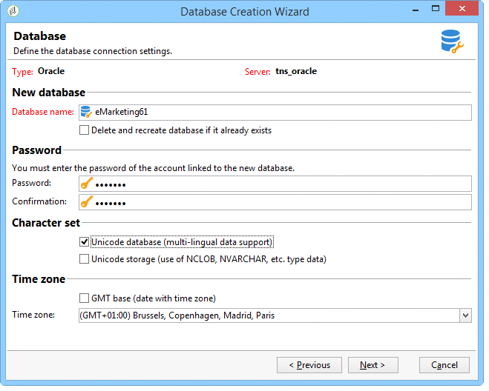

Installing the Package

How to's Page 114

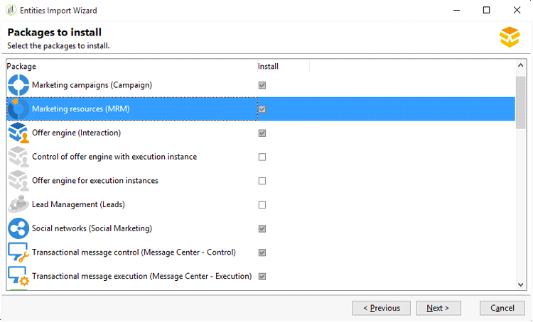

Additional Configurations

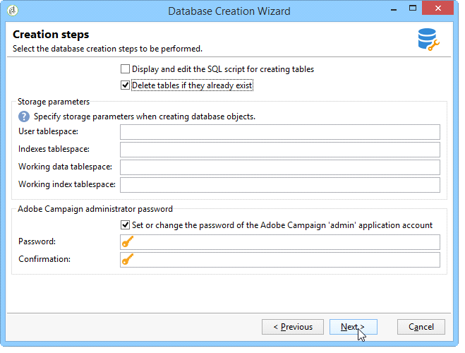

Creating the Database

How to's Page 115

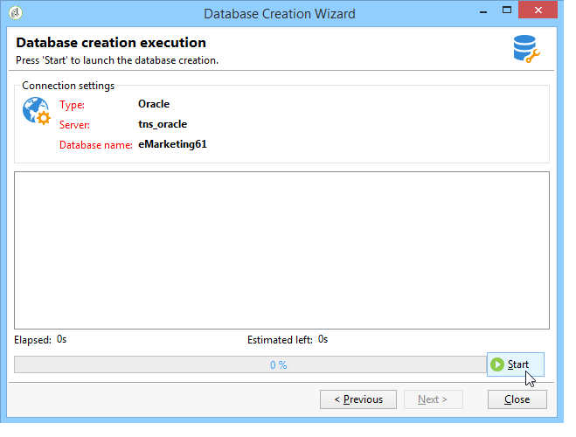

How to's Page 116

Create a New Instance   
Saturday, June 1, 2024 5:22 PM

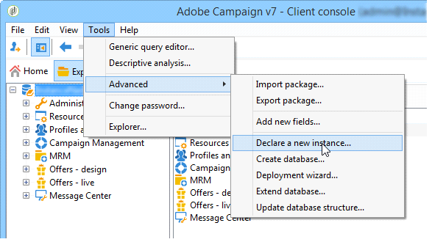

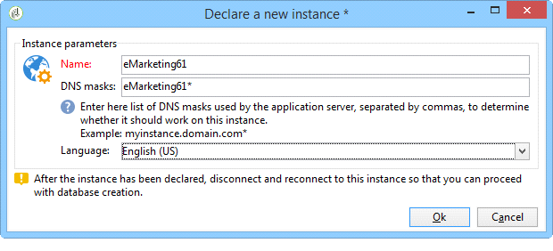

How to's Page 117

How to Login to Client Console   
Saturday, June 1, 2024 5:24 PM

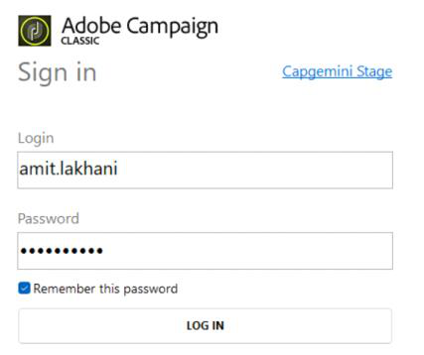

Create Connections

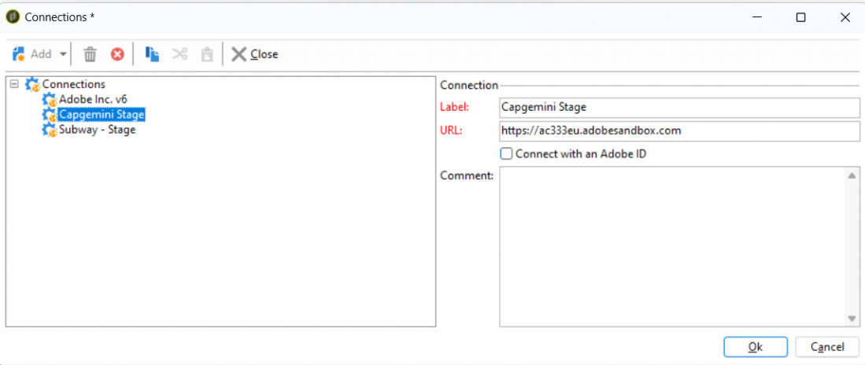

Login Successful

How to's Page 118

EXTEND A SCHEMA   
Thursday, May 30, 2024 8:43 AM

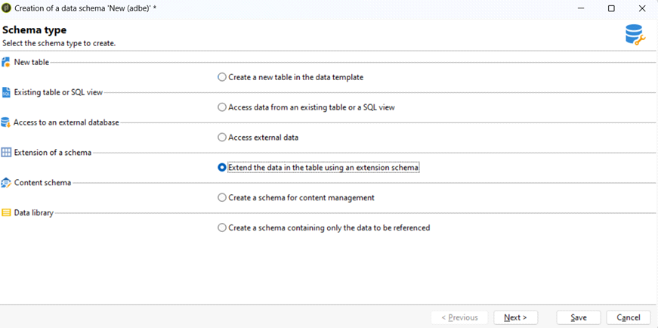

DO NOT CHANGE ANYTHING OTHER THAN NAMESPACE (OPTIONAL)

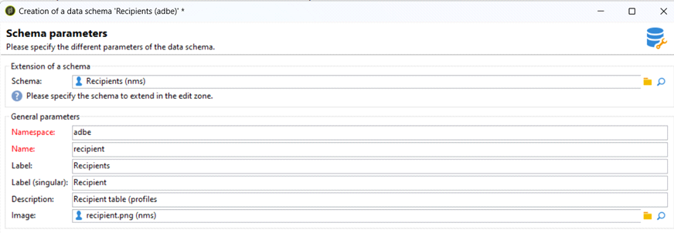

ADDED NEW COLUMNS   
DELETED 1 COLUMNS

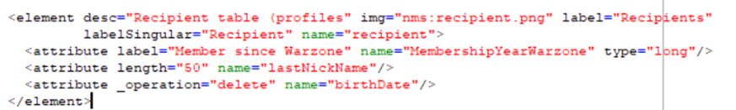

How to's Page 119

ALL THESE CHANGES TAKES PLACE IN ORIGINAL SCHEMA   
THEN…. UPDATEDATABASESTRUCTURE



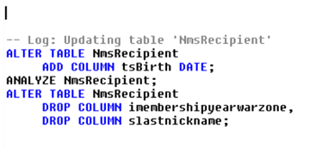

From <[https://capgemini-my.sharepoint.com/personal/amit-](https://capgemini-my.sharepoint.com/personal/amit-umedali_lakhani_capgemini_com/Documents/Documents/ACC%20Certification%20Preparation/2.%20Customization.docx)

[umedali_lakhani_capgemini_com/Documents/Documents/ACC%20Certification%20Preparation/2.%](https://capgemini-my.sharepoint.com/personal/amit-umedali_lakhani_capgemini_com/Documents/Documents/ACC%20Certification%20Preparation/2.%20Customization.docx)

[20Customization.docx](https://capgemini-my.sharepoint.com/personal/amit-umedali_lakhani_capgemini_com/Documents/Documents/ACC%20Certification%20Preparation/2.%20Customization.docx)>

How to's Page 120

QueryDef Javascript

Saturday, June 1, 2024 10:10 AM

**queryDef operation =”select” Query**   
Zero or more elements are returned as a collection.

var m = 'Chris';

var xml = <queryDef schema="nms:recipient" operation="select">

<select>  
 <node expr="@firstName"/>  
 <node expr="@lastName"/>  
 <node expr="@email"/>  
 <node expr="@gender"/>  
 </select>

<orderBy>  
 <node expr="@lastName" sort="1"/>  
 </orderBy>

<where>  
 <condition boolOperator="AND" expr="@email IS NOT NULL"/> <condition expr="@gender = 1"/>  
 </where>   
</queryDef>

var query = xtk.queryDef.create(xml);   
var res = query.ExecuteQuery();

for each (var r in res.recipient)

|  |  |
| --- | --- |
| { | if(r.@firstName == m) |

{  
 logInfo(r.@firstName +" "+r.@lastName);

|  |  |
| --- | --- |
| } | } |

--------------------------------------------------------------------------------------------------------------------

**queryDef operation = get / getIfExists Query**   
**get->** One element is returned. If no match element exists, then an **error** is returned. **getIfExists ->** One element is returned. If no match element exists, then an **empty** element is returned.

var xml = <queryDef schema="nms:recipient" operation="get">

<select>  
 <node expr="@firstName"/>  
 <node expr="@lastName"/>  
 <node expr="@email"/>  
 <node expr="@gender"/>  
 </select>

<where>  
 <condition boolOperator="AND" expr="@email IS NOT NULL"/> <condition expr="@email = 'chris.sandor@oohayyyy.com'"/> </where>

</queryDef>

var query = xtk.queryDef.create(xml);

var res = query.ExecuteQuery();

logInfo(res.@firstName);

How to's Page 121

--------------------------------------------------------------------------------------------------------------------**queryDef operation =”count ” Query**   
The number of matching records is returned in the form of an element with a count attribute.

var xml = <queryDef schema="nms:recipient" operation="count">

<where>  
 <condition expr="@email IS NOT NULL"/>  
 </where>

</queryDef>

var query = xtk.queryDef.create(xml);   
var res = query.ExecuteQuery();   
logInfo(res.@count);

----------------------------------------------------------------------------------------**InsertorUpdate Operation**

dxml = <recipient xtkschema="nms:recipient"  
 _operation="insertOrUpdate" _key="@email" lastName="Lennon"  
 firstName="John"  
 email=[johnlennon@thebeatles.com](mailto:johnlennon@thebeatles.com)   
/>

xtk.session.Write(dxml)

----------------------------------------------------------------------------------------**Delete Operation**

xtk.session.Write(  
 <recipient xtkschema="nms:recipient"  
 _operation="delete"  
 id={w.@id}/>

From

<[https://outlook.office.com/mail/id/AAMkAGI0Yjk1YzFhLTI2ZjEtNDBjMS1iMWI5LWQ5YTNjNDdhNThlMwBGAAAAAABZ9eS](https://outlook.office.com/mail/id/AAMkAGI0Yjk1YzFhLTI2ZjEtNDBjMS1iMWI5LWQ5YTNjNDdhNThlMwBGAAAAAABZ9eSuYMPvQKoF%2B4liKLsSBwDUNhtIwMavRIOdiC70keMiAAAAAAEJAADUNhtIwMavRIOdiC70keMiAABnxUOwAAA%3D?nativeVersion=1.2024.516.100)

[uYMPvQKoF%2B4liKLsSBwDUNhtIwMavRIOdiC70keMiAAAAAAEJAADUNhtIwMavRIOdiC70keMiAABnxUOwAAA%3D?](https://outlook.office.com/mail/id/AAMkAGI0Yjk1YzFhLTI2ZjEtNDBjMS1iMWI5LWQ5YTNjNDdhNThlMwBGAAAAAABZ9eSuYMPvQKoF%2B4liKLsSBwDUNhtIwMavRIOdiC70keMiAAAAAAEJAADUNhtIwMavRIOdiC70keMiAABnxUOwAAA%3D?nativeVersion=1.2024.516.100)

[nativeVersion=1.2024.516.100](https://outlook.office.com/mail/id/AAMkAGI0Yjk1YzFhLTI2ZjEtNDBjMS1iMWI5LWQ5YTNjNDdhNThlMwBGAAAAAABZ9eSuYMPvQKoF%2B4liKLsSBwDUNhtIwMavRIOdiC70keMiAAAAAAEJAADUNhtIwMavRIOdiC70keMiAABnxUOwAAA%3D?nativeVersion=1.2024.516.100)>

How to's Page 122

UPDATE DATA   
Thursday, May 30, 2024 8:45 AM

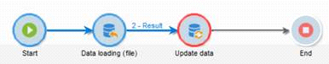

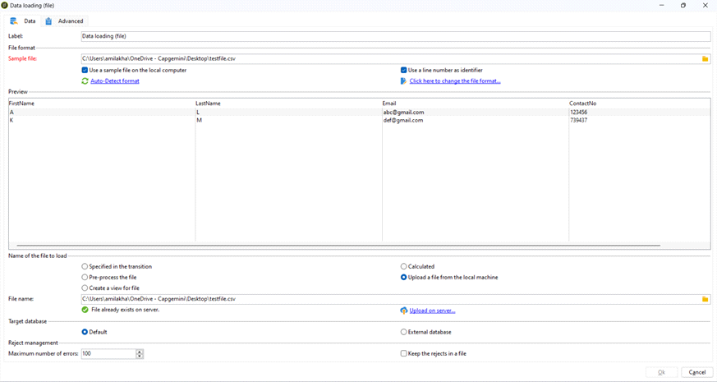

Note: Uploading on Server is Mandatory

How to's Page 123

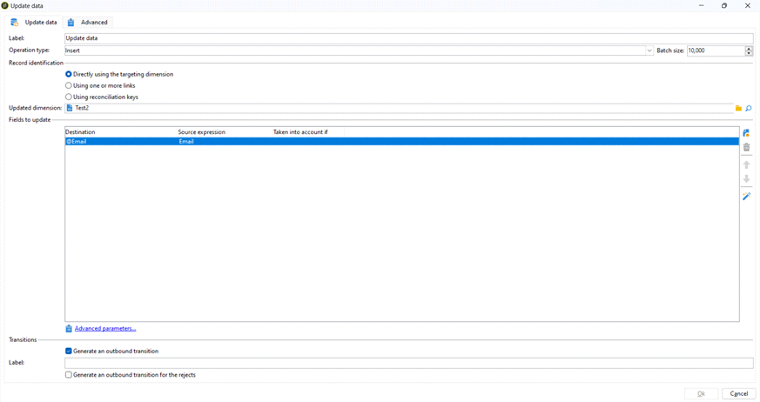

Note: Updated Dimension -> My Schema

**Extend a Schema and Add your own Attributes**

**Steps**   
Tools -> Advanced -> Update Database Structure

Delete Schema Data according to the Condition

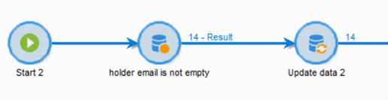

How to's Page 124

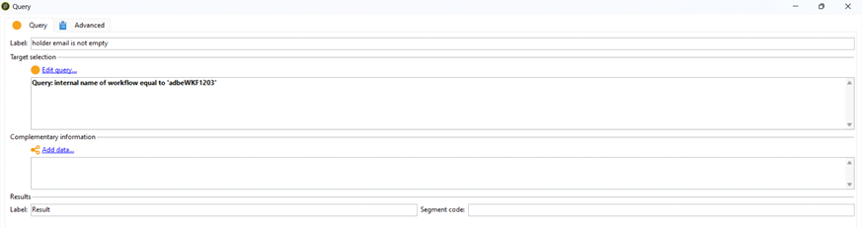

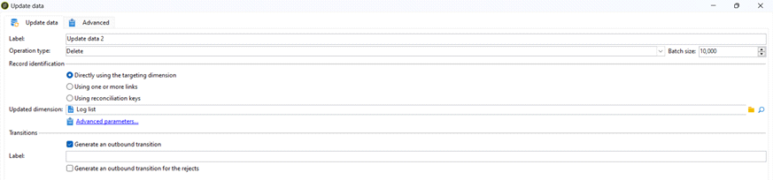

Update Data

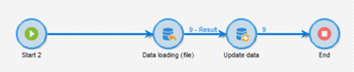

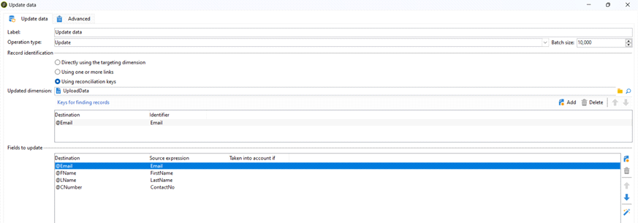

How to's Page 125

From <[https://capgemini-my.sharepoint.com/personal/amit-](https://capgemini-my.sharepoint.com/personal/amit-umedali_lakhani_capgemini_com/Documents/Documents/ACC%20Certification%20Preparation/1.%20System%20configuration.docx)  
[umedali_lakhani_capgemini_com/Documents/Documents/ACC%20Certification%20Preparation/1.%20System% 20configuration.docx](https://capgemini-my.sharepoint.com/personal/amit-umedali_lakhani_capgemini_com/Documents/Documents/ACC%20Certification%20Preparation/1.%20System%20configuration.docx)>

How to's Page 126

CREATE SCHEMA

Thursday, May 30, 2024 8:45 AM

**Create a Schema with autopk**

<srcSchema _cs="Test2 (cus)" created="2024-04-30 10:51:35.180Z" createdBy-id="0" entitySchema="xtk:srcSchema"  
 img="xtk:schema.png" label="Test2" lastModified="2024-04-30 13:24:21.960Z" mappingType="sql" md5="590EAB744838DA722E4E2159B4A36C96" modifiedBy-id="0" name="Test2" namespace="cus" xtkschema="xtk:srcSchema">  
 <createdBy _cs="amit.lakhani (amit.lakhani)"/>  
 <modifiedBy _cs="amit.lakhani (amit.lakhani)"/>

<element autopk="true" label="Test2" name="Test2">

<attribute label="Holder last name" name="LName" type="string"/> <attribute label="Holder first name" name="FName" type="string"/> <attribute label="Holder email" name="Email" type="string"/> <attribute label="Subscription date" name="SDate" type="date"/> <attribute label="Contract number" name="CNumber" type="long"/>

</element>   
</srcSchema>

**Create a Schema with Primary Key for Attribute**

<srcSchema _cs="Test1 (png)" created="2024-04-30 10:19:35.771Z" createdBy-id="0" entitySchema="xtk:srcSchema"  
 img="xtk:schema.png" label="Test1" lastModified="2024-04-30 13:21:55.926Z" mappingType="sql" md5="9064694ABFB69833EF1144583925F920" modifiedBy-id="0" name="Test1" namespace="png" xtkschema="xtk:srcSchema">  
 <createdBy _cs="amit.lakhani (amit.lakhani)"/>  
 <modifiedBy _cs="amit.lakhani (amit.lakhani)"/>

<element label="Test1" name="Test1">

<key internal="true" name="Email">  
 <keyfield xpath="@Email"/>  
 </key>

<attribute label="Holder last name" name="LName" type="string"/> <attribute label="Holder first name" name="FName" type="string"/> <attribute label="Holder email" name="Email" type="string"/> <attribute label="Subscription date" name="SDate" type="date"/> <attribute label="Contract number" name="CNumber" type="long"/>

</element>

</srcSchema>

How to's Page 127

From <[https://capgemini-my.sharepoint.com/personal/amit-](https://capgemini-my.sharepoint.com/personal/amit-umedali_lakhani_capgemini_com/Documents/Documents/ACC%20Certification%20Preparation/1.%20System%20configuration.docx)  
[umedali_lakhani_capgemini_com/Documents/Documents/ACC%20Certification%20Preparation/1.%20System% 20configuration.docx](https://capgemini-my.sharepoint.com/personal/amit-umedali_lakhani_capgemini_com/Documents/Documents/ACC%20Certification%20Preparation/1.%20System%20configuration.docx)>

How to's Page 128

IMPORT JOBS / EXPORT JOBS   
Thursday, May 30, 2024 3:38 PM

Export Jobs

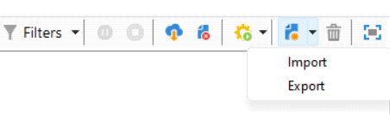

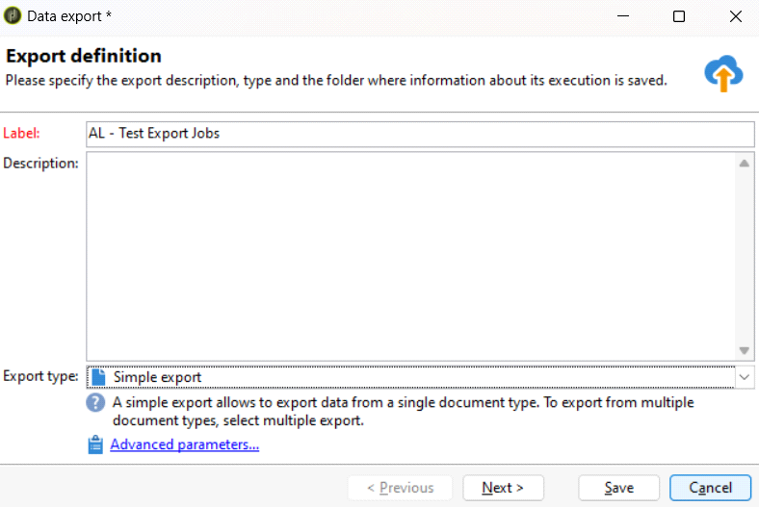

Select the Path and File Name where data needs to be stored

How to's Page 129

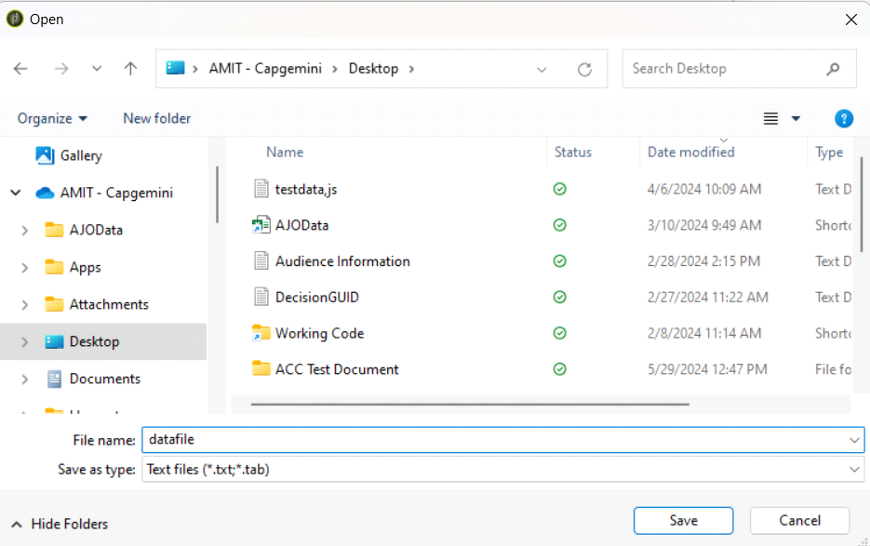

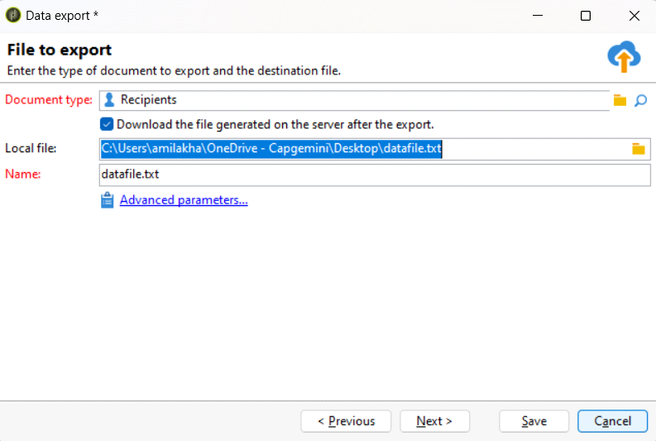

File Format Settings

How to's Page 130

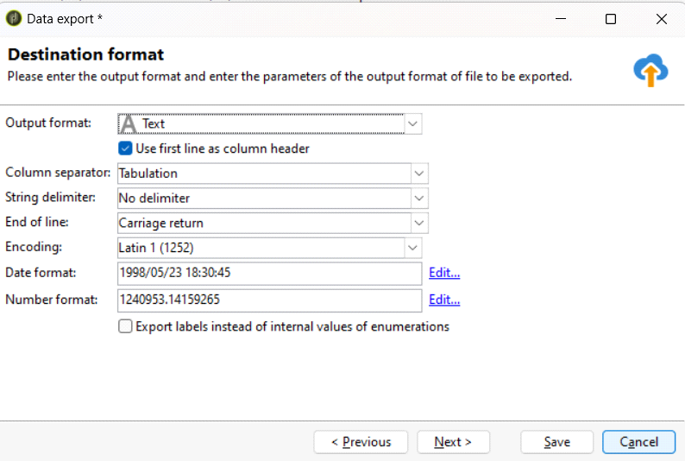

Select the Columns which needs to be Exported

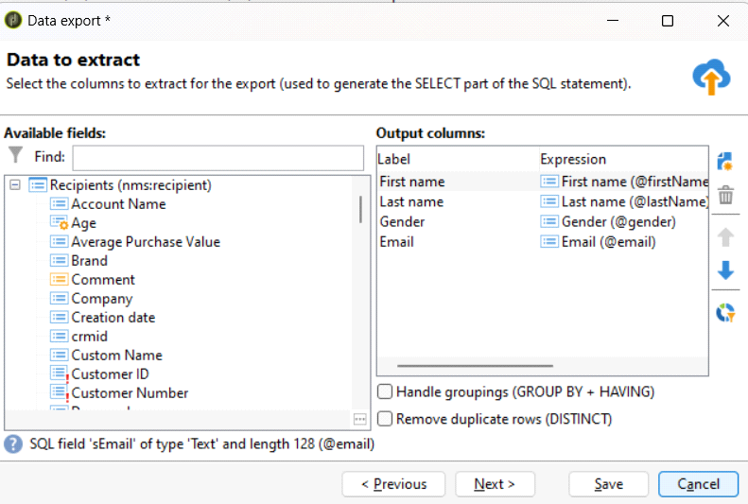

Sort the Data

How to's Page 131

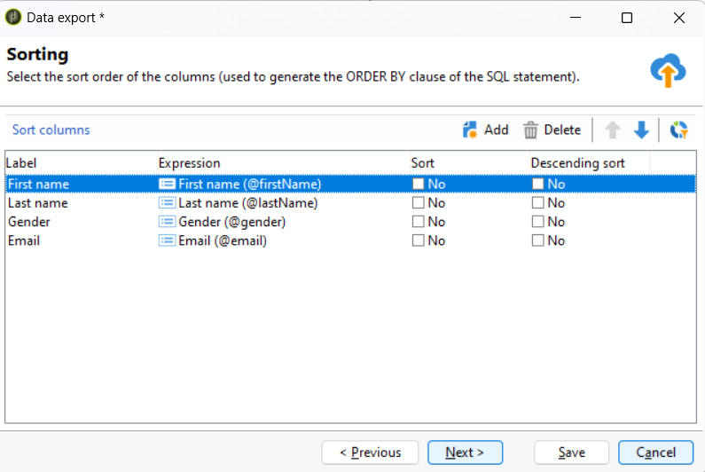

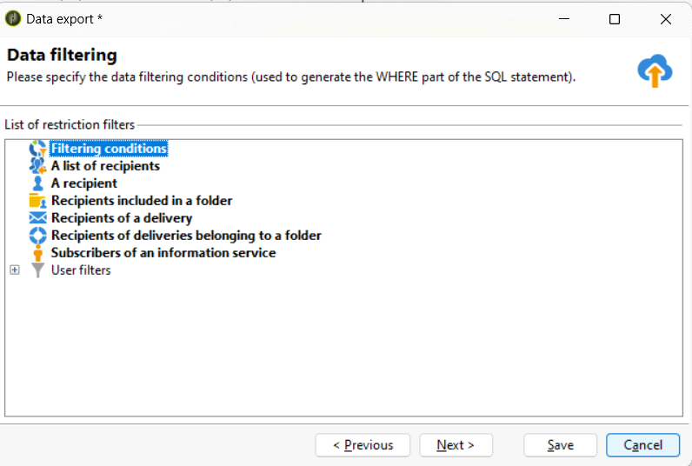

Set the Filtering Conditions

How to's Page 132

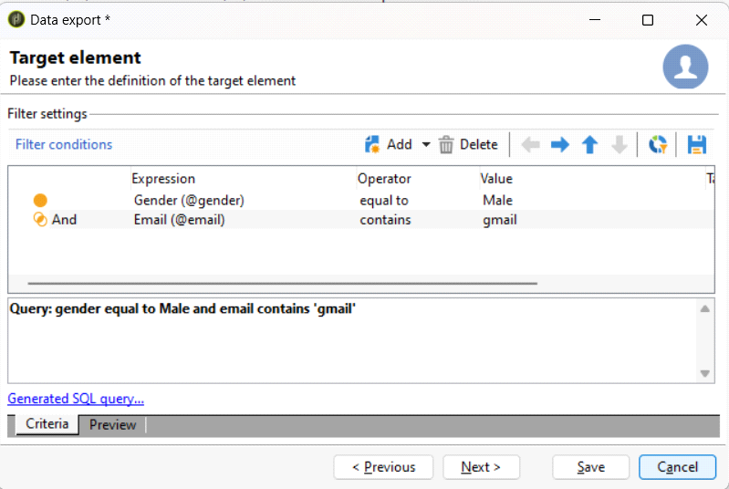

Preview the Data

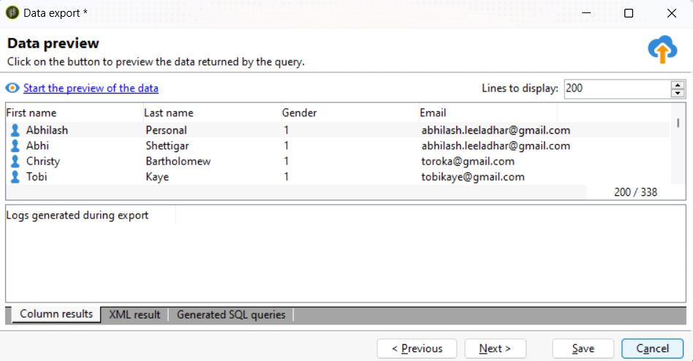

Start the Export - Some Unknown Issue

How to's Page 133

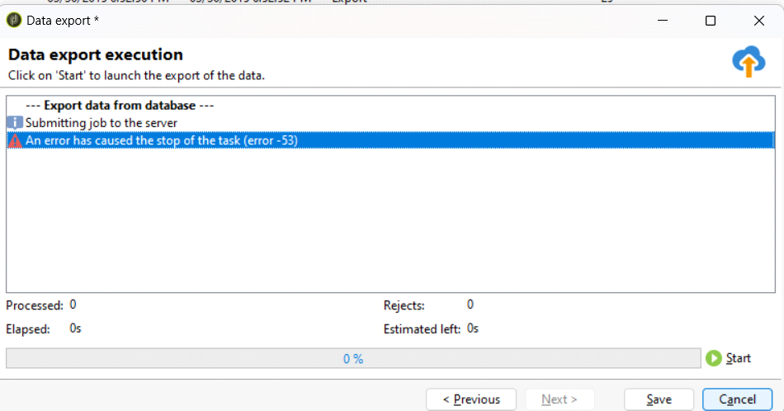

**IMPORT JOBS**

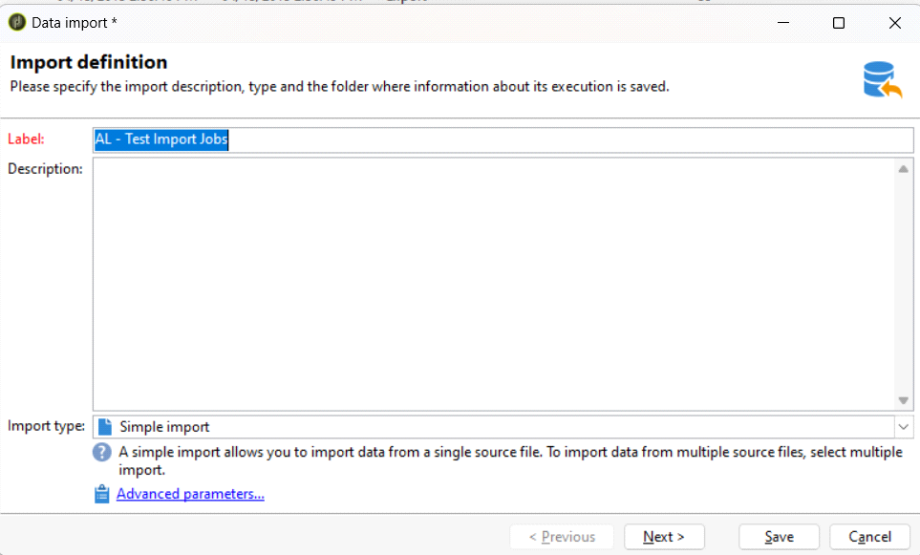

**Sample Data File**

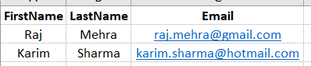

How to's Page 134

**Choosing the File for Importing the Data**

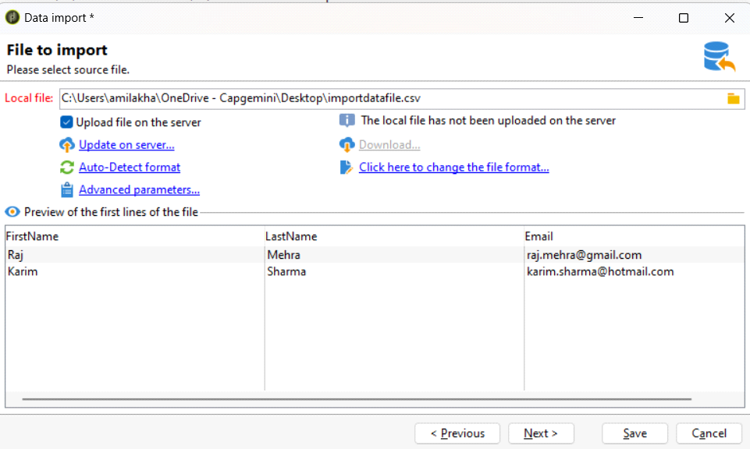

**Schema Selection & Field Mapping**

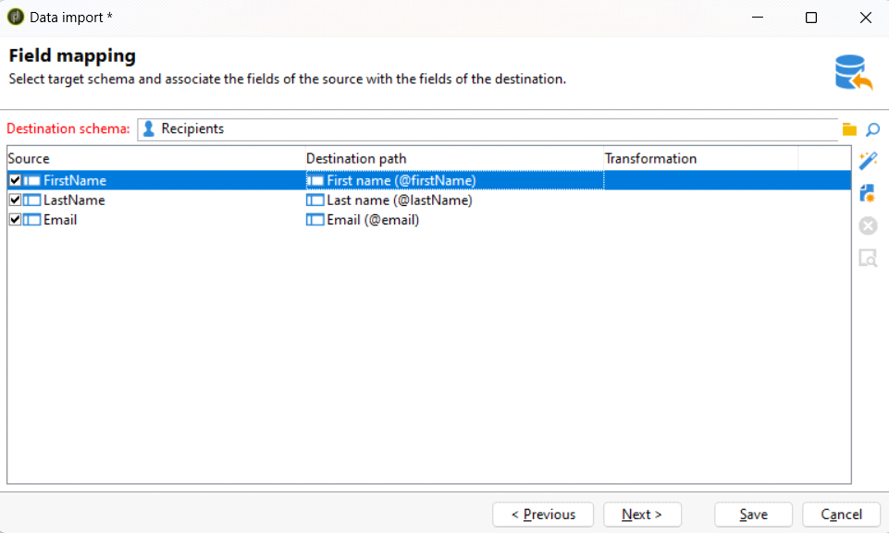

**Reconciliation**

How to's Page 135

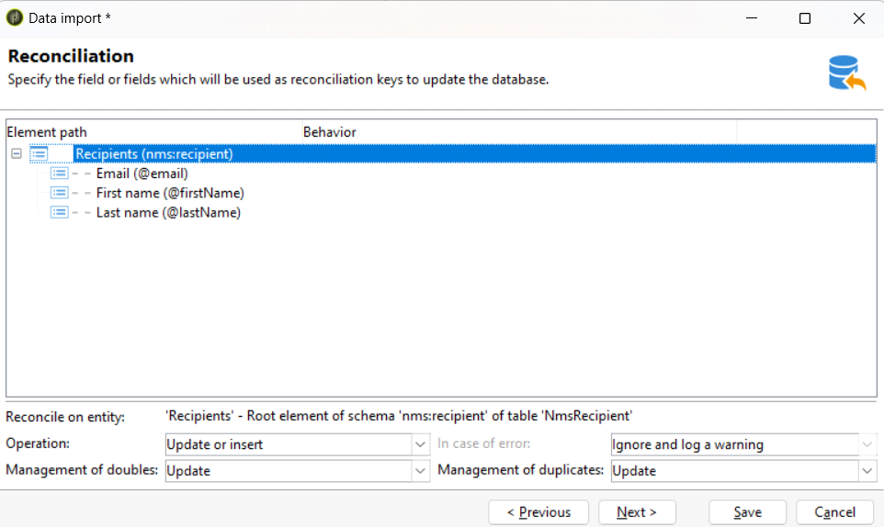

**Import Recipients**

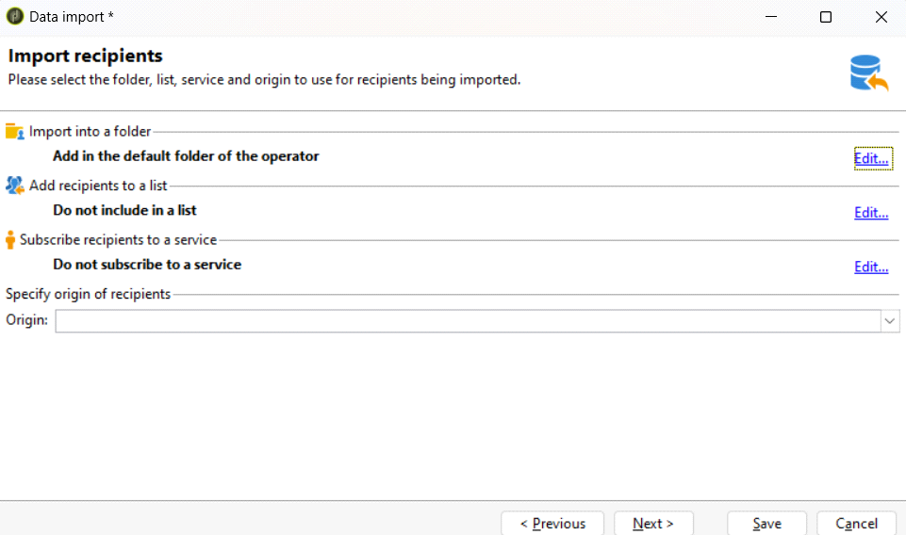

**Data Import Execution**

How to's Page 136

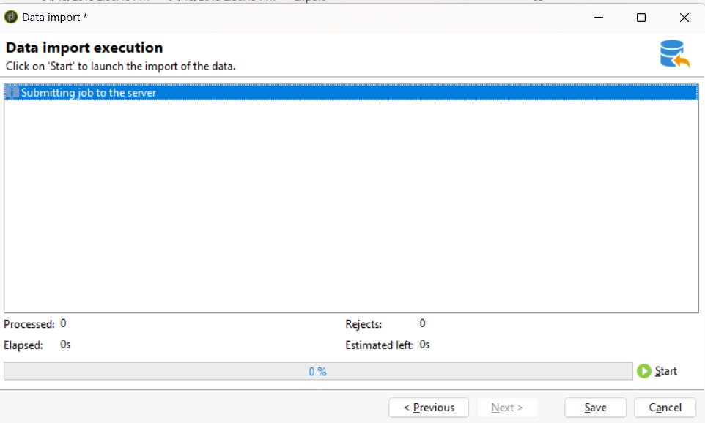

How to's Page 137

INPUT FORMS

Thursday, May 30, 2024 3:39 PM

Input Form - Interface which provides options to manually Add or Update Data in the Schema   
through UI

**EDIT TAB**

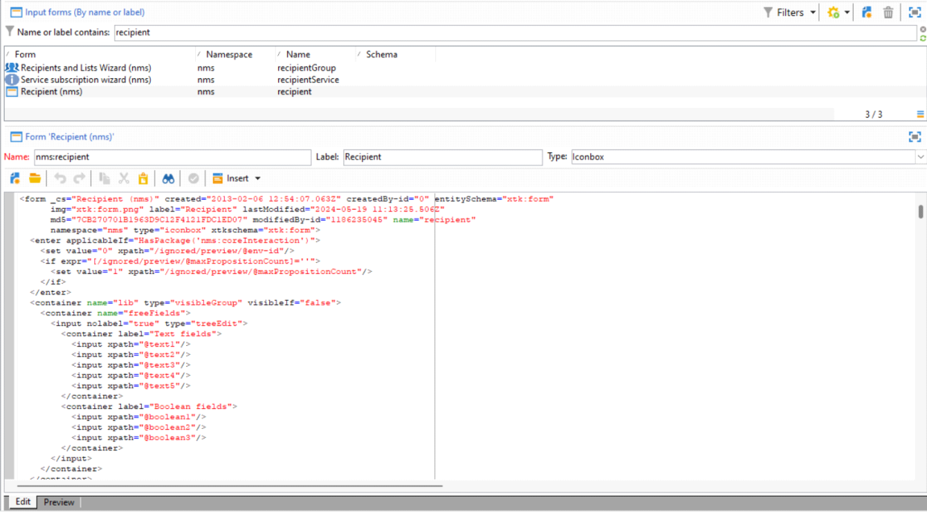

**PREVIEW TAB**

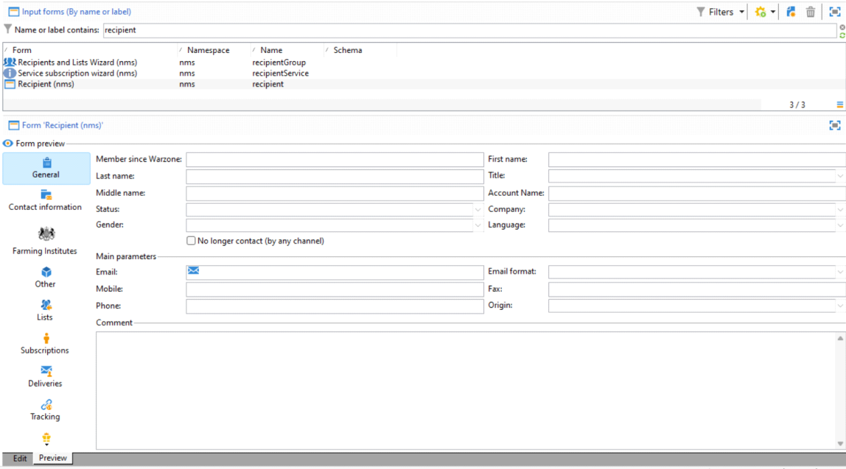

**Input Form is an XML Document, which helps in creating UI**

<form _cs="Recipient (nms)" created="2013-02-06 12:54:07.063Z" createdBy-id="0"   
entitySchema="xtk:form"  
 img="xtk:form.png" label="Recipient" lastModified="2024-05-19 11:13:25.506Z"

How to's Page 138

md5="7CB270701B1963D9C12F4121FDC1ED07" modifiedBy-id="1186235045" name="recipient" namespace="nms" type="iconbox" xtkschema="xtk:form">  
 <enter applicableIf="HasPackage('nms:coreInteraction')">  
 <set value="0" xpath="/ignored/preview/@env-id"/>  
 <if expr="[/ignored/preview/@maxPropositionCount]=''">  
 <set value="1" xpath="/ignored/preview/@maxPropositionCount"/>  
 </if>  
 </enter>  
 <container name="lib" type="visibleGroup" visibleIf="false">  
 <container name="freeFields">  
 <input nolabel="true" type="treeEdit">  
 <container label="Text fields">  
 <input xpath="@text1"/>  
 <input xpath="@text2"/>  
 <input xpath="@text3"/>  
 <input xpath="@text4"/>  
 <input xpath="@text5"/>  
 </container>  
 <container label="Boolean fields">  
 <input xpath="@boolean1"/>  
 <input xpath="@boolean2"/>  
 <input xpath="@boolean3"/>  
 </container>  
 </input>  
 </container>  
 </container>  
 <container applicableIf="hasPackage('crm:lead')" colcount="2" img="nms:recipient.png"  
 label="Summary" name="marketingHistory">  
 <input forceNavigate="true" sessionToken="true" type="urlViewer"   
urlExpr="$(serverUrl)+'/crm/marketingHistoryNl.jssp?standalone=1&amp;recipientId='+   
UrlEncode(AESEncrypt([@id]))"/>  
 </container>  
 <container applicableIf="HasPackage('crm:lead')" colcount="2" img="xtk:properties.png"  
 label="General" name="crmGeneral" readOnly="true">  
 <input xpath="@MembershipYearWarzone"/>  
 <input xpath="@firstName"/>  
 <input xpath="@lastName"/>  
 <input xpath="@salutation"/>  
 <input xpath="@status"/>  
 <input xpath="company"/>  
 <input xpath="@language"/>

<container colcount="2" colspan="2" ref="crm:common:blacklist"/>

<container colspan="2" type="visibleGroup" visibleIf="[/tmp/@folderId]=0">  
 <input createMode="none" label="Folder" writeAccess="true" xpath="folder">  
 <sysFilter>  
 <condition expr="@isView=0 and @model='nmsRecipient'"/>  
 </sysFilter>  
 </input>  
 </container>

<static colspan="2" label="Main parameters" type="separator"/>  
 <input img="nms:sendemail.png" xpath="@email"/>  
 <input xpath="@emailFormat"/>  
 <input xpath="@mobilePhone"/>  
 <input xpath="@fax"/>  
 <input xpath="@phone"/>  
 <input xpath="@homePhone"/>  
 <static colspan="2" label="Comment" type="separator"/>  
 <input colspan="2" nolabel="true" xpath="comment"/>  
 </container>  
 <container applicableIf="HasPackage('crm:lead')=false" colcount="2" img="xtk:properties.png" label="General" name="general">  
 <input xpath="@MembershipYearWarzone"/>  
 <input xpath="@firstName"/>  
 <input xpath="@lastName"/>  
 <input xpath="@salutation"/>  
 <input xpath="@middleName"/>  
 <input xpath="@account"/>  
 <input xpath="@status"/>  
 <input xpath="@company"/>  
 <input xpath="@gender"/>  
 <input xpath="@language"/>  
 <input xpath="@birthDate"/>  
 <input colspan="2" type="checkbox" xpath="@blackList"/>

<container colspan="2" type="visibleGroup" visibleIf="[/tmp/@folderId]=0">  
 <input createMode="none" label="Folder" writeAccess="true" xpath="folder">  
 <sysFilter>  
 <condition expr="@isView=0 and @model='nmsRecipient'"/>  
 </sysFilter>  
 </input>  
 </container>

<static colspan="2" label="Main parameters" type="separator"/>  
 <input img="nms:sendemail.png" xpath="@email"/>  
 <input xpath="@emailFormat"/>  
 <input xpath="@mobilePhone"/>  
 <input xpath="@fax"/>  
 <input xpath="@phone"/>  
 <input xpath="@origin"/>  
 <static colspan="2" label="Comment" type="separator"/>  
 <input colspan="2" nolabel="true" xpath="comment"/>  
 </container>  
 <container applicableIf="$(language)!='jpn'" colcount="2" img="nms:msgfolder.png"  
 label="Contact information" maxLabelWidth="200" name="address"

How to's Page 139

readOnlyIf="HasPackage('crm:lead')"  
 xpath="location">  
 <static colspan="2" label="Postal address" type="separator"/>  
 <input applicableIf="GetOption('NmsRecipient_UseOldAddr')!=1" colspan="2"   
xpath="@address1"/>  
 <input applicableIf="GetOption('NmsRecipient_UseOldAddr')!=1" colspan="2"   
xpath="@address2"/>  
 <input applicableIf="GetOption('NmsRecipient_UseOldAddr')!=1" colspan="2"   
xpath="@address3"/>  
 <input applicableIf="GetOption('NmsRecipient_UseOldAddr')!=1" colspan="2"   
xpath="@address4"/>  
 <input applicableIf="GetOption('NmsRecipient_UseOldAddr')==1" colspan="2"   
xpath="@additionalRcp"/>  
 <input applicableIf="GetOption('NmsRecipient_UseOldAddr')==1" colspan="2"   
xpath="@additionalGeo"/>  
 <input applicableIf="GetOption('NmsRecipient_UseOldAddr')==1" colspan="2" xpath="@street"/> <input applicableIf="GetOption('NmsRecipient_UseOldAddr')==1" colspan="2"   
xpath="@special"/>  
 <input xpath="@zipCode"/>  
 <input xpath="@city"/>  
 <input choiceButton="true" createMode="none" extraColumns="@isoA2,@isoA3"   
noZoom="true"  
 xpath="../country">  
 <orderBy>  
 <node expr="@label"/>  
 </orderBy>  
 <enter name="onChange">  
 <set value="" xpath="../location/@stateCode"/>  
 <reset xpath="../stateLink"/>  
 </enter>  
 </input>  
 <input choiceButton="true" createMode="none" extraColumns="@code,@countryCode" noZoom="true" notifyPathList="country/@label|../country/@_cs,@countryCode|../location/ @countryCode,country|../country"  
 xpath="../stateLink">

<sysFilter>  
 <condition expr="@countryCode = $(../location/@countryCode)"/>  
 </sysFilter>  
 <orderBy>  
 <node expr="@label"/>  
 </orderBy>  
 </input>  
 <static colspan="2" label="Address quality" type="separator"/>  
 <container type="visibleGroup" visibleIf="[../postalAddress/@addrDefined]">  
 <static img="xtk:xtkcheck.png" label=" " nolabel="false">Address specified</static>  
 </container>  
 <container type="visibleGroup" visibleIf="[../postalAddress/@addrDefined]==false">  
 <static img="xtk:logwarn.png" label=" " nolabel="false">Address not specified</static> </container>  
 <input readOnly="true" xpath="../postalAddress/@addrErrorCount"/>  
 <input readOnly="true" xpath="../postalAddress/@addrQuality"/>  
 <input readOnly="true" xpath="../postalAddress/@addrLastCheck"/>  
 </container>  
 <container applicableIf="$(language)='jpn'" colcount="2" img="nms:msgfolder.png"  
 label="Contact information" maxLabelWidth="200" name="address"   
readOnlyIf="HasPackage('crm:lead')"  
 xpath="location">  
 <static colspan="2" label="Postal address" type="separator"/>  
 <input choiceButton="true" createMode="none" extraColumns="@isoA2,@isoA3"   
noZoom="true"  
 xpath="../country">  
 <orderBy>  
 <node expr="@label"/>  
 </orderBy>  
 <enter name="onChange">  
 <set value="" xpath="../location/@stateCode"/>  
 <reset xpath="../stateLink"/>  
 </enter>  
 </input>  
 <input choiceButton="true" createMode="none" extraColumns="@code,@countryCode" noZoom="true" notifyPathList="country/@label|../country/@_cs,@countryCode|../location/ @countryCode,country|../country"  
 xpath="../stateLink">

<sysFilter>  
 <condition expr="@countryCode = $(../location/@countryCode)"/>  
 </sysFilter>  
 <orderBy>  
 <node expr="@label"/>  
 </orderBy>  
 </input>  
 <input xpath="@zipCode"/>  
 <input xpath="@city"/>  
 <input applicableIf="GetOption('NmsRecipient_UseOldAddr')==1" colspan="2"   
xpath="@special"/>  
 <input applicableIf="GetOption('NmsRecipient_UseOldAddr')==1" colspan="2" xpath="@street"/> <input applicableIf="GetOption('NmsRecipient_UseOldAddr')==1" colspan="2"   
xpath="@additionalGeo"/>  
 <input applicableIf="GetOption('NmsRecipient_UseOldAddr')==1" colspan="2"   
xpath="@additionalRcp"/>  
 <input applicableIf="GetOption('NmsRecipient_UseOldAddr')!=1" colspan="2"   
xpath="@address4"/>  
 <input applicableIf="GetOption('NmsRecipient_UseOldAddr')!=1" colspan="2"   
xpath="@address3"/>  
 <input applicableIf="GetOption('NmsRecipient_UseOldAddr')!=1" colspan="2"   
xpath="@address2"/>

How to's Page 140

<input applicableIf="GetOption('NmsRecipient_UseOldAddr')!=1" colspan="2"   
xpath="@address1"/>  
 <static colspan="2" label="Address quality" type="separator"/>  
 <container type="visibleGroup" visibleIf="[../postalAddress/@addrDefined]">  
 <static img="xtk:xtkcheck.png" label=" " nolabel="false">Address specified</static>  
 </container>  
 <container type="visibleGroup" visibleIf="[../postalAddress/@addrDefined]==false"> <static img="xtk:logwarn.png" label=" " nolabel="false">Address not specified</static> </container>  
 <input readOnly="true" xpath="../postalAddress/@addrErrorCount"/>  
 <input readOnly="true" xpath="../postalAddress/@addrQuality"/>  
 <input readOnly="true" xpath="../postalAddress/@addrLastCheck"/>  
 </container>  
 <container img="defra:ukgov.png" label="Farming Institutes" name="institutes"><!-- Added by Samson Odelowo for DEFRA Demo-->  
 <input label="Farming Institute" xpath="@farmerType"/>  
 </container>  
 <container img="nms:others.png" label="Other" name="others"   
visibleIf="HasPackage('crm:lead')=false">  
 <container ref="nms:recipient:lib/freeFields"/>  
 <container applicableIf="HasPackage('nms:social')" type="visibleGroup"   
visibleIf="HasPackage('nms:social')">  
 <input disableDefaultFilter="true" enumImage="@origin" hideEditButtons="true"  
 img="nms:visitor.png" nolabel="true" toolbarCaption="Digital identities"  
 type="linklist" xpath="visitor" zoom="true">  
 <input xpath="[.]"/>  
 <orderBy>  
 <node expr="@name"/>  
 <node expr="@lastModified" sortDesc="true"/>  
 </orderBy>  
 <sysFilter>  
 <condition expr="@origin != 0 "/>  
 </sysFilter>  
 </input>  
 </container>  
 </container>  
 <container applicableIf="HasPackage('crm:lead')" img="crm:lead.png" label="Leads"  
 name="leads">  
 <container type="notebook">  
 <container label="Leads">  
 <input hideEditButtons="true" img="crm:outgoingLead.png" nolabel="true" refresh="true" toolbarCaption="Leads generated on the recipient" type="linklist"  
 xpath="outgoingLead" zoom="true">  
 <input xpath="@lastActivity"/>  
 <input xpath="@score"/>  
 <input xpath="@rating"/>  
 <input xpath="@destination"/>  
 <input xpath="@progressStatus"/>  
 <input xpath="@stage"/>  
 <input xpath="@conversionDate"/>  
 <orderBy>  
 <node expr="@lastActivity" sortDesc="true"/>  
 </orderBy>  
 </input>  
 </container>

<container label="Activities">  
 <input hideEditButtons="true" img="crm:incomingLead.png" name="incomingLeadRcp" nolabel="true" refresh="true" toolbarCaption="Activities related to the recipient" type="linklist" xpath="incomingLead" zoom="true">  
 <input xpath="@eventDate"/>  
 <input xpath="@type"/>  
 <input xpath="@firstName"/>  
 <input xpath="@lastName"/>  
 <input xpath="@email"/>  
 <input xpath="company"/>  
 <input xpath="operation"/>  
 <input xpath="delivery"/>  
 <input xpath="landingPage"/>  
 <input xpath="fileImport"/>  
 <orderBy>  
 <node expr="@eventDate" sortDesc="true"/>  
 </orderBy>  
 </input>  
 </container>  
 </container>  
 <container applicableIf="HasPackage('nms:social')" type="visibleGroup"   
visibleIf="HasPackage('nms:social')">  
 <input disableDefaultFilter="true" enumImage="@origin" hideEditButtons="true"  
 nolabel="true" toolbarCaption="Digital identities" type="linklist" xpath="visitor" zoom="true">  
 <input xpath="@name"/>  
 <orderBy>  
 <node expr="@name"/>  
 <node expr="@lastModified" sortDesc="true"/>  
 </orderBy>  
 <sysFilter>  
 <condition expr="@origin != 0 "/>  
 </sysFilter>  
 </input>  
 </container>  
 </container>  
 <container applicableIf="HasPackage('xxl:fullfdaMkt')=false" img="nms:rcpgroup.png" label="Lists" name="group">  
 <input choicePath="/tmp/choiceList" filterFormChoice="@deleteStatus = 0 and @type=0 and @schema='nms:recipient'"  
 img="nms:rcpgroup.png" labelFormChoice="Add in the lists" newEntityFormChoice="true"

How to's Page 141

nolabel="true" promptDeleteLabel="Do you want to remove the recipient from the selected lists?"  
 selectionPath="/tmp/entityList" toolbarCaption="Lists to which the recipient belongs" type="linkList" xpath="rcpGrpRel" xpathChoiceTarget="rcpGroup"   
xpathEditTarget="rcpGroup"  
 zoom="true">  
 <sysFilter>  
 <condition expr="[rcpGroup/@deleteStatus] = 0"/>  
 <condition expr="[rcpGroup/@type] = 0"/>  
 <condition expr="[rcpGroup/@schema] = 'nms:recipient'"/>  
 </sysFilter>  
 <enter name="add">  
 <soapCall name="RegisterGroup" service="nms:recipient">  
 <param exprIn="/tmp/choiceList" type="DOMElement"/>  
 <param exprIn="/tmp/entityList" type="DOMElement"/>  
 <param exprIn="'true'" type="boolean"/>  
 </soapCall>  
 </enter>  
 <enter name="remove">  
 <soapCall name="RegisterGroup" service="nms:recipient">  
 <param exprIn="/tmp/choiceList" type="DOMElement"/>  
 <param exprIn="/tmp/entityList" type="DOMElement"/>  
 <param exprIn="'false'" type="boolean"/>  
 </soapCall>  
 </enter>

<input type="string" xpath="rcpGroup/@label"/>  
 </input>  
 </container>  
 <container img="nms:subscribe.png" label="Subscriptions" name="subscribe">  
 <container type="notebook">

<!--[of]:Without Leads-->  
 <container applicableIf="HasPackage('crm:lead')=false" label="Active subscriptions"> <input choicePath="/tmp/choiceList" form="nms:subscription" img="nms:subscribe.png" labelFormChoice="Select the services" newEntityFormChoice="true" nolabel="true" promptDeleteLabel="Do you want to delete selected subscriptions?"  
 selectionPath="/tmp/entityList" toolbarCaption="Recipient subscriptions"  
 type="serviceList" xpath="subscription" xpathChoiceTarget="service"  
 zoom="true">  
 <enter name="add">  
 <soapCall name="RecipientSubscribe" service="nms:subscription">  
 <param exprIn="/tmp/entityList" type="DOMElement"/>  
 <param exprIn="/tmp/choiceList" type="DOMElement"/>  
 <param exprIn="'true'" type="boolean"/>  
 <param exprIn="[/tmp/sendMsg]" type="DOMElement"/>  
 <param type="DOMElement" xpathOut="/tmp/sendConfirmation"/>  
 </soapCall>  
 </enter>

<enter name="remove">  
 <soapCall name="RecipientSubscribe" service="nms:subscription">  
 <param exprIn="/tmp/entityList" type="DOMElement"/>  
 <param exprIn="/tmp/choiceList" type="DOMElement"/>  
 <param exprIn="'false'" type="boolean"/>  
 <param exprIn="[/tmp/sendMsg]" type="DOMElement"/>  
 <param type="DOMElement" xpathOut="/tmp/sendConfirmation"/>  
 </soapCall>  
 </enter>

<input xpath="service/@label"/>  
 <input xpath="@address"/>  
 <input xpath="@emailFormat"/>  
 <input xpath="@expirationDate"/>

<input hidden="true" xpath="[@service-id]"/>

</input>  
 </container>

<container applicableIf="HasPackage('crm:lead')=false" label="History">  
 <input hideEditButtons="true" img="nms:histo.png" nolabel="true" toolbarCaption="History" type="linklist" xpath="subHisto">  
 <input xpath="@date"/>  
 <input xpath="recipient"/>  
 <input xpath="@action"/>  
 </input>  
 </container>   
<!--[cf]-->   
<!--[of]:With Leads-->  
 <container applicableIf="HasPackage('crm:lead')" label="Active subscriptions">  
 <input choicePath="/tmp/choiceList" form="nms:subscription" hideEditButtons="true" img="nms:subscribe.png" labelFormChoice="Select the services"   
newEntityFormChoice="true"  
 nolabel="true" selectionPath="/tmp/entityList" toolbarCaption="Recipient subscriptions" type="serviceList" xpath="subscription" xpathChoiceTarget="service"  
 zoom="true">

<input xpath="service/@label"/>  
 <input xpath="@address"/>  
 <input xpath="@emailFormat"/>  
 <input xpath="@expirationDate"/>

<input hidden="true" xpath="[@service-id]"/>

</input>  
 </container>

How to's Page 142

<container applicableIf="HasPackage('crm:lead')" label="History">  
 <input hideEditButtons="true" img="nms:histo.png" name="incomingLeadSub"  
 nolabel="true" toolbarCaption="History" type="linklist" xpath="incomingLead">  
 <input xpath="@eventDate"/>  
 <input xpath="@type"/>  
 <input xpath="service"/>  
 <input label="Landing page service" xpath="[landingPage/service]"/>  
 <sysFilter>  
 <condition expr="@type='subscription' OR @type='unsubscription'"/>  
 </sysFilter>  
 <orderBy>  
 <node expr="@eventDate" sortDesc="true"/>  
 </orderBy>  
 </input>  
 </container>   
<!--[cf]-->

</container>  
 </container>  
 <container img="nms:broadLog.png" label="Deliveries" name="delivery">  
 <container type="notebook">  
 <container label="Messages">  
 <input enumImage="@status" hideEditButtons="true" img="nms:broadLog.png"  
 nolabel="true" toolbarCaption="Recipient delivery logs" type="linklist"  
 xpath="broadLog">  
 <input size="14" xpath="@lastModified"/>  
 <input size="20" xpath="@status"/>  
 <input size="30" xpath="msg/@failureReason"/>  
 <input size="25" xpath="delivery"/>  
 <input xpath="msg/@text"/>  
 <orderBy>  
 <node expr="@lastModified" sortDesc="true"/>  
 </orderBy>  
 <sysFilter>  
 <condition expr="[delivery/@deleteStatus] = 0"/>  
 </sysFilter>  
 </input>  
 </container>  
 <container label="Exclusions">  
 <input hideEditButtons="true" img="nms:excludeLog.png" nolabel="true"   
toolbarCaption="Recipient exclusion logs"  
 type="linklist" xpath="excludeLog">  
 <input xpath="@lastModified"/>  
 <input xpath="@status"/>  
 <input xpath="msg/@failureReason"/>  
 <input xpath="@address"/>  
 <input xpath="msg/@text"/>  
 <input label="Modification date" xpath="@lastModified"/>  
 <orderBy>  
 <node expr="@lastModified" sortDesc="true"/>  
 </orderBy>  
 </input>  
 </container>  
 </container>  
 </container>  
 <container img="nms:tracking.png" label="Tracking" name="tracking">  
 <container type="notebook">

<container label="Tracking logs">  
 <input hideEditButtons="true" img="nms:tracking.png" nolabel="true"   
toolbarCaption="Recipient tracking logs"  
 type="linklist" xpath="trackingLog">  
 <input xpath="@logDate"/>  
 <input xpath="url/@label"/>  
 <input xpath="url/@type"/>  
 <input xpath="delivery"/>  
 <orderBy>  
 <node expr="@logDate" sortDesc="true"/>  
 </orderBy>  
 </input>  
 </container>  
 <!-- NEO-30620: FullFDAMKT do not support survey-->  
 <container applicableIf="HasPackage('nms:survey') and HasPackage('xxl:fullfdaMkt')=false" label="Surveys">  
 <input delButton="true" form="nms:webAppLog" hideEditButtons="true"   
img="nms:survey.png"  
 nolabel="true" toolbarCaption="Survey responses" type="linklist" xpath="webAppLog" zoom="true">  
 <input xpath="@logDate"/>  
 <input xpath="webApp"/>  
 <input xpath="@score"/>  
 <input xpath="@origin"/>  
 <orderBy>  
 <node expr="@logDate" sortDesc="true"/>  
 </orderBy>  
 </input>  
 </container>  
 </container>  
 </container>  
 <container applicableIf="HasPackage('nms:coreInteraction') AND   
HasPackage('xxl:fullfdaMkt')=false"  
 img="nms:proposition.png" label="Propositions" name="proposition">  
 <container type="notebook">  
 <container label="Propositions" name="propositionHistory">  
 <input hideEditButtons="true" img="nms:proposition.png" nolabel="true"   
toolbarCaption="Recipient propositions"

How to's Page 143

type="linklist" xpath="proposition">  
 <input size="20" xpath="offer"/>  
 <input size="15" xpath="@eventDate"/>  
 <input size="15" xpath="@lastModified"/>  
 <input size="20" xpath="@status"/>  
 <input size="20" xpath="offerSpace"/>  
 <input size="25" xpath="broadLog/delivery"/>  
 <orderBy>  
 <node expr="@lastModified" sortDesc="true"/>  
 </orderBy>  
 <sysFilter>  
 <condition expr="Coalesce([broadLog/delivery/@deleteStatus], 0) = 0"/>  
 </sysFilter>  
 </input>  
 </container>

<container applicableIf="HasPackage('nms:interaction')" label="Preview" name="preview"> <container colcount="2">  
 <input label="Propositions" type="number" xpath="/ignored/preview/   
@maxPropositionCount"/>  
 <input label="Themes" xpath="/ignored/preview/@themes"/>  
 <input createMode="none" label="Category" schema="nms:offerCategory" type="linkEdit" xpath="/ignored/preview/category">  
 <enter name="onChange">  
 <set expr="[/ignored/preview/category]" xpath="/ignored/preview/category/@id"/>

<if expr="[/ignored/preview/category/@id] != '' and [/ignored/preview/category/@id] != 0"> <!-- load categorie's env-id to filter space's input -->  
 <set value="nms:offerCategory" xpath="/ignored/queryDef/@schema"/>  
 <set value="GetOfferEnv(@id)" xpath="/ignored/queryDef/select/node[1]/@expr"/> <set value="@env-id" xpath="/ignored/queryDef/select/node[1]/@alias"/>  
 <set value="@name" xpath="/ignored/queryDef/select/node[2]/@expr"/>  
 <set value="get" xpath="/ignored/queryDef/@operation"/>  
 <set expr="'@id='+[/ignored/preview/category/@id]"   
xpath="/ignored/queryDef/where/condition/@expr"/>  
 <soapCall name="ExecuteQuery" service="xtk:queryDef">  
 <param exprIn="[/ignored/queryDef]" type="DOMDocument"/>  
 <param type="DOMDocument" xpathOut="/ignored/cat"/>  
 </soapCall>  
 <set expr="[/ignored/cat/@env-id]" xpath="/ignored/preview/@env-id"/>  
 </if>  
 <if expr="[/ignored/preview/category/@id] = '' or [/ignored/preview/category/@id] = 0"> <set expr="0" xpath="/ignored/preview/@env-id"/>  
 </if>  
 </enter>  
 <sysFilter>  
 <condition expr="@model like 'nmsOfferCategory%' or @model like 'nmsOfferEnv%'"/> </sysFilter>  
 </input>  
 <input label="Space" schema="nms:offerSpace" type="linkEdit" xpath="/ignored/preview/ @space-id">  
 <sysFilter>  
 <condition enabledIf="$(/ignored/preview/@env-id) != '' and $(/ignored/preview/@env-id) !

= 0"  
 expr="[@env-id] = $(/ignored/preview/@env-id)"/>  
 </sysFilter>  
 </input>  
 </container>  
 <input alwaysActive="true" forceNavigate="true" sessionToken="true" type="urlViewer" urlExpr="Iif([/ignored/preview/@space-id] != '', $(serverUrl) +   
'/webApp/interactionPreview?_decorate=0&amp;standalone=1&amp;space=' + [/ignored/preview/ @space-id] + '&amp;target=' + @id + '&amp;count=' + [/ignored/preview/@maxPropositionCount] + '&amp;categories=' + [/ignored/cat/@name] + '&amp;themes=' + [/ignored/preview/@themes], '')"/>  
 </container>  
 </container>  
 </container>  
 <leave>  
 <if expr="[/tmp/@folderId]!=0 AND [/tmp/@folderId]!=''">  
 <set expr="[/tmp/@folderId]" xpath="@folder-id"/>  
 </if>  
 <check expr="[@folder-id]!=0">  
 <error>The folder is not specified.</error>  
 </check>  
 </leave>   
</form>

How to's Page 144

PRE - DEFINED FILTERS   
Thursday, May 30, 2024 6:23 PM

Pre - Defined Filters can be created and can be used in Query Activities

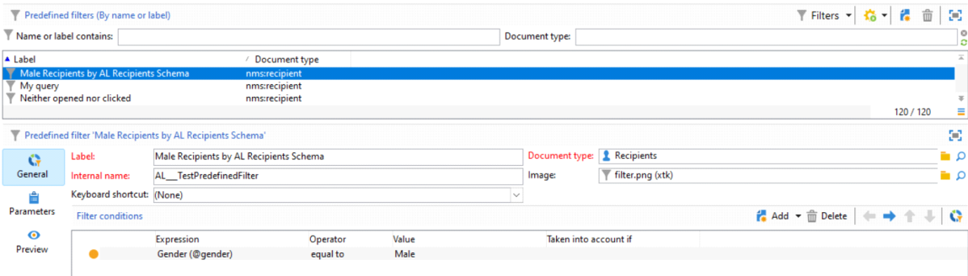

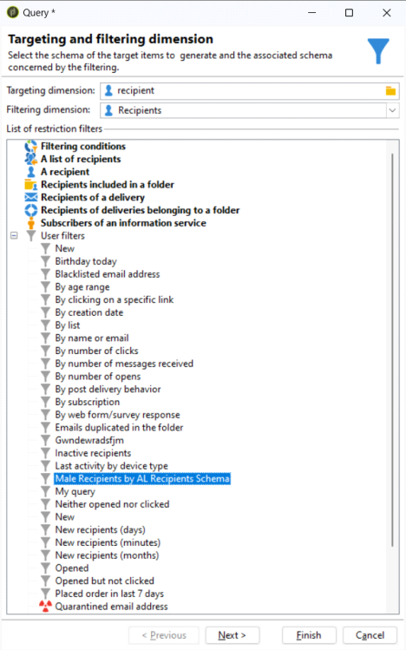

How to's Page 145

Manage Marketing Resource

Sunday, June 2, 2024 4:38 PM

**Marketing Resources -**

A document, which can be uploaded onto Adobe Server   
Can be Reviewed and Approved   
Can be Published   
Can be used by multiple Operators for Reading Mode   
While Editing Mode, it needs to be Locked and used by any Operator   
Until Lock is not Opened, it cannot be used by any other Operator

Even in Lock State, it is readable by other Operators, but not Editable

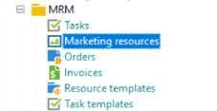

**Create a New Marketing Resource and Upload the PDF File**

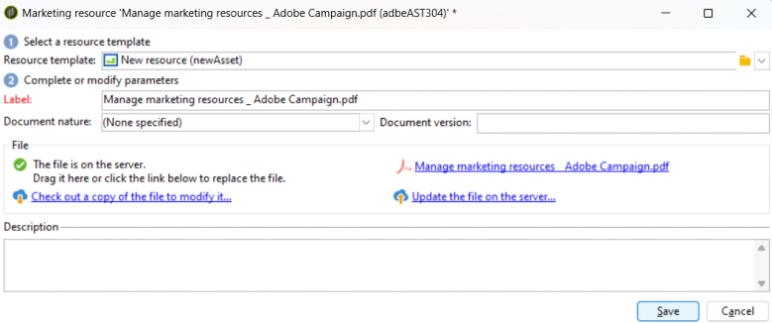

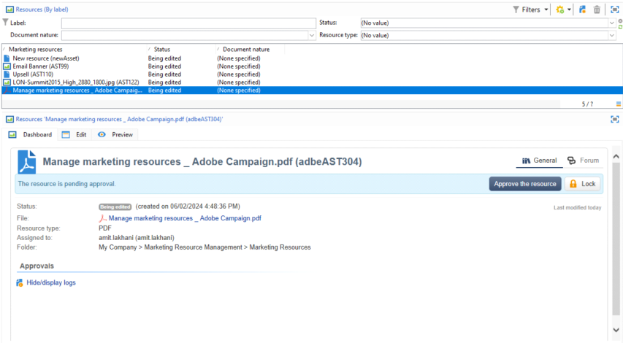

**Approve the Resource**   
**Lock the Resource**

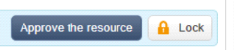

**Assign to Operator for Review**

Addon's Page 146

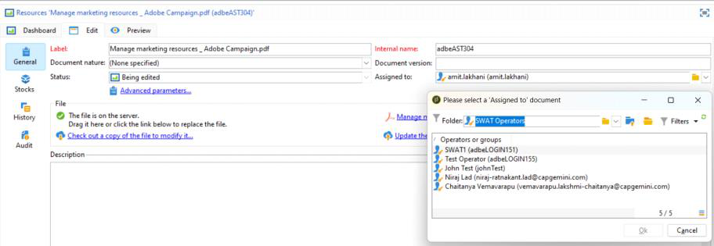

**Preview Tab**

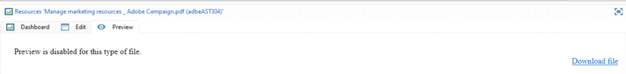

**History of Editing of File by Operators, can be viewed here**

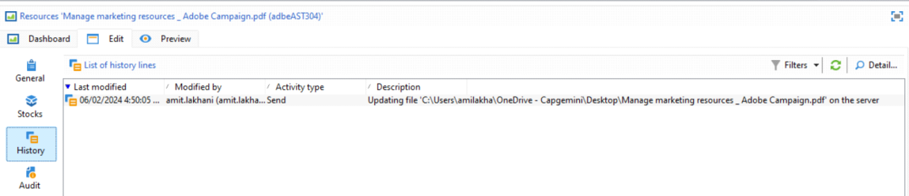

Addon's Page 147

Content Management

Sunday, June 2, 2024 4:55 PM

**Simple Words - Good Powerful Editor for Content Editing**

• Installable package for creating recurring newsletters or websites.

• Helps in creating, validating, and publishing messages.

• Supports team collaboration, workflow management, and content aggregation.

• Automatically formats messages for email, mail, SMS, web, etc.

• Provides input options for content creators.

• Manages layout and changes automatically using a stylesheet.

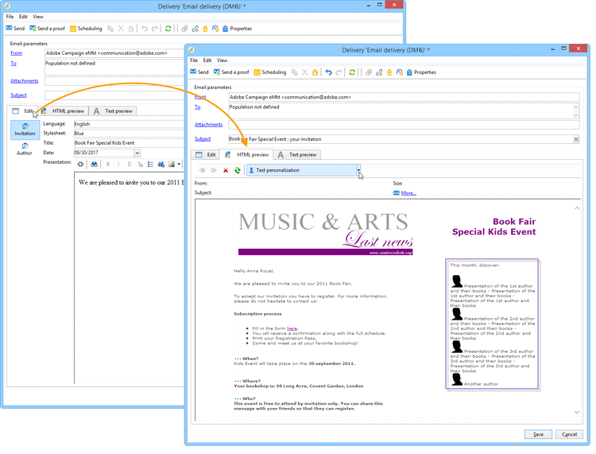

Addon's Page 148

Task Management

Sunday, June 2, 2024 5:04 PM

Task Management

Simple Words - Jira Tickets / PBI

An Operator   
can create a task   
Add an Expiry Data   
Add a Comment   
Finish a Task

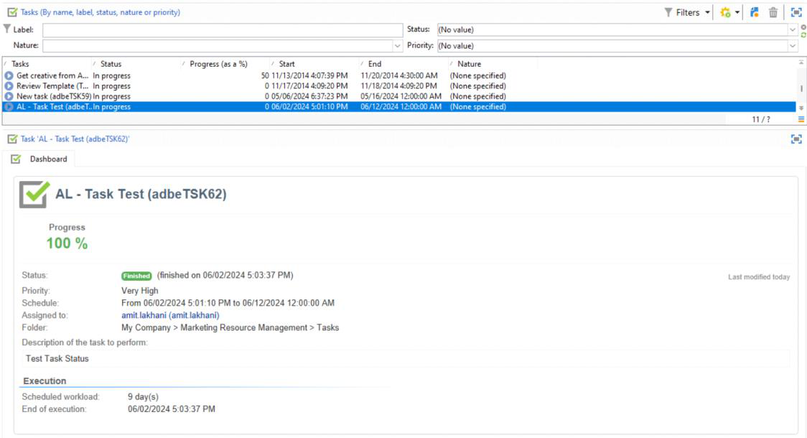

**Based on the status of the task, workflow can be Controlled inside a Workflow**

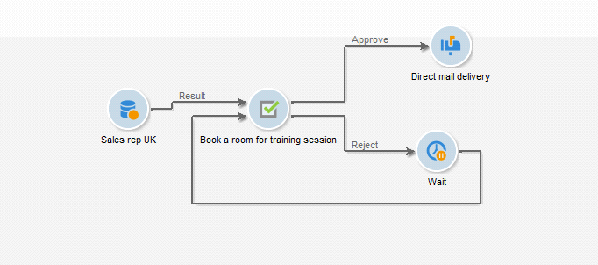

Addon's Page 149

Distributed Marketing

Sunday, June 2, 2024 5:09 PM

**Adobe Campaign Distributed Marketing**

•**Purpose**: Run joint marketing campaigns between headquarters and local branches.

•**Central Entities**: Create and manage campaign templates; allow local adjustments; control

costs.

•**Local Entities**: Gain more freedom; save on execution costs.

•**Campaign Types**:

○ **Local Campaign**: Customized by local branches.

○ **Collaborative Campaign**: Shared content and costs; various customization options.

•**Ordering**: Local branches order campaigns; need approval.

•**Workspace**: Access campaigns from the Campaigns tab.

•**Operators/Entities**: Set user permissions and approval rules.

•**Implementation**:

○ Headquarters creates and publishes campaigns.

○ Local branches use campaigns as allowed.

•**Tasks**:

○ **Integrator**: Set up entities, permissions, and forms.

○ **Admin**: Update forms, create and configure campaigns.

○ **Local Operator**: Customize, review, and order campaigns.

Addon's Page 150

FFDA API - Federated Data Access

Sunday, June 2, 2024 5:28 PM

**Lehman Language -**

Create a Schema (Staging not Enabled Yet)

Add necessary Attributes

Update the Database Structure

Add **autoStg=“true"** in the schema

**Result**

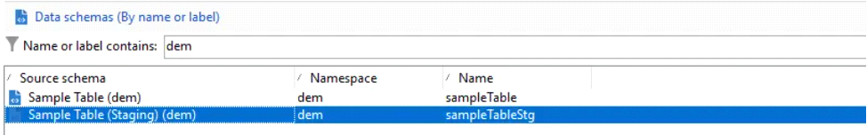

**FFDA Campaign APIs Overview**

**Purpose:**

Manage data between Campaign local database and Cloud database using specific APIs.

**Prerequisites:**

Enable the staging mechanism on the schema.

**APIs**

**1. Ingestion API: xtk.session.ingest**

○ **Purpose**: Insert data only.

○ **Usage**:

▪ **In a workflow**: Use JavaScript code to insert data.

▪ **SOAP call**: Authenticate and use a SOAP payload to insert data.

**2. Data Update/Delete API: xtk.session.ingestExt**

○ **Purpose**: Update or delete data.

○ **Usage**:

▪ **In a workflow**: Use JavaScript code to update data.

▪ **SOAP call**: Authenticate and use a SOAP payload to update data.

**Example Usages**

**Insert Data (No Reconciliation)**

**Using Workflow**

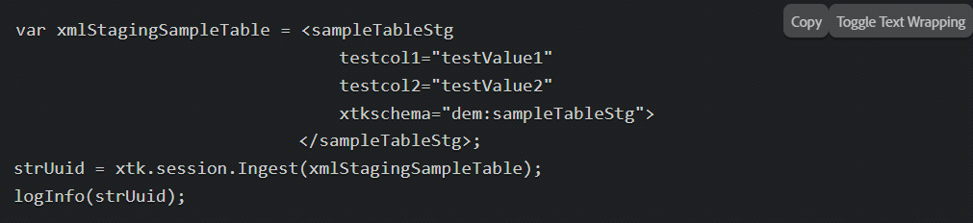

Addon's Page 151

Soap Call   
Request

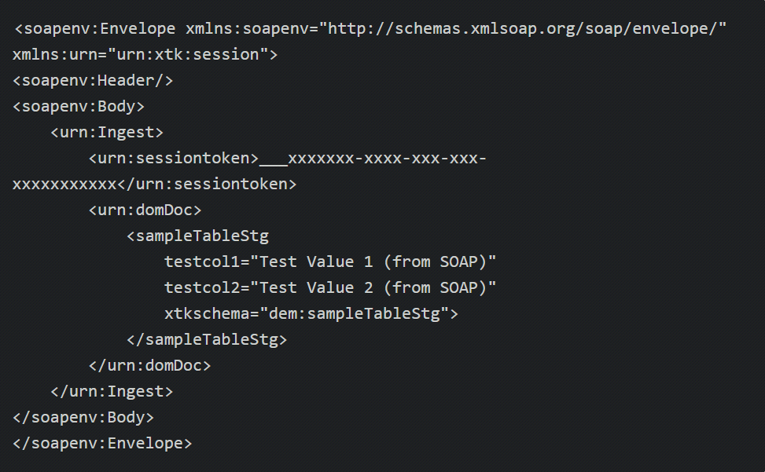

Response

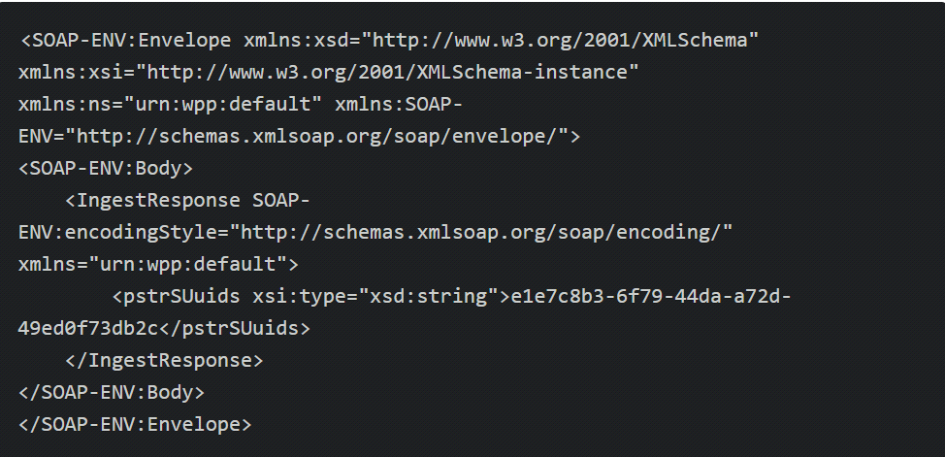

**Insert Data (Reconciliation)**

Using Workflow

Addon's Page 152

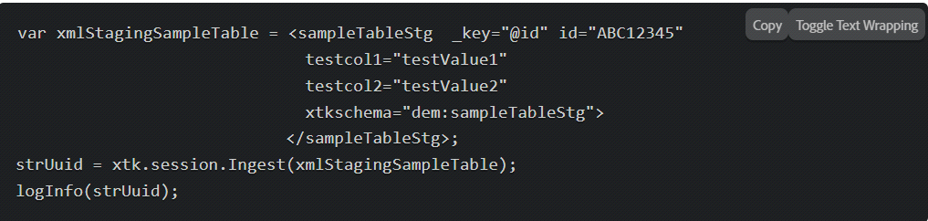

Using SOAP Call

Request

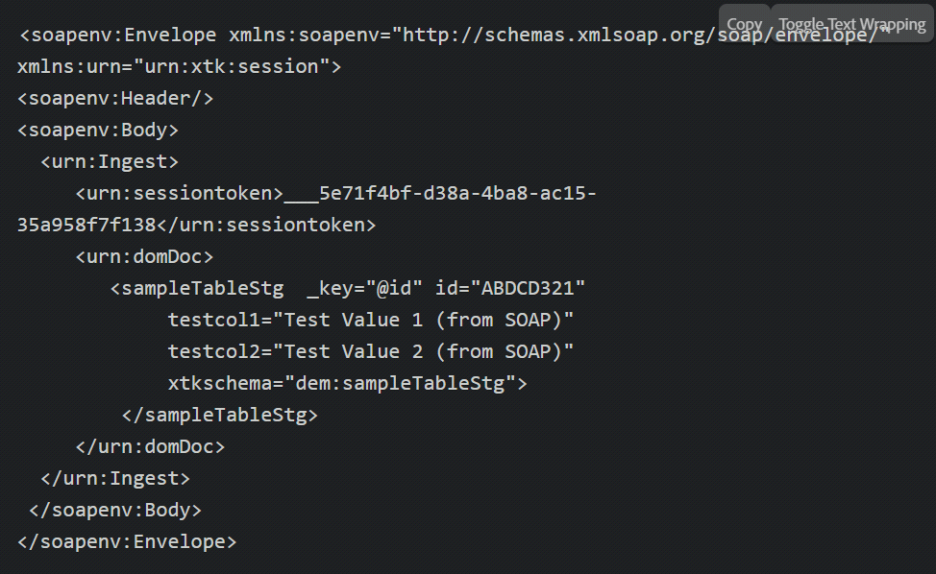

Response

Addon's Page 153

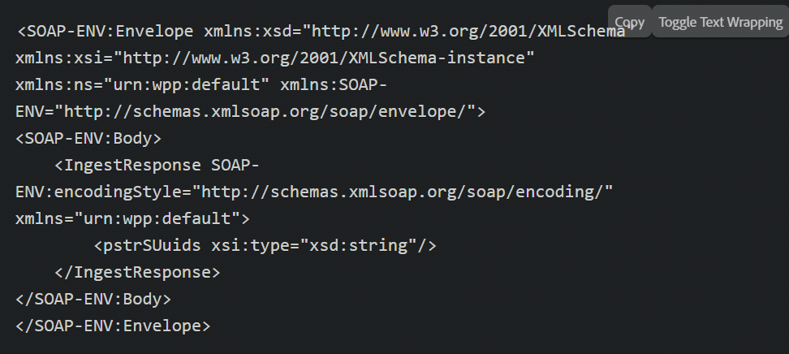

Insert / Update   
Using Workflow

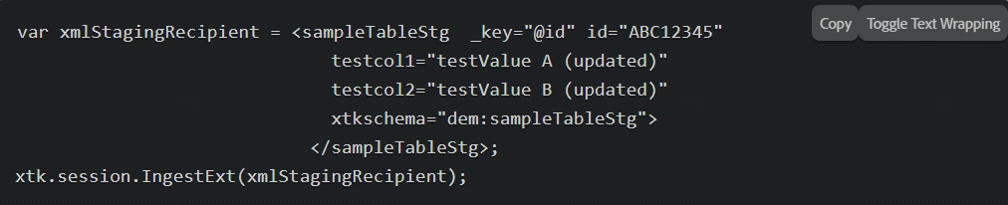

Using SOAP Call   
Request

Addon's Page 154

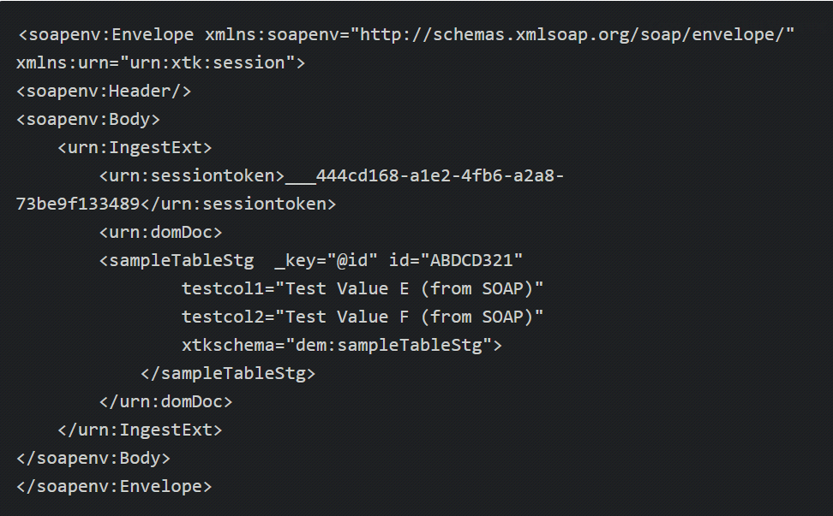

Response

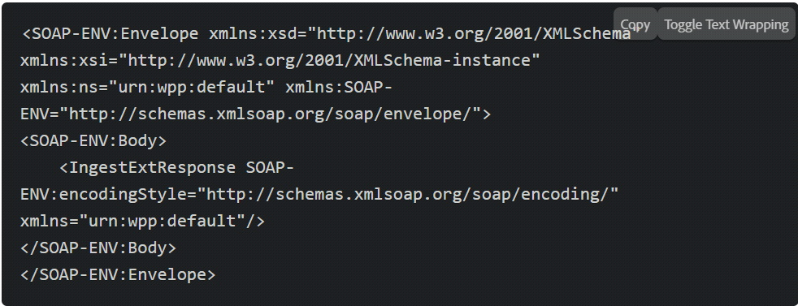

Federated Data Access

**Simple Words - Access data from External Database directly without importing them to Adobe Environment**

**1. Integration with External Databases**: FDA allows you to connect Adobe Campaign to various external databases, including Amazon Redshift, Google BigQuery, PostgreSQL, Snowflake, Vertica Analytics, Microsoft Azure Synapse, MySQL, Netezza, Oracle, SAP HANA, SQL Server, Sybase, Teradata, and Hadoop via HiveSQL. This integration enables you to leverage data stored in these external sources directly within Campaign workflows.

Addon's Page 155

**2. Compatibility and Versioning**: The compatibility matrix provided for FDA outlines the supported versions of each external database system that can be integrated with Campaign. It ensures that the version of the external database aligns with the requirements of Adobe Campaign for seamless data access and integration.

**3. Hosting Environment**: The compatibility of external databases with Campaign depends on your hosting model. Managed Services (hosted), Hybrid, and On-premise environments have different sets of compatible external database systems. It's essential to verify the compatibility based on your specific hosting environment.

**4. Data Access and Manipulation**: With FDA, you can perform various operations on data stored in external databases directly from within Adobe Campaign. This includes querying data, performing joins and transformations, filtering records, and executing SQL queries against external tables.

**5. Use Cases**: FDA opens up a range of use cases for leveraging external data within Campaign workflows. For example, you can enrich customer profiles with data from a centralized data warehouse, perform advanced segmentation based on real-time data feeds, or personalize campaigns using insights from external analytics platforms.

Overall, Federated Data Access in Adobe Campaign facilitates seamless integration and access to external databases, enabling marketers to leverage a wider range of data sources and drive more personalized and targeted campaigns.

Addon's Page 156

Different Terminologies used while creating Schema Sunday, June 2, 2024 5:50 PM

Addon's Page 157

Create a Application Filter   
Sunday, June 2, 2024 5:52 PM

What is Application Filters

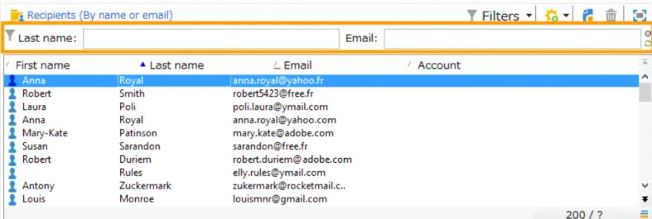

Filter can be used in 2 different ways   
 1. Go to Predefined Filters and create them and use them in the Schema   
 For eg.

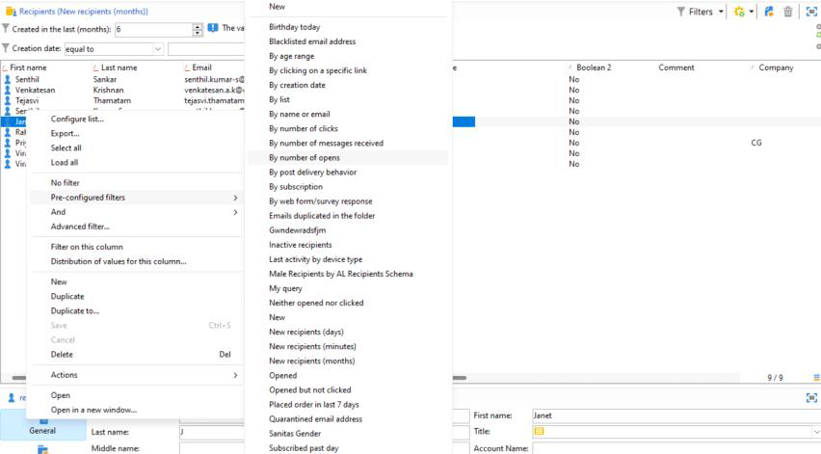

Once Pre - Defined Filter is Selected, it will be Applied



2. Use a Filter based on an Attribute based on a Schema

**Filter on this Columns**

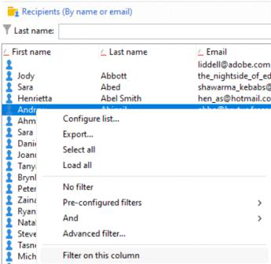

Addon's Page 158

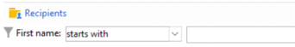

Addon's Page 159

Adobe Campaign Classic Compatibility Matrix

|  |  |
| --- | --- |
| Sunday, June 2, 2024 | 6:15 PM |

|  |  |  |
| --- | --- | --- |
| **Category** | **Supported Versions** | **Additional Notes** |
| **Operating Systems** |  |  |
| CentOs | 7.x |  |
| Debian | 11 (starting Campaign v7.3) | 10 |
| RHEL | 8.x, 7.x |  |
| Windows Server | 2019 (starting Campaign v7.2), 2016 |  |
| **Web Servers** |  |  |
| Microsoft IIS | 10.0 on Windows Server 2016 and 2019 |  |
| Apache | 2.4 for RHEL7 - CentOS 7, Debian 8/9, Windows |  |
| **Tools** |  |  |
| Java Development Kit (JDK) | 11, 9, 8 | Supports JDK developed by Oracle and OpenJDK. |
| Libre Office | 7 (and previous versions if embedded in your system) |  |
| SpamAssassin | 3.4.x |  |
| **RDBMS** |  |  |
| Oracle | 19c, 18c, 12c, 11g R2 |  |
| PostgreSQL | 14.x (starting Campaign v7.3.2), 13.x, 12.x, 11.x | Amazon RDS for PostgreSQL with specified versions. |
| SQL Server | 2019, 2017, 2016, 2014 | Not supported as primary database when Campaign server is running on Linux. |
| **CRM Connectors** |  |  |
| Salesforce connector API | API version 49 |  |
| Microsoft Dynamics connector | Web API |  |
| **Federated Data Access (FDA)** |  |  |
| Amazon Redshift | v7.0 19.1.4 minimum |  |
| Google BigQuery | 7.2 minimum |  |
| PostgreSQL | 14.x, 13.x, 12.x, 11.x | v7.0 19.1.4 minimum |
| Snowflake | 7.2 minimum |  |
| Vertica Analytics | v7.0 19.1.4 minimum |  |
| Microsoft Azure Synapse | v7.0 19.1.4 minimum | Hybrid and On-premise environments only. |
| MySQL | 8, 5.7 | v7.3 minimum for Hybrid and On-premise environments, v7.0 minimum for Managed Services (hosted). |
| Netezza | 7.2 | v7.0 minimum |
| Oracle | 19c, 18c, 12c, 11g | v7.0 minimum |
| SAP HANA | version 1 SPS 12 | v7.0 minimum |
| SQL Server | 2019, 2017, 2016, 2014, 2012 SP1 and SP2 | v7.0 minimum |
| Sybase | IQ 16, ASE 15.7 | v7.0 minimum |
| Teradata | 17.x, 16.x (last version) | v7.0 minimum |
| Hadoop via HiveSQL | HortonWorks HDP 2.4.X, 2.5.x, 2.6.x; HDInsight 3.4, 3.5, 3.6; Cloudera CDH6.x | v7.0 minimum |
| **Client Console** |  |  |
| Operating systems | OS version | Campaign version |
| Microsoft Windows | 11, 10 | v7.3 minimum |
| Microsoft Windows Server | 2019, 2016 | v7.2.1 minimum |
| Microsoft WebView2 runtime | Latest version is mandatory for Campaign client console. | Download Microsoft Edge WebView2 from Microsoft Developer site. |
| **Mobile SDK** |  |  |
| Google Android | 12 (starting Campaign v7.3), 9.0, 8.x, 7.x | with mobile SDK build 1.1.1 |
| Apple iOS | iOS 9 - 15 | with mobile SDK build 1.0.26, compatible with 32 and 64-bit versions. iOS 15 supported starting v7.3 |
| **Browsers** |  |  |
| Google Chrome | Latest version |  |
| Microsoft Edge | Latest version |  |
| Mozilla Firefox | Latest version |  |
| Safari | Latest version |  |

Addon's Page 160

Navigation Hierarchy   
Monday, June 3, 2024 7:25 AM

XML Document which decides how Folders will be associated with Each Other (Hierarchy)

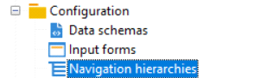

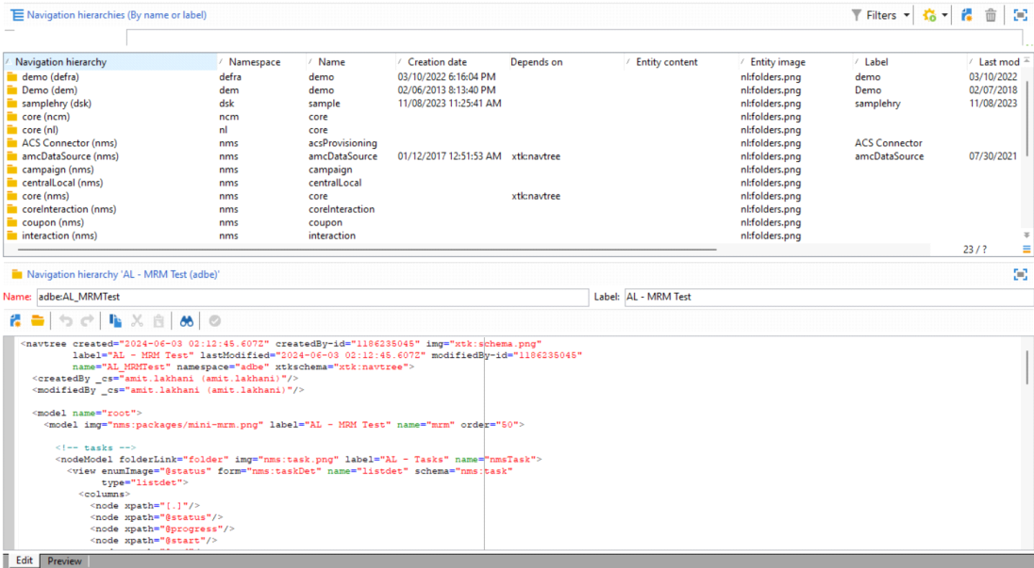

**NavTree Schema**

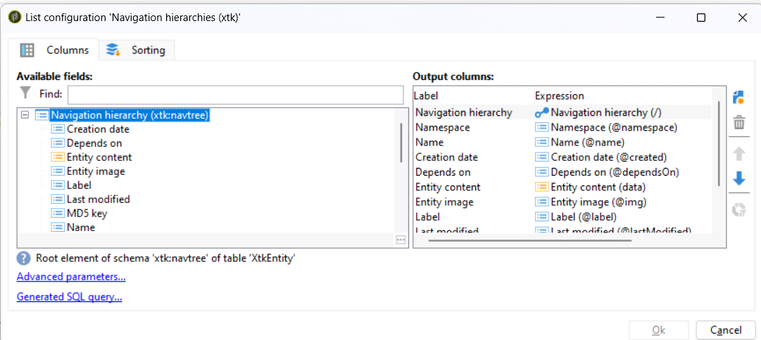

**Create a Node using XML**

Addon's Page 161

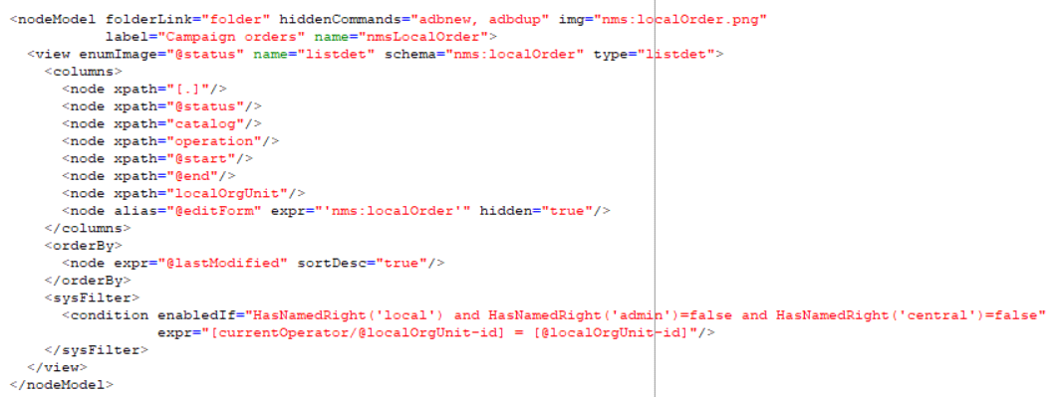

**Output Result in NavTree View**

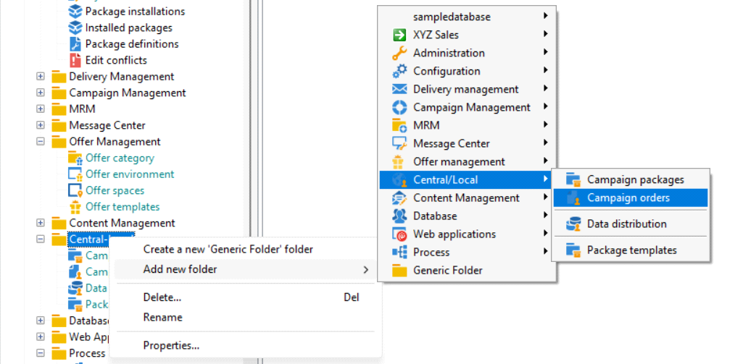

**Tips for configuring Navigation Tree**

To configure the Campaign Explorer navigation tree, follow these steps:

**1. Structure the XML Document**:

○ Start with a <navtree> root element, specifying name and namespace attributes.

○ Include global commands within a <commands> element.

○ Define folder types within <model> and <nodemodel> elements.

**2. Define Global Commands**:

○ Use the <command> element to declare commands, specifying attributes like name,

label, desc, form, and rights.

○ Include optional elements like <soapCall> for SOAP API calls, and <enter> for form

context initialization.

Addon's Page 162

○ Commands can be nested and separated by using a command with a label value of '-'.

**3. Configure Folder Types**:

○ Inside <model> elements, use <nodemodel> elements to define folder types.

○ Attributes for <nodemodel> include name, label, img, and rights like insertRight,

editRight, deleteRight.

○ Use the <view> element to configure the list associated with the folder, specifying

attributes like schema and type (e.g., listdet, list, form, editForm).

○ Columns for the list are defined using <columns> and <node> elements with xpath

attributes.

**4. Add Shortcut Commands**:

○ Include commands within <nodemodel> elements to create actions accessible from the

list’s action menu.

○ Define these commands similar to global commands, with additional properties like

monoSelection, refreshView, and enabledIf.

**5. Manage Linked Folders**:

○ For linked folders, use the folderLink attribute in <nodemodel> to define the folder link

as per the data schema.

○ Configure the corresponding linked folder in the data schema using an <element> tag

with appropriate attributes.

Addon's Page 163

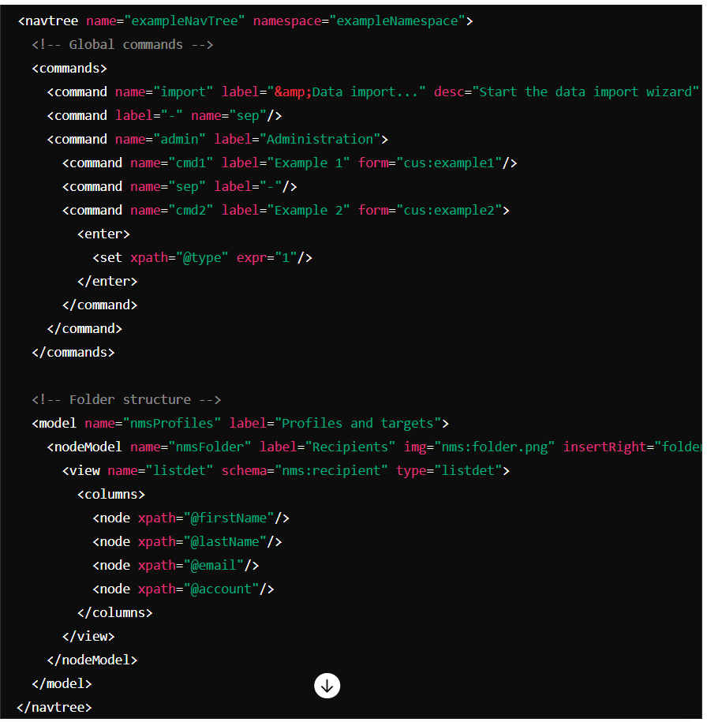

Addon's Page 164

Export in a Package   
Monday, June 3, 2024 7:32 AM

????????????????

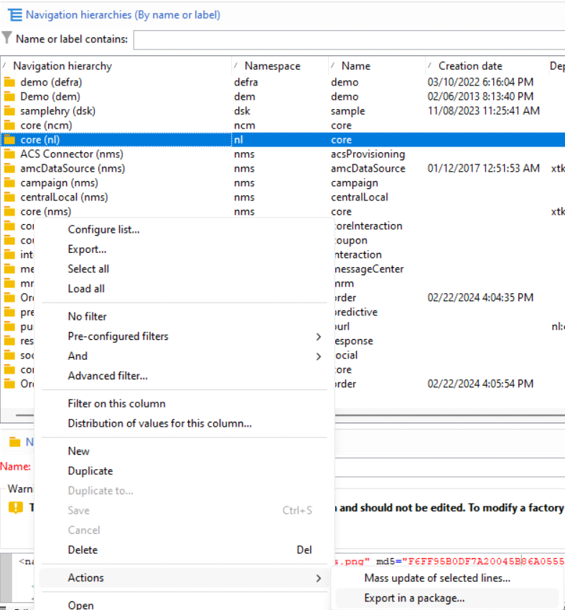

Addon's Page 165

Form Rendering   
Monday, June 3, 2024 7:59 AM

**Form rendering**

• [Web Forms](https://experienceleague.adobe.com/en/docs/campaign-classic/using/designing-content/web-forms/form-rendering#)

**Selecting the form rendering template**

The form settings enable you to select the template used to generate the pages. To access them, click the **Properties** button in the form detail toolbar, and select the **Rendering** tab. There are a number of templates (style sheets) available by default.

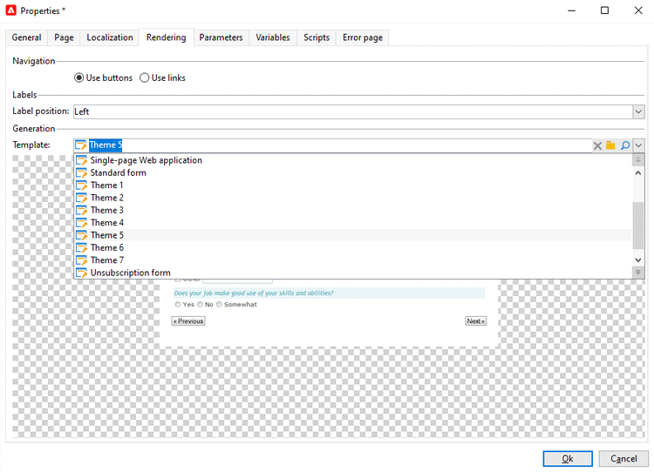

The bottom section of the editor enables you to view a rendering of the selected template.

The zoom feature lets you edit the selected template.

Addon's Page 166

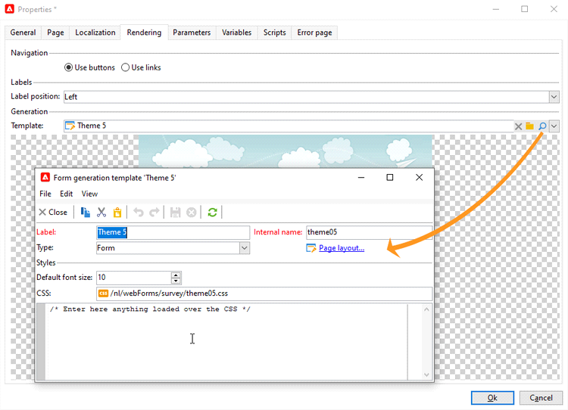

You can modify or override these templates. To do this, click the **Page layout…** link and personalize the information.

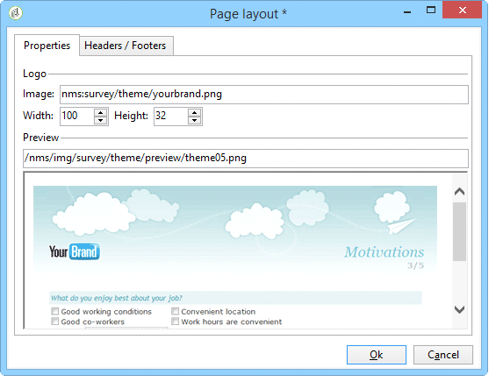

You can:

• Change the image used as a logo and adapt its size,  
• Also specify the path for accessing the preview image when users select this rendering template.

The **Headers/Footers** tab lets you change the information displayed in the headers and footers of each form page using this template.

Addon's Page 167

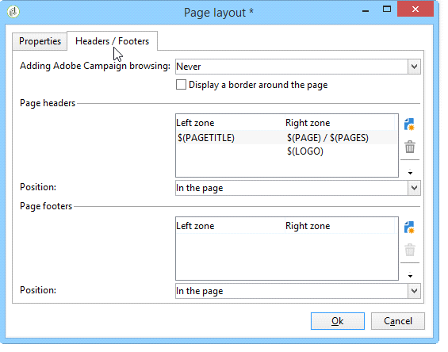

Each line of the **Page headers** and **Page footers** section corresponds to a line in the HTML page. Click **Add** to create a new line.

Select an existing line and click the **Detail** button to personalize it.

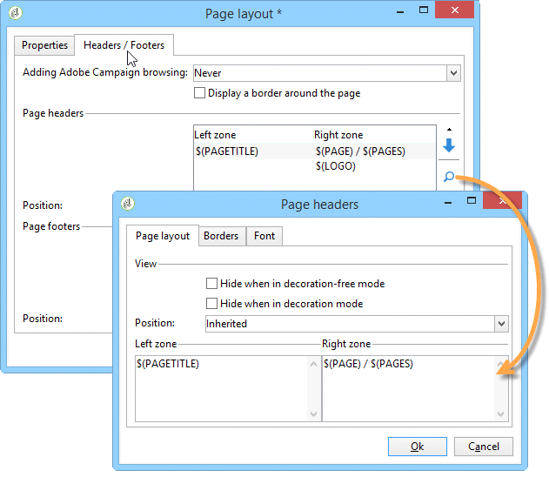

You can change the content of the line, add borders, and change the font attributes via the relevant tabs. Click **OK** to confirm these changes.

The **Position** fields let you define the position of elements in the page header and footer.

Addon's Page 168

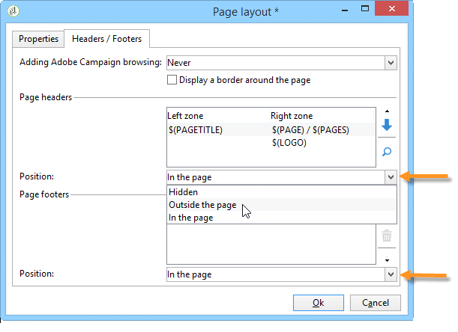

**NOTE**

Rendering templates are stored in the **Administration > Configuration > Form rendering** node.

For more on this, refer to [Customizing form rendering](https://experienceleague.adobe.com/en/docs/campaign-classic/using/designing-content/web-forms/form-rendering#customizing-form-rendering)

**Customizing form rendering**

**Changing the layout of elements**

You can overload the style sheet for each element of the form (input fields, images, radio buttons, etc.).

To do this, use the **Advanced** tab.

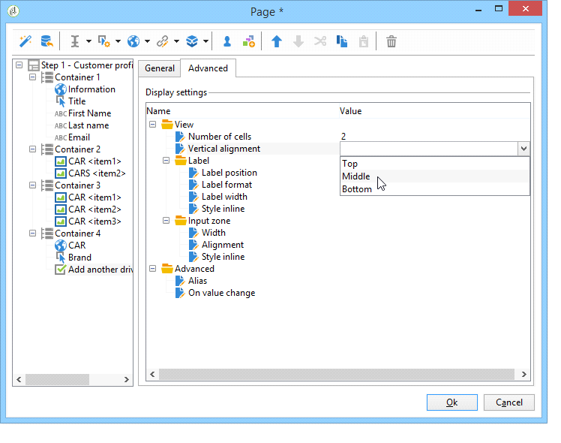

It enables you to define the following properties:

• **Label position**: see [Defining the position of labels](https://experienceleague.adobe.com/en/docs/campaign-classic/using/designing-content/web-forms/defining-web-forms-layout),

• **Label format**: Word wrap or No word wrap,

Addon's Page 169

|  |  |
| --- | --- |
| • • •  •  • • | **Number of cells** : see [Positioning the fields on the page](https://experienceleague.adobe.com/en/docs/campaign-classic/using/designing-content/web-forms/defining-web-forms-layout),  **Horizontal alignment** (Left, Right, Centered) and **Vertical alignment** (High, Low, Middle),  **Width** of the zone: this can be expressed as a percentage or in ems, points, or pixels (default value),  Maximum **Length**: Maximum number of characters allowed (for Text, Number and Password type controls),  **Lines**: number of lines for a **Multi-line text** type zone,  **Style inline**: enables you to overload the CSS style sheet with additional settings. These are separated using **;** characters as shown in the example below: |

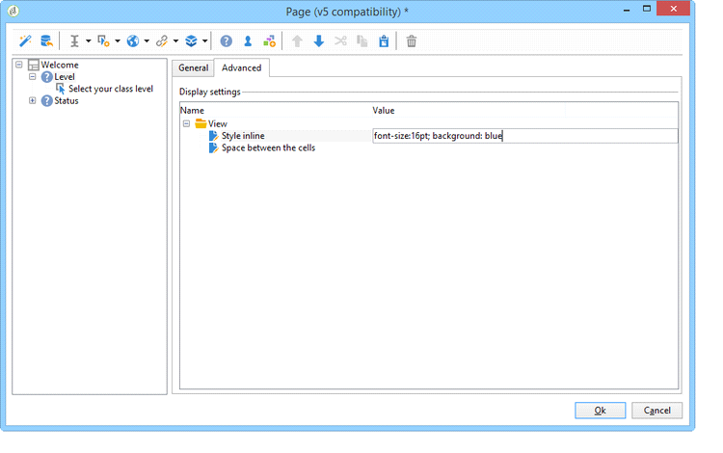

**Defining headers and footers**

Fields are sequenced in a tree structure whose root has the same name as the page. Select it to modify the name.

The title of the window must be entered in the **Page** tab of the form property window. You can also add a set content to the page header and footer (this information will be shown on every page). This content is entered in the matching sections of the **Texts** tab, as shown below:

Addon's Page 170

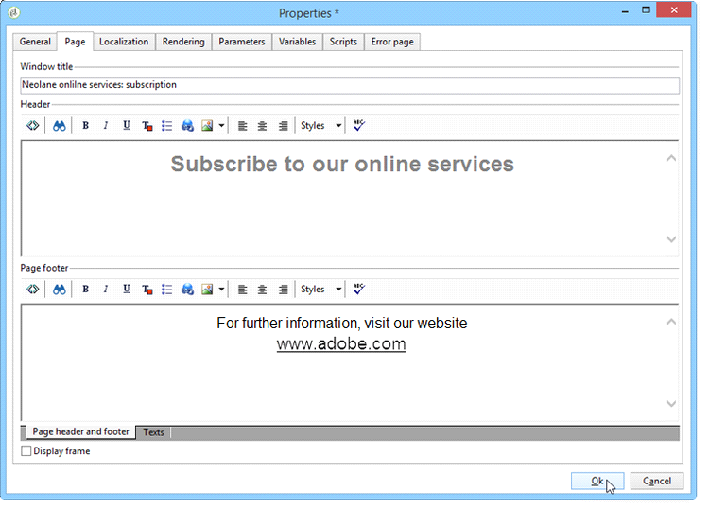

**Adding elements to HTML header**

You can enter additional elements to be inserted into the HTML header of a form page. To do this, enter the elements in the **Header** tab of the relevant page.

This lets you reference an icon that will be displayed in the page’s title bar, for example.

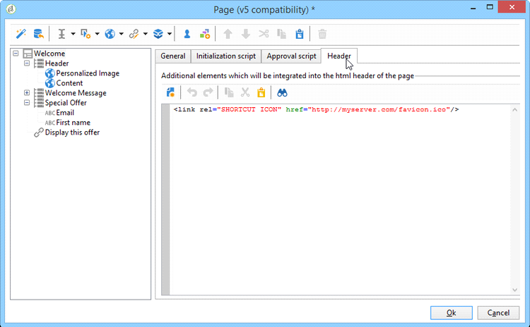

**Defining control settings**

When the user fills in the form, a check is automatically carried out on certain fields depending on their format or configuration. This lets you make certain fields mandatory (refer to [Defining](https://experienceleague.adobe.com/en/docs/campaign-classic/using/designing-content/web-forms/form-rendering#defining-mandatory-fields) [mandatory fields](https://experienceleague.adobe.com/en/docs/campaign-classic/using/designing-content/web-forms/form-rendering#defining-mandatory-fields)) or check the format of the data entered (refer to [Checking data format](https://experienceleague.adobe.com/en/docs/campaign-classic/using/designing-content/web-forms/form-rendering#checking-data-format)[). C](https://experienceleague.adobe.com/en/docs/campaign-classic/using/designing-content/web-forms/form-rendering#defining-mandatory-fields)hecks are carried out during page approval (by clicking a link or button which enables an output transition).

Addon's Page 171

**Defining mandatory fields**   
To make certain fields mandatory, select this option when creating the field.

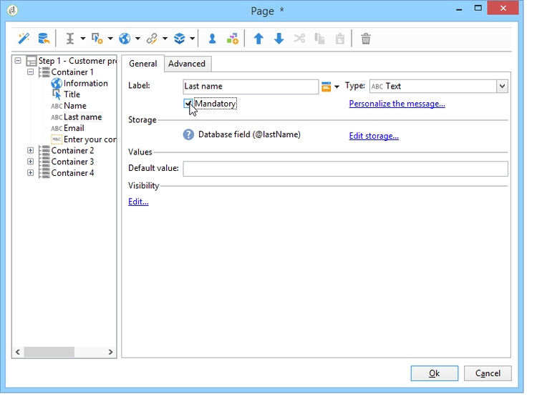

If the user approves this page without having entered the field, the following message will be displayed:

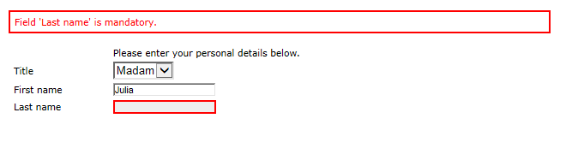

You can personalize this message by clicking the **Personalize this message** link.

Addon's Page 172

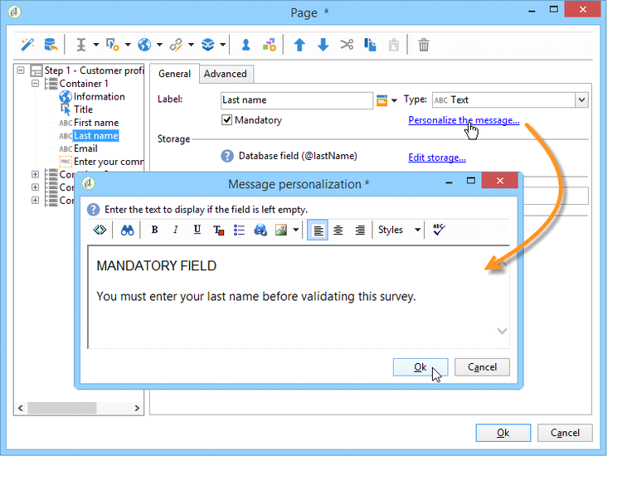

If the user approves this page without having entered the field, the following message will be displayed:

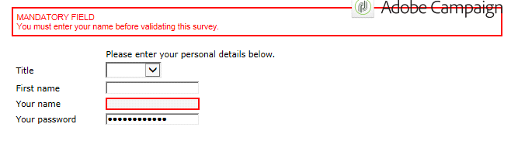

**Checking data format**

For form checks whose values are stored in an existing field of the database, the rules for the storage field will be applied.

For form checks whose values are stored in a variable, approval rules depend on the format of the variable.

For example, if you create a **Number** check to store the client number, as shown below:

Addon's Page 173

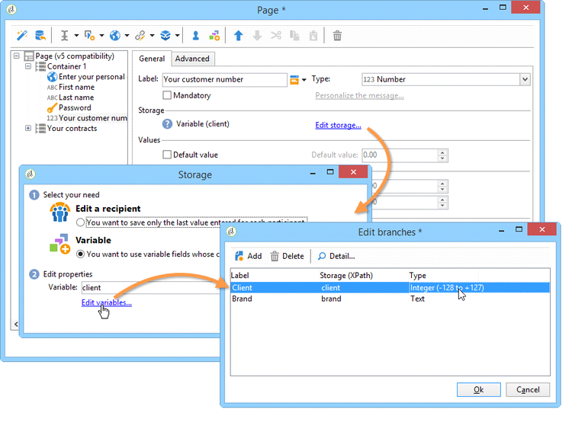

The user must enter an integer in the form field.

**Defining fields conditional display**   
You can configure the display of fields on the page to be displayed based on the values chosen by the user. This can apply to one field or a group of fields (when they are grouped in a container).

For each element of the page, the **Visibility** section lets you define the display conditions.

Addon's Page 174

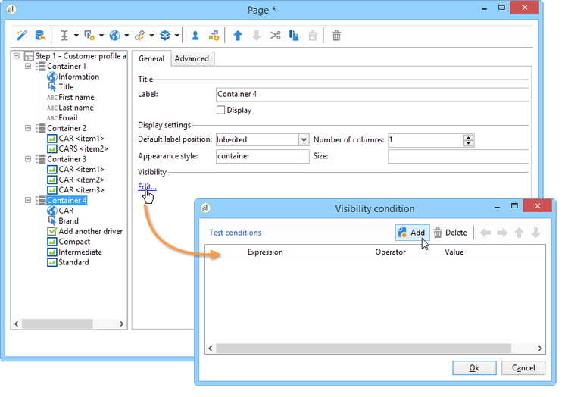

Conditions can concern the value of database fields or variables.   
In the field selection window, you can choose from the following data:

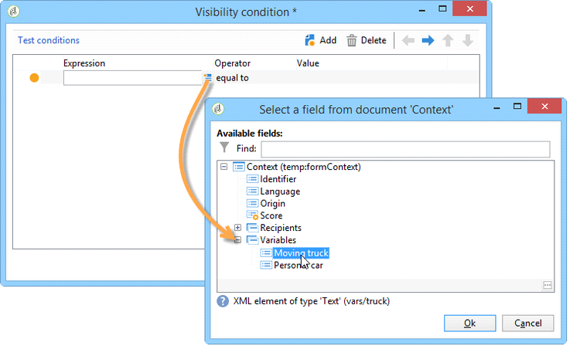

|  |  |
| --- | --- |
| •  •  • | The main tree contains the parameters of the form context. The default parameters are the Identifier (which matches the [encry](https://experienceleague.adobe.com/en/docs/campaign-classic/using/designing-content/web-forms/defining-web-forms-properties)pted identifier of the recipient), Language and Origin. For more on this, refer to this [page](https://experienceleague.adobe.com/en/docs/campaign-classic/using/designing-content/web-forms/defining-web-forms-properties).  The **Recipients** sub-tree contains the input fields inserted into the form and stored in the database.  For more on this, refer to [Storing data in the database](https://experienceleague.adobe.com/en/docs/campaign-classic/using/designing-content/web-forms/web-forms-answers).  The **Var[iables](https://experienceleague.adobe.com/en/docs/campaign-classic/using/designing-content/web-forms/web-forms-answers)** [sub-tree contains the a](https://experienceleague.adobe.com/en/docs/campaign-classic/using/designing-content/web-forms/web-forms-answers)vailable variables for this form. For more on this, refer to [Storing data in a local variable](https://experienceleague.adobe.com/en/docs/campaign-classic/using/designing-content/web-forms/web-forms-answers). |

For more on this, refer to the use case available here: [Displaying different options depending on](https://experienceleague.adobe.com/en/docs/campaign-classic/using/designing-content/web-forms/use-cases-web-forms) [the selected values](https://experienceleague.adobe.com/en/docs/campaign-classic/using/designing-content/web-forms/use-cases-web-forms).

You [can](https://experienceleague.adobe.com/en/docs/campaign-classic/using/designing-content/web-forms/defining-web-forms-page-sequencing) also condition the display of form pages using the **Test** object. For more on this, refer to this [page](https://experienceleague.adobe.com/en/docs/campaign-classic/using/designing-content/web-forms/defining-web-forms-page-sequencing).

Addon's Page 175

**Importing elements from an existing form**   
It’s possible to import fields or containers from other Web forms. This lets you create a library of re-usable blocks which will be inserted into forms, such as the address block, the newsletter subscription area, etc.

To import an element into a form, apply the following steps:

|  |  |
| --- | --- |
| 1. | Edit the page which you want to insert one or more elements into, then click **Import an existing block** in the toolbar. |

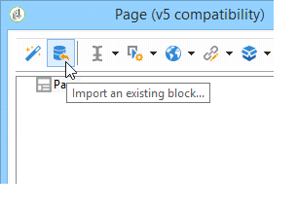

|  |  |
| --- | --- |
| 2. | Select the Web form which contains the fields to import and choose the containers and fields to import. |

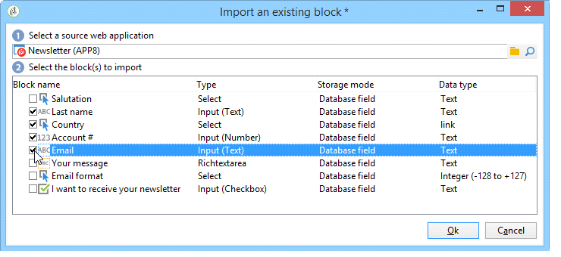

**NOTE**   
The **Edit link** icon to the right of the source form name lets you view the selected Web form.

3. Click **Ok** to confirm insertion.

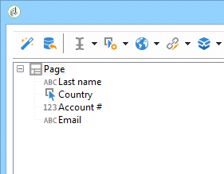

From <<https://experienceleague.adobe.com/en/docs/campaign-classic/using/designing-content/web-forms/form-rendering>>

Addon's Page 176

Custom Expressions in Schema   
Monday, June 3, 2024 9:43 AM

When you include the line <element label="Recipient" name="lnkRecipient" revCardinality="single" revLink="lnkTransactions" target="nms:recipient" type="link"/> in a custom table definition in Adobe Campaign Classic, you are defining a link between the custom table and the Recipient table. Here's a breakdown of the attributes:   
**1.**  **label="Recipient"**: This is the display name for the link. It provides a user-friendly name for the link.

**2.**  **name="lnkRecipient"**: This is the internal name of the link. It's used by the system to identify this link.

**revCardinality="single"**: This specifies the cardinality of the reverse link. "Single" means that each record in the custom table is linked to one record in the **3.**

Recipient table.

(It means 1 -1 Relationshiop)   
**1.**  **revLink="lnkTransactions"**: This specifies the name of the reverse link. It defines the link from the Recipient table back to the custom table. This is useful if you need to navigate from the Recipient table to the custom table.

**2.**  **target="nms**   
 **"**: This defines the target table of the link, which in this case is the Recipient table (specified by the nms:recipient schema).

**3.**  **type="link"**: This indicates that the element is a link to another table.

-------------------------------------------------------------------------------------------------------------------------------------------------  
**1 - Many** Link between Recipient Table and Custom Table   
**Recipient**   
<element label="Custom Records"name="lnkCustomTable"revCardinality="multiple"target="cus:customTable"type="link"/> **Custom**   
<element label="Recipient"name="lnkRecipient" revCardinality="single" revLink="lnkCustomTable" target="nms:recipient"type="link"/>

Addon's Page 177

Out of the Box Variable in ACC

|  |  |
| --- | --- |
| Monday, June 3, 2024 | 1:38 PM |

|  |  |  |  |
| --- | --- | --- | --- |
| **Variable Type** | **Description** | **Common Uses** | **Key Attributes** |
| **Instance** | Represents the entire workflow or campaign process. | Used to store data that is persistent throughout the workflow's lifecycle. | Global scope, accessible by all tasks and events within the workflow. |
| **Task** | Represents individual activities or steps within a workflow. | Used to store data specific to a particular task. | Local scope, accessible only by the task to which it is associated. |
| **Event** | Represents actions or triggers within a workflow, such as the completion of a task or a time-based trigger. | Used to store data relevant to specific events or triggers within the workflow. | Event-specific scope, accessible only during the event's execution. |

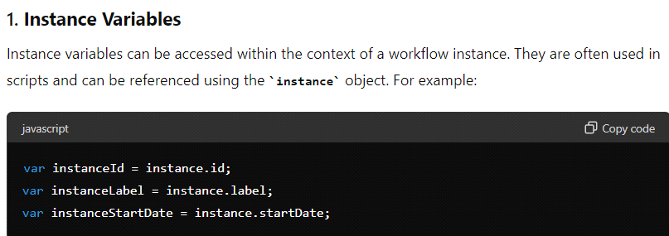

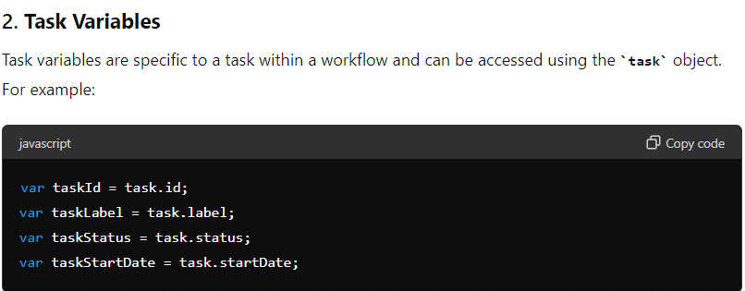

Addon's Page 178

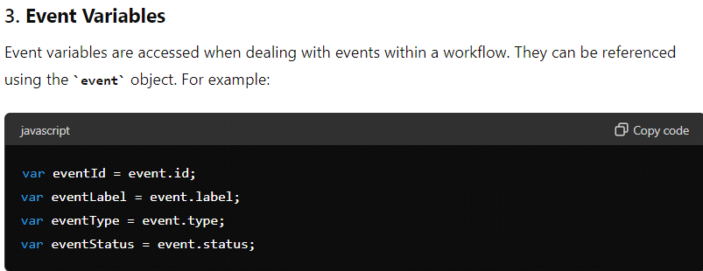

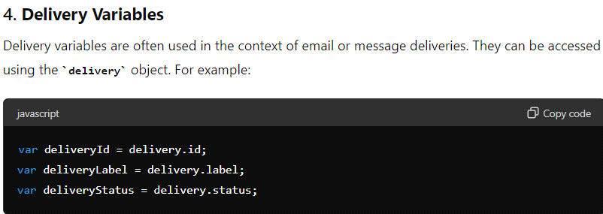

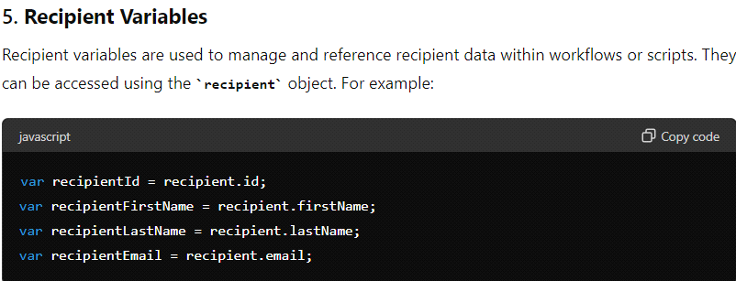

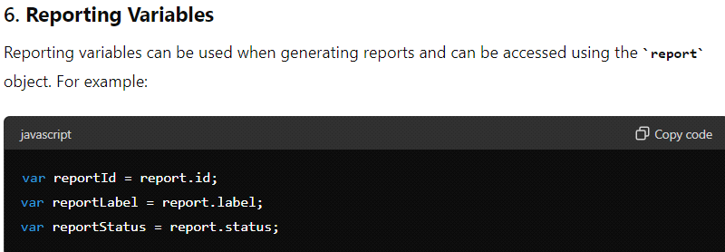

Addon's Page 179

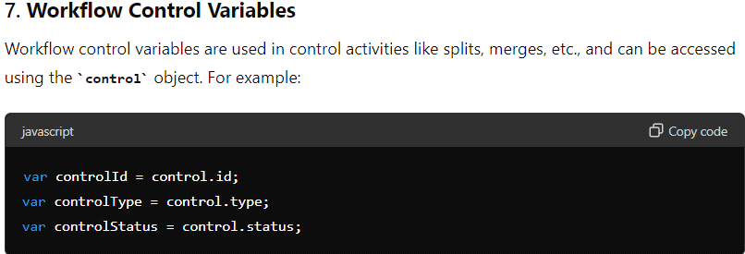

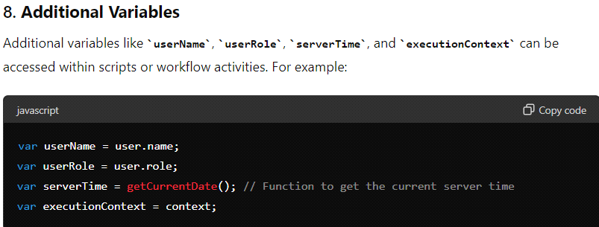

Addon's Page 180

OOTB Functions in Adobe Campaign Classic Monday, June 3, 2024 1:47 PM

|  |  |
| --- | --- |
| **General Utility Functions** |  |
|  |  |
| **Function** | **Description** |
| logInfo | Logs an informational message to the console. |
| logError | Logs an error message to the console. |
| logWarning | Logs a warning message to the console. |
| logDebug | Logs a debug message to the console. |
| alertAssignee | Sends an alert to the assigned operator. |
| execSQL | Executes an SQL query on the database. |
| getOption | Retrieves the value of an option. |
| setOption | Sets the value of an option. |
| sendEmail | Sends an email to a specified recipient. |
| sendNotification | Sends a notification to a user or group. |
|  |  |
| **Workflow Functions** |  |
|  |  |
| **Function** | **Description** |
| startWorkflow | Starts a specified workflow. |
| stopWorkflow | Stops a specified workflow. |
| pauseWorkflow | Pauses a specified workflow. |
| resumeWorkflow | Resumes a specified workflow. |
| abortWorkflow | Aborts a specified workflow. |
| getWorkflowState | Retrieves the current state of a workflow. |
| setWorkflowState | Sets the state of a workflow. |
| createTask | Creates a new task within a workflow. |
| completeTask | Completes a specified task within a workflow. |
|  |  |
| **Data Manipulation Functions** |  |
|  |  |
| **Function** | **Description** |
| queryDef | Executes a predefined query and returns the results. |
| schemaDef | Retrieves the definition of a schema. |
| loadData | Loads data into a specified table. |
| saveData | Saves data from a specified table. |
| deleteData | Deletes data from a specified table. |
| updateData | Updates data in a specified table. |
|  |  |
| Addon's Page 181 | |

|  |  |
| --- | --- |
| **Messaging Functions** | |
|  |  |
| **Function** | **Description** |
| prepareDelivery | Prepares a delivery for sending. |
| sendDelivery | Sends a prepared delivery. |
| cancelDelivery | Cancels a scheduled delivery. |
| getDeliveryState | Retrieves the current state of a delivery. |
| createDelivery | Creates a new delivery. |
| updateDelivery | Updates an existing delivery. |
|  |  |
| **API Interaction Functions** |  |
|  |  |
| **Function** | **Description** |
| callAPI | Calls an external API and returns the response. |
| parseXML | Parses an XML string and returns an XML object. |
| parseJSON | Parses a JSON string and returns a JSON object. |
| generateToken | Generates a token for API authentication. |
|  |  |
| **System Functions** |  |
|  |  |
| **Function** | **Description** |
| getCurrentUser | Retrieves the currently logged-in user. |
| getCurrentTime | Retrieves the current system time. |
| getCurrentDate | Retrieves the current system date. |
| getServerInfo | Retrieves information about the server. |
| restartServer | Restarts the server. |
| shutdownServer | Shuts down the server. |
|  |  |
| **Variable Access Functions** |  |
|  |  |
| **Function** | **Description** |
| getInstanceVariable | Retrieves the value of an instance variable. |
| setInstanceVariable | Sets the value of an instance variable. |
| getTaskVariable | Retrieves the value of a task variable. |
| setTaskVariable | Sets the value of a task variable. |
| getEventVariable | Retrieves the value of an event variable. |
| setEventVariable | Sets the value of an event variable. |

Addon's Page 182

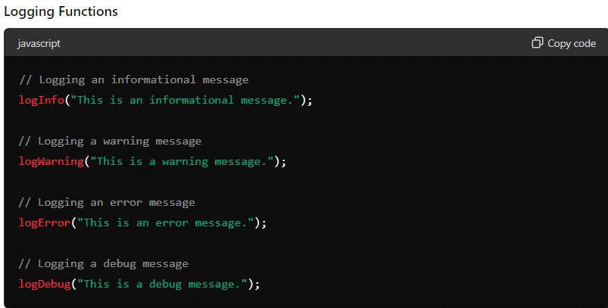

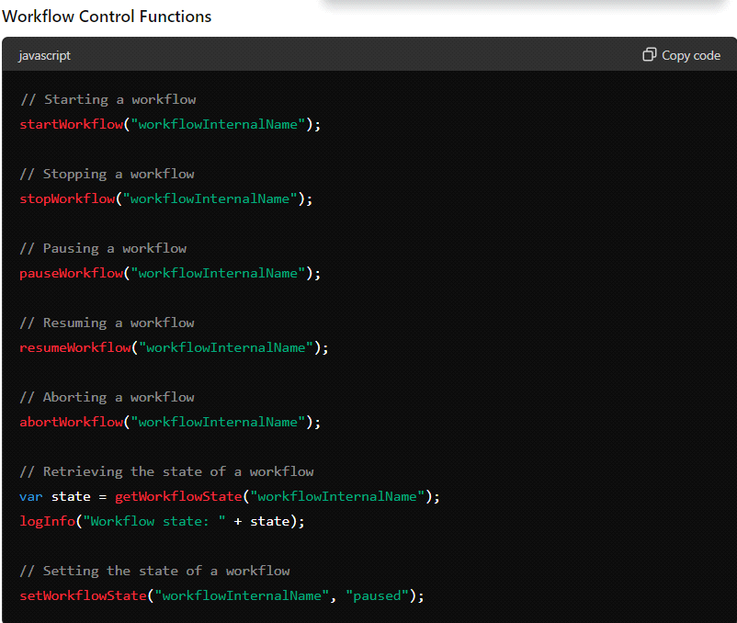

Addon's Page 183

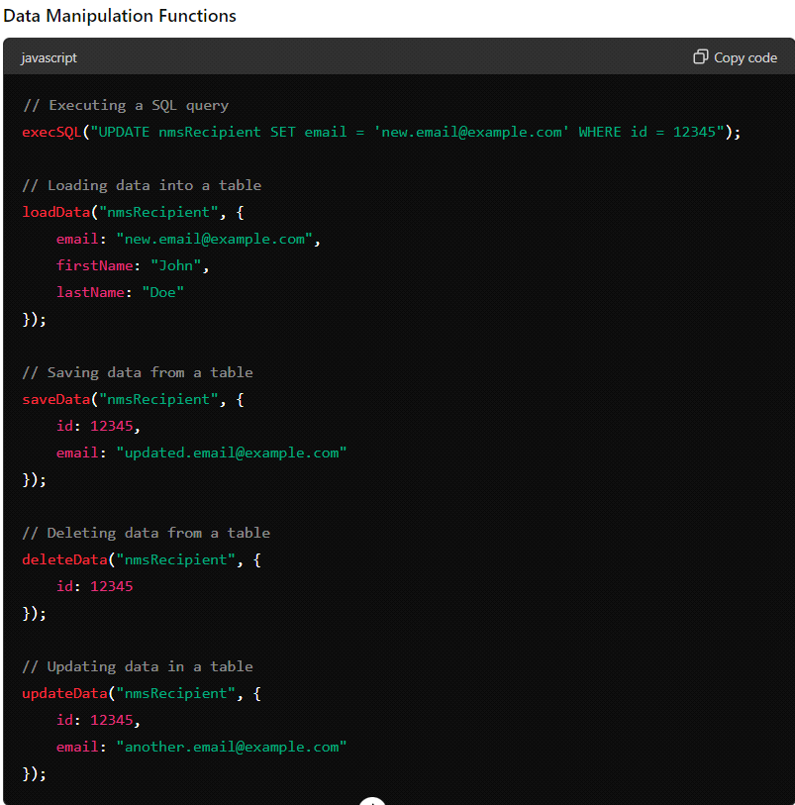

Addon's Page 184

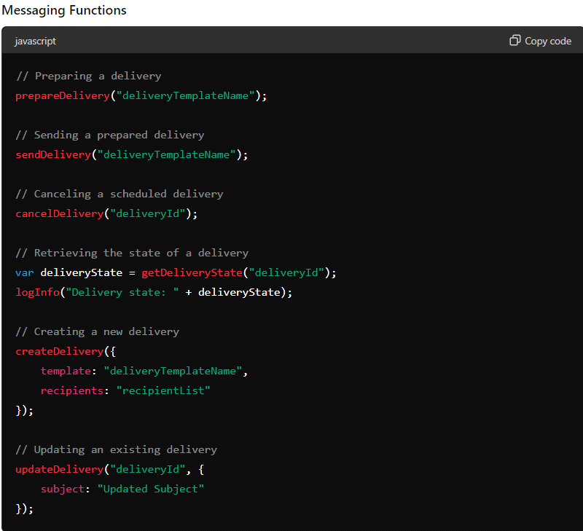

Addon's Page 185

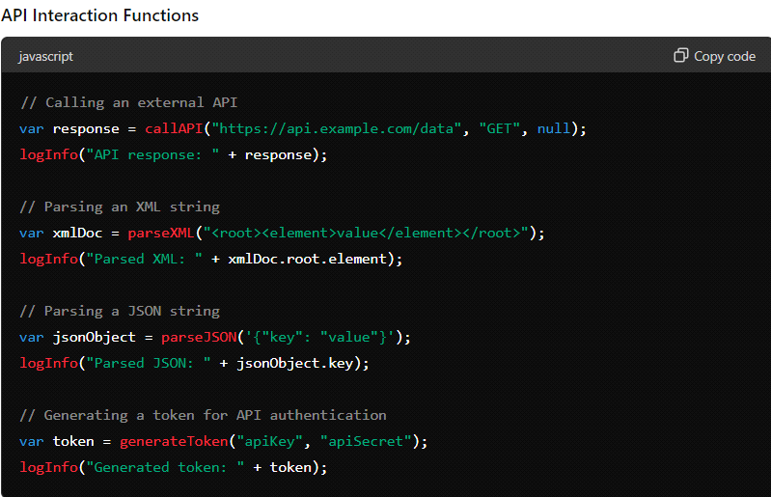

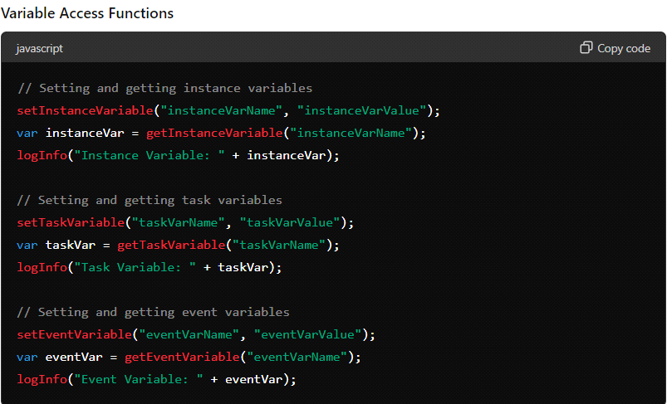

Addon's Page 186

List all Database connected to ACC Monday, June 3, 2024 2:01 PM

Addon's Page 187

Images   
Saturday, June 8, 2024 2:01 PM

Images -  
They are loaded into Adobe Server for Future Use   
They can be imported or Exported, as per the requirement

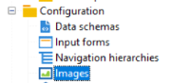

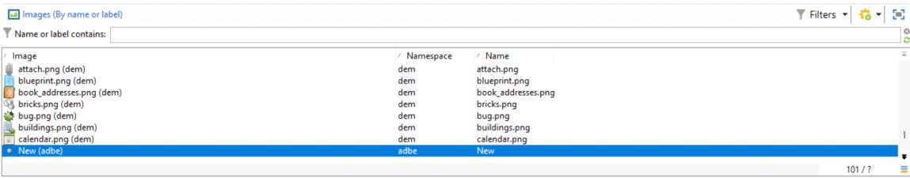

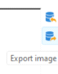

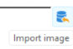

Preview



Addon's Page 188

Personalization Blocks   
Monday, June 3, 2024 5:07 PM

Personalization blocks are dynamic, personalized and contain a specific rendering that you can insert into your deliveries. For example, you can add a logo, a greeting message, or a link to a mirror page. See [Insert personalization blocks](https://experienceleague.adobe.com/en/docs/campaign-classic/using/sending-messages/personalizing-deliveries/personalization-blocks#inserting-personalization-blocks).

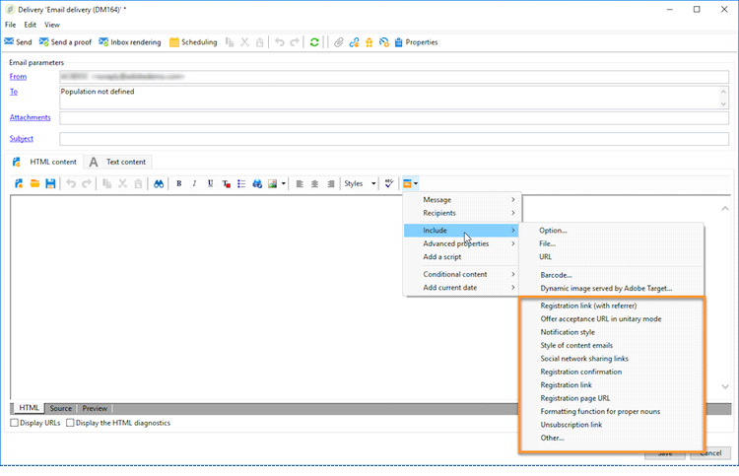

Practitioner Pointers Page 189

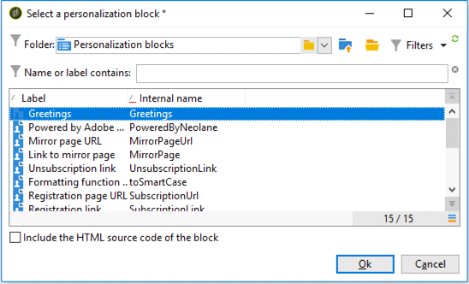

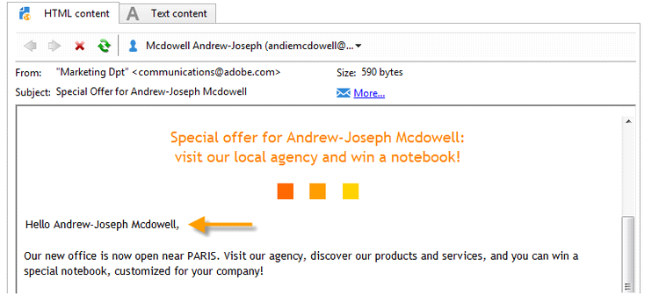

Practitioner Pointers Page 190

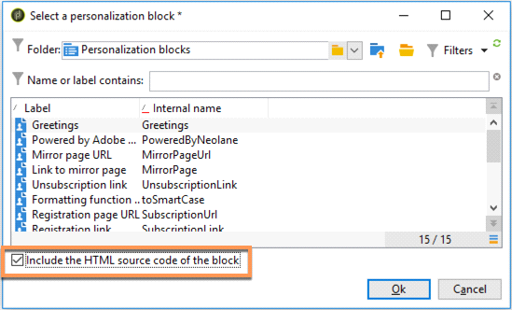

Practitioner Pointers Page 191

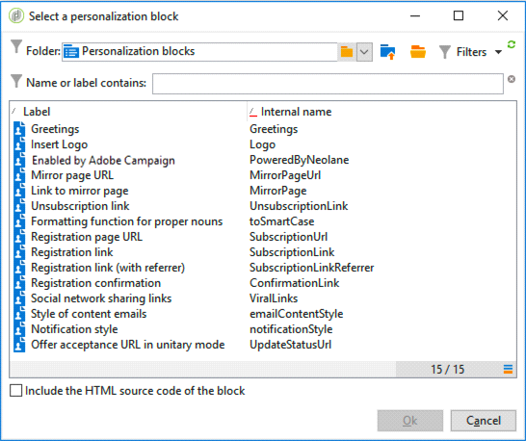

Practitioner Pointers Page 192

Personalization Fields

Monday, June 3, 2024 5:11 PM

Personalization fields are used for first-level personalization of the content of delivered messages. The fields you insert in a main content show the position where to insert the data from the selected data source.

For example, the personalization field with the **<%= recipient.LastName %>** syntax tells Adobe Campaign to insert the name of the recipient into the database (recipient table)

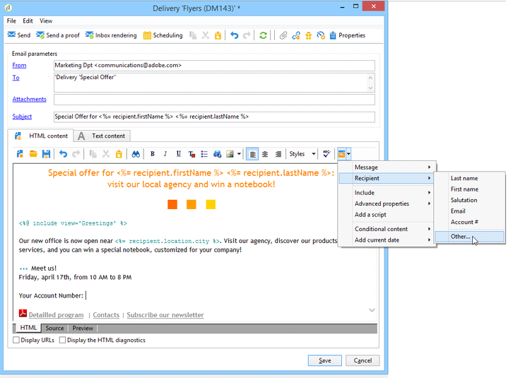

Practitioner Pointers Page 193

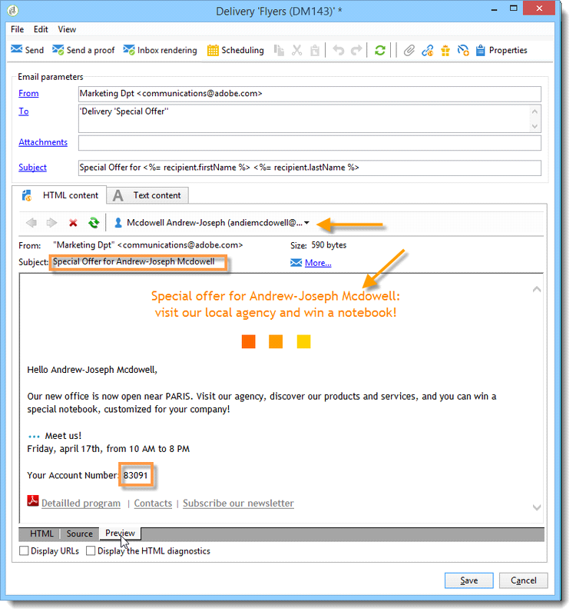

Practitioner Pointers Page 194

Dynamic Content / Dynamic Scripting / Dynamic Content Rendering

Monday, June 3, 2024 5:13 PM

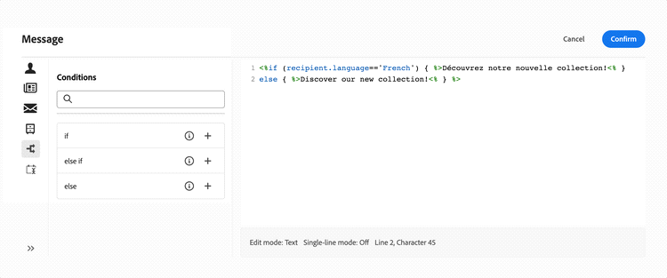

Practitioner Pointers Page 195

Message Center / Transactional Messaging

Monday, June 3, 2024 5:16 PM

**Transactional messaging architecture**

Last update: April 11, 2024

•**TOPICS:**

•[Transactional Messaging](https://experienceleague.adobe.com/en/docs/campaign-classic/using/transactional-messaging/configure-transactional-messaging/transactional-messaging-architecture#)

•[Message Center](https://experienceleague.adobe.com/en/docs/campaign-classic/using/transactional-messaging/configure-transactional-messaging/transactional-messaging-architecture#)

•[Architecture](https://experienceleague.adobe.com/en/docs/campaign-classic/using/transactional-messaging/configure-transactional-messaging/transactional-messaging-architecture#)

Transactional messaging relies on a specific architecture, which is made up of several instances:

•A **control instance**, on which the message templates are created.

•One or more **execution instances**, which receive events and deliver messages.

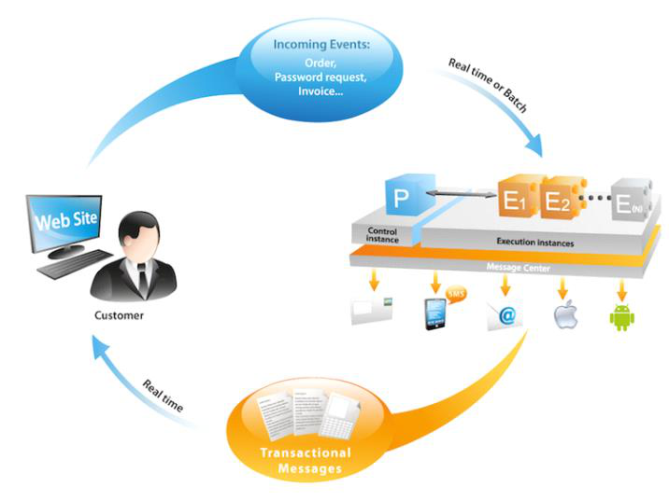

**Control instance**  **Execution instance**

Adobe Campaign users log on to the control Execution instances are here to:

instance to:

|  |  |  |  |
| --- | --- | --- | --- |
| • | Create transactional message templates | • | Receive events |
| • | Link them to transactional message |
| • | Generate the message preview using a | • | templates |
| seed list |
| Send a personalized message to each |
| • | Display reports | recipient |
| • | Monitor the execution instances |

**Install instances**

There are several precautions to take when installing the Transactional message packages.

Adobe recommends you to work in a test environment before putting into production. You also

need to have a compatible Adobe Campaign license. For more information, please contact your

Adobe account executive.

**IMPORTANT**

The control instance and the execution instance(s) must be installed on different machines. They

cannot share the same Campaign instance.

If you need to use several channels, you must install and configure related packages before

installing Transactional message packages. For more on this, see [Add a delivery channel](https://experienceleague.adobe.com/en/docs/campaign-classic/using/transactional-messaging/configure-transactional-messaging/transactional-messaging-architecture#adding-a-delivery-channel).

**Control instance**

To install the control instance on your machine, select the **Transactional message**

**con[trol](https://experienceleague.adobe.com/en/docs/campaign-classic/using/installing-campaign-classic/initial-configuration/installing-campaign-standard-packages)** package via the **[Tools](https://experienceleague.adobe.com/en/docs/campaign-classic/using/installing-campaign-classic/initial-configuration/installing-campaign-standard-packages)** > **[Advanced](https://experienceleague.adobe.com/en/docs/campaign-classic/using/installing-campaign-classic/initial-configuration/installing-campaign-standard-packages)** > **[Impo](https://experienceleague.adobe.com/en/docs/campaign-classic/using/installing-campaign-classic/initial-configuration/installing-campaign-standard-packages)rt package** menu. For more on this,

see [Installing Campaign Classic standard packages](https://experienceleague.adobe.com/en/docs/campaign-classic/using/installing-campaign-classic/initial-configuration/installing-campaign-standard-packages).

Practitioner Pointers Page 196

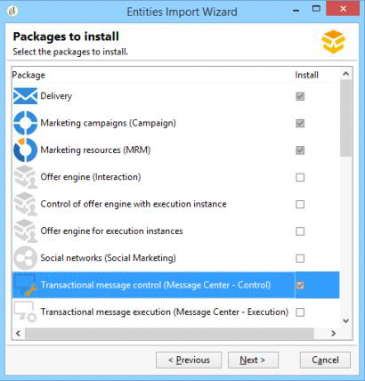

The detailed steps to configure the control instance are presented in [this section](https://experienceleague.adobe.com/en/docs/campaign-classic/using/transactional-messaging/configure-transactional-messaging/configuring-instances#control-instance).

**Support several control instances**

**IMPORTANT**

Sharing an execution cluster with several control instances is only supported for on-premise   
environments.

It is possible to share an execution cluster among several control instances. For example, if you   
manage several specialized stores, you can configure one control instance per brand and link   
them all to the same execution cluster.

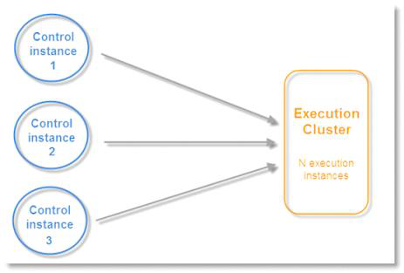

**NOTE**

For more on the necessary configuration, refer to [Use several control instances](https://experienceleague.adobe.com/en/docs/campaign-classic/using/transactional-messaging/configure-transactional-messaging/configuring-instances#using-several-control-instances).

**Execution instance**

To install an execution instance on your machine, select the **Transactional message**   
**execution** package via the **Tools** > **Advanced** > **Import package** menu. For more on this,   
see [Installing Campaign Classic standard packages](https://experienceleague.adobe.com/en/docs/campaign-classic/using/installing-campaign-classic/initial-configuration/installing-campaign-standard-packages).

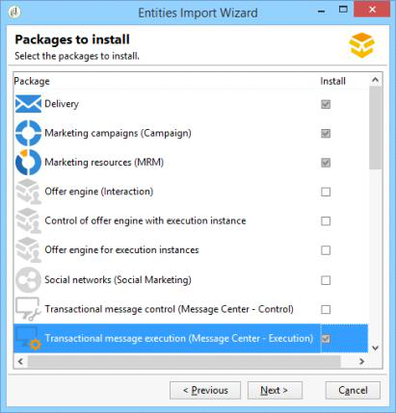

The detailed steps to configure an execution instance are presented in [this section](https://experienceleague.adobe.com/en/docs/campaign-classic/using/transactional-messaging/configure-transactional-messaging/configuring-instances#execution-instance).

**Available delivery channels**

Practitioner Pointers Page 197

|  |
| --- |
| </SOAP-ENV:Body>  </SOAP-ENV:Envelope> |

Copy   
Toggle Text Wrapping

**NOTE**

The creation of message templates remains the same.

**Transactional messaging and LINE**

Combined with LINE Channel, transactional messages allow you to send real time messages on   
the LINE app installed in consumer mobile devices. This is used to send the Welcome message   
when a LINE user adds the brand’s page.

To use transactional message module with LINE, the following elements are needed for the   
configuration on your **marketing** instance and your **execution** instance:

•Install the **LINE Connect** package on both instances.

•Install the **Transactional message control** package on your marketing instance, and

the **Transactional message execution** package on the execution instance.

•Create a LINE **external account** and **service** on both instances with identical naming for

them to be synchronized. For more information on how to create a LINE external account

and service, refer to [this section](https://experienceleague.adobe.com/en/docs/campaign-classic/using/sending-messages/line-channel#setting-up-line-channel).

Then, from the **Explorer** , in **Platform** > **External account** , you need to configure different   
external accounts on both instances:

|  |  |
| --- | --- |
| 1. | Create an **External database** external account in your **execution** instance with the following configuration: |

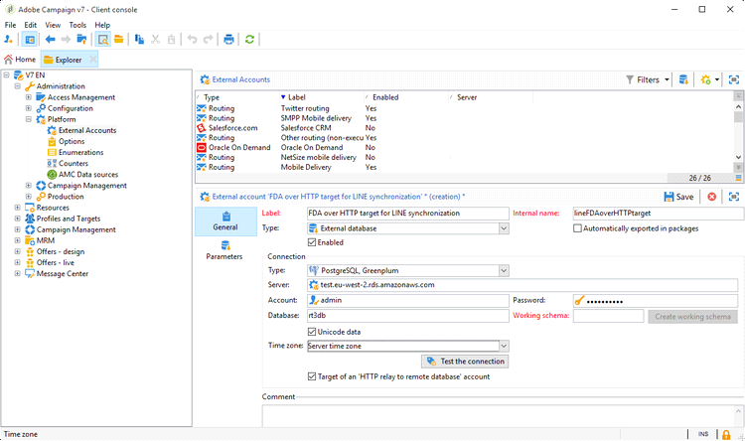

○**Label** and **Internal name** : name your external account as needed.

○**Type** : select **External database** .

○**Enabled** box must be checked.

From the **Connection** category:

|  |  |  |
| --- | --- | --- |
| 2. | ○ | **Type** : select your database server e.g. PostgresSQL. |
| ○ | **Server** : enter your database server URL. |
| ○ | **Account** : enter your database account. |
| **NOTE**  The database user needs to have read rights on the following tables for FDA connection: XtkOption, NmsVisitor, NmsVisitorSub, NmsService,  NmsBroadLogRtEvent, NmsBroadLogBatchEvent, NmsTrackingLogRtEvent, NmsTrackingLogBatchEvent, NmsRtEvent, NmsBatchEvent, NmsBroadLogMsg, NmsTrackingUrl, NmsDelivery, NmsWebTrackingLogXtkFolder. | |
| ○ | **Password** : enter the password for your database account. |
| ○ | **Database** : enter the database name of the execution instance. |
| ○ | **Target of an HTTP relay to remote database’s account** box must be checked. |
| Create an **External Database** account in your **marketing** instance with the following configuration. | |

Practitioner Pointers Page 199

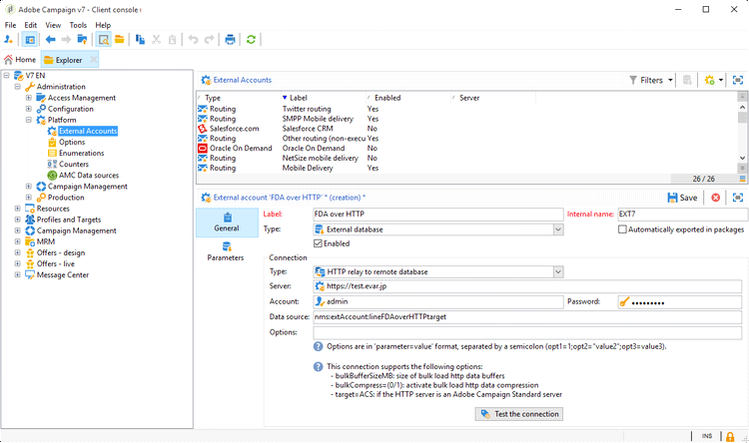

○**Label** and **Internal name** : name your external account as needed.

○**Type** : select **External database** .

○Enabled box must be checked.

From the **Connection** category:

○**Type** : select **HTTP relay to remote Database** .

○**Server** : enter your campaign’s server URL of the execution instance.

○**Account** : enter the account used to access your execution instance.

○**Password** : enter the password for the account used to access your execution

instance.

○**Data Source** : enter the following syntax **nms:extAccount:ID** of your external

database account in the execution instance.

|  |  |
| --- | --- |
| 3. | Create an **Execution instance** external account in your **marketing** instance using the following configuration to create the data synchronization workflow: |

Practitioner Pointers Page 200

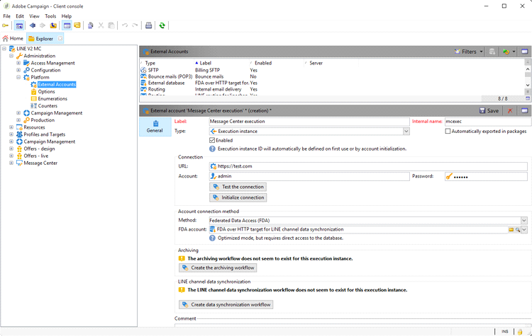

○**Label** and **Internal name** : name your external account as needed.

○**Type** : select **Execution instance** .

○Enabled box must be checked.

From the **Connection** category:

○**URL** : enter your execution instance’s URL.

○**Account** : enter your account used to access your execution instance.

○**Password** : enter the password for the account used to access your execution

instance.

From the **Account connection method** category:

○**Method** : select **Federated Data Access (FDA)** .

○**FDA account** : select your FDA account from the drop-down.

○Click the **Create the archiving workflow** button.

○Click the **Create data synchronization workflow** button to create the LINE data

sync workflow.

4. You can now start [creating transactional messages](https://experienceleague.adobe.com/en/docs/campaign-classic/using/transactional-messaging/message-templates/creating-the-message-template).

From <[https://experienceleague.adobe.com/en/docs/campaign-classic/using/transactional-messaging/configure-](https://experienceleague.adobe.com/en/docs/campaign-classic/using/transactional-messaging/configure-transactional-messaging/transactional-messaging-architecture)

[transactional-messaging/transactional-messaging-architecture](https://experienceleague.adobe.com/en/docs/campaign-classic/using/transactional-messaging/configure-transactional-messaging/transactional-messaging-architecture)>

Practitioner Pointers Page 201

Campaign Types

|  |  |
| --- | --- |
| Monday, June 3, 2024 | 5:17 PM |

|  |  |  |  |
| --- | --- | --- | --- |
| **Campaign Type** | **Description** | **Key Features** | **Examples** |
| Periodic | Scheduled at regular intervals. | - Recurs based on set time intervals. | Weekly newsletters, monthly promotions |
| Recurring | Repeatedly executed at set times. | - Scheduled to repeat at predefined intervals. | Daily morning updates, weekly specials |
| Standard | Generic campaign type. | - May encompass various scheduling methods. | One-time sends, recurring schedules, triggered events |
| Unique | Single instance campaign. | - Executed only once, not repeating. | Special promotions, one-time events |

Practitioner Pointers Page 202

Delivery Logs & Audits

|  |  |
| --- | --- |
| Monday, June 3, 2024 | 5:27 PM |

|  |  |  |
| --- | --- | --- |
| **Section** | **Purpose** | **Key Information** |
| Delivery -> Logs | Provides detailed information about the delivery process for each campaign, including delivery status, recipient details, and any errors encountered. | - Delivery status for each recipient (e.g., delivered, bounced, opened). - Timestamps of delivery actions (e.g., sent time, opened time). - Recipient details (e.g., email addresses, target audience segments). - Error messages and diagnostic information for failed deliveries or other issues. |
| Delivery -> Audit Logs | Records administrative actions and changes related to deliveries and campaigns within the Adobe Campaign platform. | - Records of user logins and activities. - Changes made to delivery settings or configurations. - Any administrative actions related to deliveries or campaigns. |
| Journal -> Logs | Contains system activity logs, providing a record of various system-level events and processes. | - System-level events and processes. - Database transactions. - Backend processes and operations. |
| Journal -> Audit Logs | Records system-wide actions and changes across the Adobe Campaign platform. | - Records of administrative actions and changes. - User logins and activities. - System-wide events and changes. |

|  |  |
| --- | --- |
| **Section** | **Purpose** |
| Delivery Dashboard > Tracking | Allows business practitioners to monitor the delivery logs and all messages related to proofs in Adobe Campaign Classic. This section provides detailed tracking information about the delivery process, including delivery status, recipient details, and any errors encountered. |
| Delivery Dashboard > Audit | This section records administrative actions and changes related to deliveries and campaigns within Adobe Campaign Classic. It tracks user logins, changes to delivery settings, and other administrative activities. However, it may not specifically provide access to delivery logs and messages related to proofs. |
| Delivery > Execution folder | Typically used for executing deliveries, this folder may not directly provide access to delivery logs and messages related to proofs. It's more focused on the execution of delivery operations rather than monitoring logs and proofs. |
| Delivery > Inbox Rendering tab | This tab within the Delivery section allows users to preview how their email messages will render in various email clients' inboxes. It doesn't specifically provide access to delivery logs or messages related to proofs. It's more focused on visualizing the appearance of email messages. |

Practitioner Pointers Page 203

Different Hosting Environment

Monday, June 3, 2024 6:15 PM

**On-premise:**

1. Adobe Campaign Classic is installed and operated within the organization's premises.

2. The organization manages all aspects of the software, including installation, maintenance, security, and updates.

3. They have full control over the hardware, networking, and software configurations.

4. It requires a significant upfront investment in hardware, software licenses, and IT resources.

5. Provides complete control and customization over the software and infrastructure.

6. Offers high security as data remains within the organization's own servers.

7. However, it involves higher maintenance overhead and longer deployment times.

**Managed Cloud Service:**

1. Adobe Campaign Classic is hosted and managed by Adobe or a third-party provider in the cloud.

2. The organization accesses the software over the internet, and the provider handles server maintenance, updates, security, andscalability.

3. Organizations pay a subscription fee for this service, typically on a monthly or yearly basis.

4. Offers easier deployment, scalability, and reduced maintenance burden for the organization.

5. Provides flexibility to scale resources up or down based on demand.

6. However, the organization has less control over the underlying infrastructure and security.

**Hybrid Environments:**

1. Hybrid environments combine both on-premise and cloud-based deployments of Adobe Campaign Classic.

2. Organizations can keep sensitive data on-premise for security reasons while leveraging cloud services for other tasks.

3. Provides flexibility to tailor the deployment to specific needs and requirements.

4. Requires integration between on-premise and cloud systems for seamless operation.

5. Offers the benefits of both deployment models but may add complexity to management.

6. Allows organizations to take advantage of cloud scalability while maintaining control over sensitive data.

Practitioner Pointers Page 204

Barcodes in Adobe Campaign Classic

|  |  |
| --- | --- |
| Monday, June 3, 2024 | 6:28 PM |

|  |  |
| --- | --- |
| **Pair** | **Description** |
| ISBN & PDF417 | - **ISBN (International Standard Book Number)**: A unique identifier for books, typically represented as a 13-digit barcode. <br> - **PDF417**: A two-dimensional (2D) barcode format capable of encoding large amounts of data. |
| Code39 & UPC-A | - **Code39**: A linear barcode that can encode alphanumeric characters, often used in logistics and inventory. <br> - **UPC-A (Universal Product Code)**: A linear barcode used mainly in retail for product identification, consisting of 12 digits. |
| Codabar & DataMatrix | - **Codabar**: A linear barcode that encodes numeric data and a few special characters, used in libraries, blood banks, and airbills. <br> - **DataMatrix**: A 2D barcode that can encode large amounts of data in a small space, often used in healthcare and logistics. |

**Detailed Descriptions:**

**ISBN (International Standard Book Number)**  
• **Usage**: Identifies books uniquely.

• **Format**: 13 digits (earlier versions used 10 digits).

• **Structure**: Prefix (usually 978 or 979), registration group, registrant, publication, and check digit.

**Example**: •

**PDF417**  
• **Usage**: Can encode large amounts of data, including text, numbers, files, and images.• **Format**: 2D barcode consisting of multiple rows and columns.

• **Capacity**: Up to 1,850 alphanumeric characters.

**Example**: •

**Code39**  
• **Usage**: Used in various industries for inventory, logistics, and military applications.

• **Format**: Encodes alphanumeric data (A-Z, 0-9) and some special characters.• **Capacity**: Variable length, typically up to 43 characters.

**Example**: •

**UPC-A (Universal Product Code)**  
• **Usage**: Primarily used in retail for product identification.

• **Format**: 12 digits (composed of a number system digit, manufacturer code, product code, and check digit).• **Capacity**: Fixed length of 12 digits.

**Example**: •

**Codabar**  
• **Usage**: Used in libraries, blood banks, and airbills for easy and error-free data entry.• **Format**: Numeric (0-9) and six special characters (-, $, :, /, ., +).

• **Capacity**: Variable length.

**Example**: •

**DataMatrix**  
• **Usage**: Widely used in logistics, healthcare, and manufacturing due to its ability to store large amounts of data in a small space.• **Format**: 2D barcode consisting of black and white cells in a square or rectangular pattern.

• **Capacity**: Up to 2,335 alphanumeric characters.

**Example**: •

Practitioner Pointers Page 205

Different Database & FDA Access Monday, June 3, 2024 6:48 PM

Practitioner Pointers Page 206

FDA Rights   
Monday, June 3, 2024 6:51 PM

|  |  |  |  |  |  |  |
| --- | --- | --- | --- | --- | --- | --- |
|  | **Snowflake** | **Redshift** | **Oracle** | **SQLServer** | **PostgreSQ**  **L** | **MySQL** |
| **Connecti ng to**  **remote**  **database** | USAGE ON WAREHOU SE, USAGE ON  DATABASE and USAGE ON  SCHEMA  privileges | Creating a user linked to the AWS account | CREATE SESSION privilege | CONNECT permission | CONNECT privilege | Creating a user tied  to a  remote  host who  has ALL  PRIVILEG ES |
| **Creating tables** | CREATE  TABLE ON SCHEMA  privilege | CREATE privilege | CREATE TABLE  privilege | CREATE  TABLE  permission | CREATE privilege | CREATE privilege |
| **Creating indexes** | N/A | CREATE privilege | INDEX or  CREATE ANY INDEX  privilege | ALTER  permission | CREATE privilege | INDEX  privilege |
| **Creating functions** | CREATE  FUNCTION ON  SCHEMA  privilege | USAGE ON LANGUAG  E plpythonu privilege to be able to  call external python  scripts | CREATE  PROCEDURE or CREATE  ANY  PROCEDURE privilege | CREATE  FUNCTION permission | USAGE privilege | CREATE ROUTINE privilege |
| **Creating procedur es** | N/A | USAGE ON LANGUAG  E plpythonu privilege to be able to  call external python  scripts | CREATE  PROCEDURE or CREATE  ANY  PROCEDURE privilege | CREATE  PROCEDU RE  permission | USAGE  privilege  (procedure s are  functions) | CREATE ROUTINE privilege |
| **Removin g objects (tables,**  **indexes, functions ,**  **procedur es)** | Owning the object | Owning the object or  being a  superuser | DROP ANY < object >  privilege | ALTER  permission | Table:  owning the table Index: owning the index  Function:  owning the function | DROP  privilege |
| **Monitorin g**  **execution s** | MONITOR  privilege on the required object | No privilege required to use  EXPLAIN  command  Practi | INSERT and SELECT  privilege and necessary  privilege to  execute the  statement for which the  EXPLAIN  PLAN is  tioner Pointers Pag | SHOWPLA N  permission  e 207 | No  privilege  required to use  EXPLAIN  statement | SELECT privilege |

|  |  |  |  |  |  |  |
| --- | --- | --- | --- | --- | --- | --- |
|  |  |  | based on |  |  |  |
| **Writing data** | INSERT  and/or  UPDATE  privileges  (depending on write  operation) | INSERT and  UPDATE privileges | INSERT and  UPDATE or  INSERT and  UPDATE ANY TABLE  privileges | INSERT  and  UPDATE  permission s | INSERT and  UPDATE privileges | INSERT and  UPDATE privileges |
| **Loading data into tables** | CREATE  STAGE ON SCHEMA,  SELECT  and  INSERT on the target  table  privileges | SELECT and  INSERT privileges | SELECT and INSERT  privileges | INSERT,  ADMINIST ER BULK  OPERATIO NS and  ALTER  TABLE  permission s | SELECT and  INSERT privileges | FILE  privilege |
| **Accessin**  **g to client data** | SELECT on (FUTURE) TABLE(S)  or VIEW(S) privilege(s) | SELECT privilege | SELECT or  SELECT ANY TABLE  privilege | SELECT  permission | SELECT privilege | SELECT privilege |
| **Accessin g to**  **metadata** | SELECT on INFORMATI ON_SCHE  MA  SCHEMA  privilege | SELECT privilege | No privilege required to use  DESCRIBE statement | VIEW  DEFINITIO N  permission | No  privilege  required to use “\d  table”  command | SELECT privilege |

|  |  |  |  |  |  |  |
| --- | --- | --- | --- | --- | --- | --- |
|  | **DB2 UDB** | **TeraData** | **InfiniDB** | **Sybase IQ / Sybase ASE** | **Netezza** | **AsterDat a** |
| **Connectin g to**  **remote**  **database** | CONNEC T authority | CONNECT privilege | Creating a user tied to a remote  host who  has ALL  PRIVILEG  ES | No permission required to use the CONNECT statement | No  privilege required | CONNEC T  privilege |
| **Creating tables** | CREATET AB  authority | CREATE TABLE or TABLE  keyword | CREATE privilege | RESOURCE authority and CREATE  permission | TABLE  privilege | CREATE privilege |
| **Creating indexes** | INDEX  privilege | CREATE INDEX or INDEX  keyword | INDEX  privilege | RESOURCE authority and CREATE  permission | INDEX  privilege | CREATE privilege |
| **Creating functions** | IMPLICIT_ SCHEMA authority | CREATE  FUNCTION or  Practi | CREATE ROUTINE privilege  tioner Pointers | RESOURCE  authority or DBA authority for  Page 208 | FUNCTIO N  privilege | CREATE FUNCTIO N |

|  |  |  |  |  |  |  |
| --- | --- | --- | --- | --- | --- | --- |
|  | or  CREATEI N privilege | FUNCTION keyword |  | Java functions |  | privilege |
| **Creating**  **procedure s** | IMPLICIT_ SCHEMA authority  or  CREATEI N privilege | CREATE  PROCEDUR E or  PROCEDUR E keyword | CREATE ROUTINE privilege | RESOURCE authority | PROCED URE  privilege | CREATE FUNCTIO N  privilege |
| **Removing objects**  **(tables,**  **indexes,**  **functions, procedure s)** | DROPIN  privilege or CONTROL privilege or owning the object | DROP  < object > or object  related  keyword | DROP  privilege | Owning the  object or DBA authority | DROP  privilege | Owning  the object |
| **Monitorin g**  **execution s** | EXPLAIN authority | No privilege required to use  EXPLAIN  statement | SELECT privilege | Only a system Administrator can execute  sp_showplan | No  privilege  required  to use  EXPLAIN statement | No  privilege  required  to use  EXPLAIN statement |
| **Writing data** | INSERT  and  UPDATE privileges or  DATAACC ESS  authority | INSERT and UPDATE  privileges | INSERT and  UPDATE privileges | INSERT and UPDATE  permissions | INSERT and  UPDATE privileges | INSERT and  UPDATE privileges |
| **Loading data into tables** | LOAD  authority | SELECT  and INSERT privileges to respectively use COPY  TO and  COPY  FROM  statements | FILE  privilege | Be the owner of the table or  ALTER  permission.  Depending on  the -gl option,  LOAD TABLE  might only be  performed if the user has the  DBA authority | SELECT and  INSERT privileges | SELECT and  INSERT privileges |
| **Accessin**  **g to client data** | INSERT/U PDATE  privileges or  DATAACC ESS  authority | SELECT privilege | SELECT privilege | SELECT  permission | SELECT privilege | SELECT privilege |
| **Accessin g to**  **metadata** | No  authorizati on  required to use  DESCRIB  E  statement | SHOW  privilege | SELECT privilege | No permission required to use DESCRIBE  statement | No  privilege  required  to use “\d table”  command | No  privilege required  to use  SHOW  command |

Practitioner Pointers Page 209

Types of Delivery

|  |  |
| --- | --- |
| Tuesday, June 4, 2024 | 10:24 AM |

|  |  |
| --- | --- |
| **Type of Delivery** | **Description** |
| **Email Delivery** | Sends marketing emails to targeted recipients. Includes features like personalization, templates, tracking, and reporting. |
| **SMS Delivery** | Sends text messages to mobile devices. Useful for short, time-sensitive messages. Includes personalization and opt-out management. |
| **Push Notification** | Sends notifications to mobile app users. Requires integration with mobile app platforms. Supports personalization and segmentation. |
| **Direct Mail** | Generates and manages physical mailings. Can be used for personalized letters, postcards, and catalogs. |
| **In-App Message** | Delivers messages directly within a mobile app. Ideal for engaging users while they are using the app. Supports targeting and personalization. |
| **Social Media** | Manages posts and advertisements on social media platforms. Integrates with networks like Facebook, Twitter, and LinkedIn for broad reach and engagement. |
| **Transactional Email** | Sends triggered emails based on user actions or events (e.g., order confirmations, password resets). Ensures timely and relevant communication. |
| **Landing Pages** | Creates web pages for campaigns, such as subscription forms or surveys. Collects data directly from users and integrates with campaign workflows. |
| **Fax Delivery** | Sends messages via fax to recipients. Less common but still used in certain industries for formal communications. |
| **Voice Messaging** | Sends pre-recorded voice messages to recipients' phones. Can be used for reminders, alerts, or customer service messages. |

Practitioner Pointers Page 210

Important Features

Saturday, June 8, 2024 9:13 AM

**External Identifier**

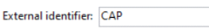

It is a Tag System, which helps in Bundling

**Organizational Entities (OU)**

It helps in bifurcating the business into multiple sections

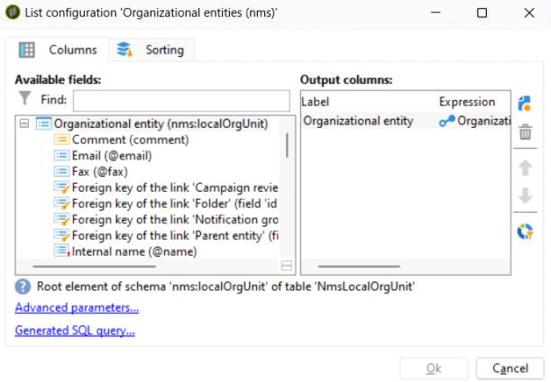

**Dashboard** - Not Much Idea

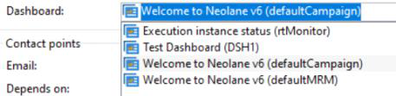

**Regional Settings**

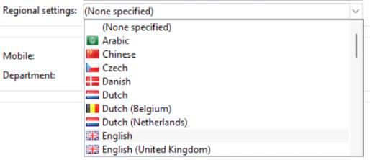

**Depends On** - No Idea

Practitioner Pointers Page 211

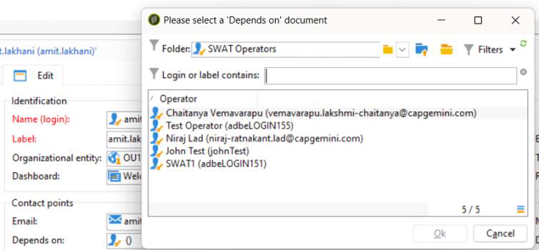

**Session Timeout**   
Operator will Logout after specified timeout is Applied, In case Operator is in Idle State

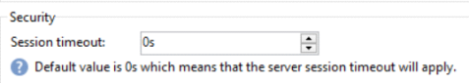

**Disable Account**   
Account will be disabled, and Operator cannot access the Application

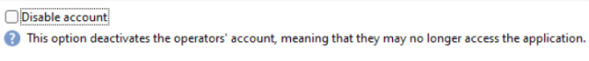

**Forbid Access from Rich Client**   
Operator Web and API Access is Prohibited



**Authorized Connection Zone**   
If a Operator is associated to a connection Zone, then Operator can access ACC System only through the configured IP Address Range

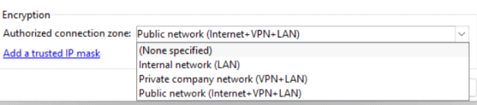

**List of Trusted IP Rights**   
User can login through available connection Zone

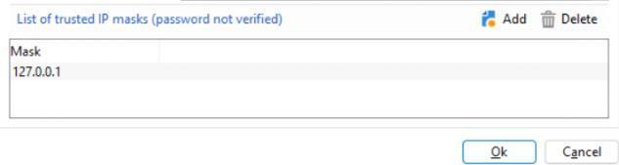

**Folder Rights in the Audit Section**   
Operator can perform CRUD Operations in the Folder according to the given Rights

Practitioner Pointers Page 212

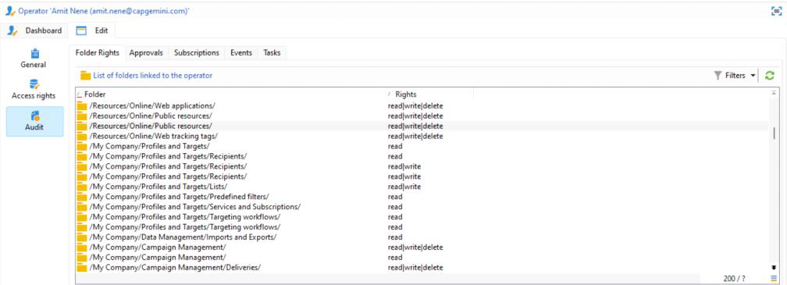

**Different Tabs for Operator**

Folder Rights

Approvals

Subscriptions

Events

Tasks

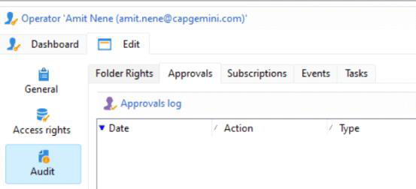

**MTA**

**Control Instance**

**Execution Instance**

**Selected Folder Access**

**IP Affinity**

**Different types of Delivery Reports**

**nms:SecurityGroup**

Practitioner Pointers Page 213

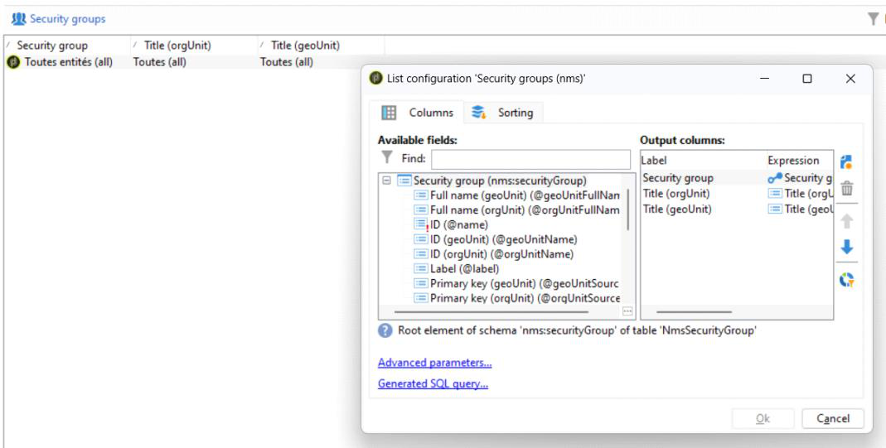

Connecting Security Group to Folder Mapping

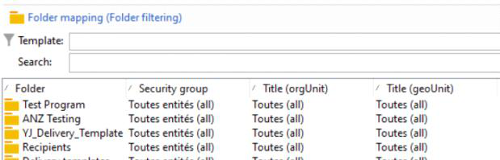

Practitioner Pointers Page 214

Default Control Rules

|  |  |
| --- | --- |
| Saturday, June 8, 2024 | 1:10 PM |

|  |  |  |  |
| --- | --- | --- | --- |
| **Label** | **Chann el** | **Execution phase** | **Description** |
| **A/B Test** | Email | At the start of  personalization | Extracts the test population for a delivery with an A/B test. |
| **Check delivery size** | All | After targeting | Checks the size of the messages. |
| **Check email content is not empty** | Email | After targeting | Generates an error if the content of the message is empty. |
| **Check In-App content for broadcast template** | In-App | At the start  personalization | Checks that In-App content / triggers are not empty for broadcast template. |
| **Check In-App content for profile template** | In-App | At the start of  personalization | Checks that In-App content / triggers are not empty for profile template. |
| **Check In-App content for subscriber template** | In-App | At the start of  personalization | Checks that In-App content / triggers are not empty for subscriber template. |
| **Check proof size** | All | After targeting | Generates an error message if the proof target population exceeds 100 recipients. |
| **Check social network sharing link** | Email | At the start of  personalization | Checks the presence of a link to a mirror page when including a social network sharing link (ViralLinks) in the content. |
| **Check subject** | Email | At the start of  personalization | Checks that the subject and sender address do not contain special characters which may cause problems on certain mail transfer agents, and checks that the message subject has been completed. |
| **Check unsubscription link** | Email | At the start of  personalization | Checks for the presence of at least one unsubscription (opt-out) URL in each content (HTML and Text). |
| **Check URL labels** | Email | At the start of  personalization | Checks that each tracking URL has a label. |
| **Check URLs** | Email | At the start of  personalization | Checks the tracking URLs (presence of the “&” character). |

Practitioner Pointers Page 215

Audit Trial   
Saturday, June 8, 2024 1:38 PM

The **Audit trail** functionality within Adobe Campaign offers a granular record of all modifications   
made to important entities

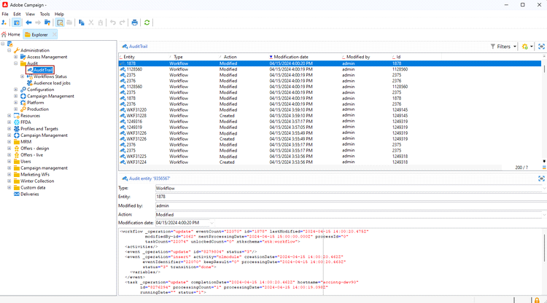

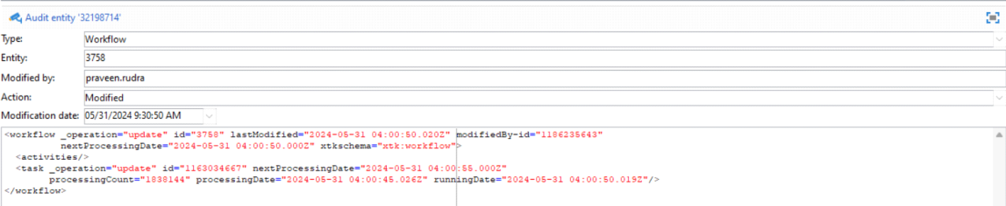

**How to disable Audit Logs**

In Options Table, set the Value for disabling

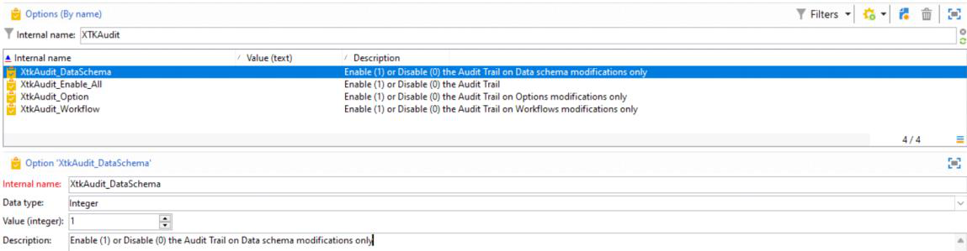

Practitioner Pointers Page 216

Dashboard   
Saturday, June 8, 2024 1:46 PM

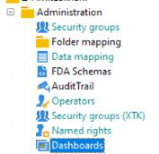

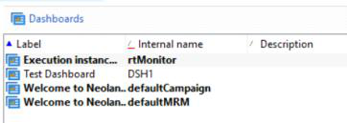

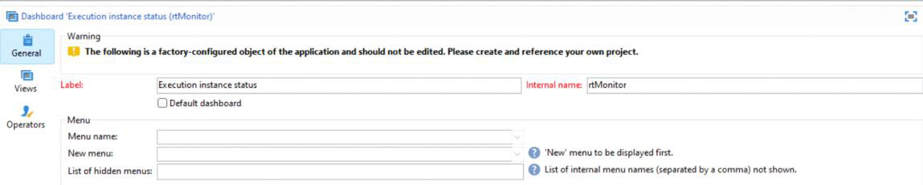

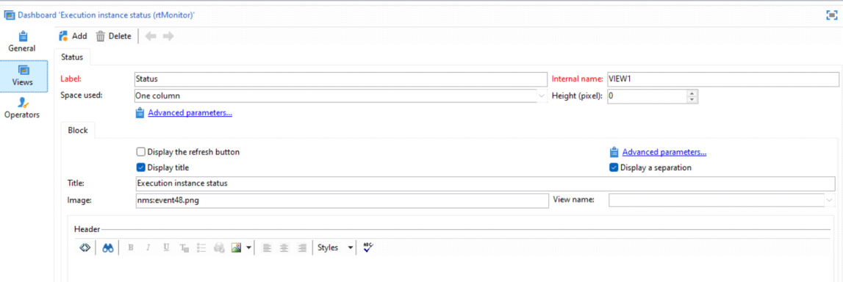

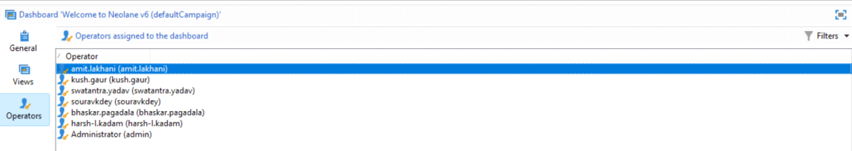

Practitioner Pointers Page 217

File Resources

Saturday, June 8, 2024 1:49 PM

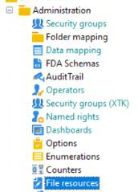

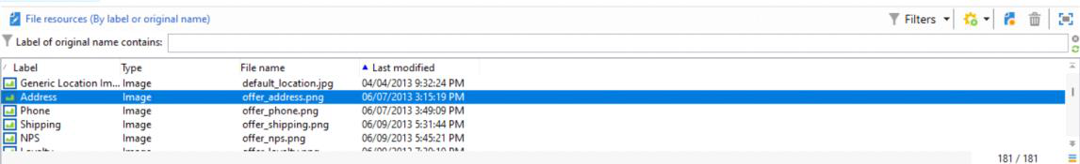

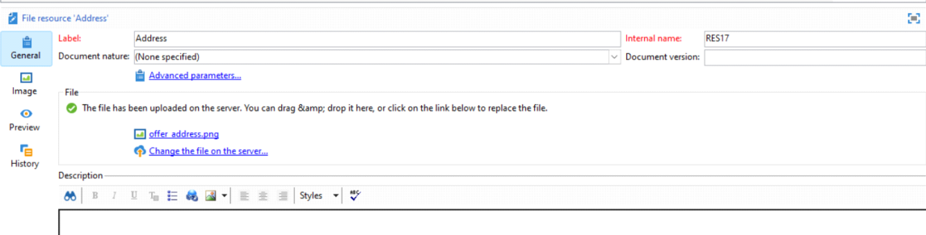

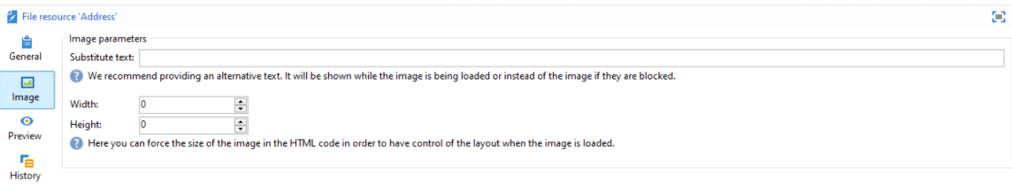

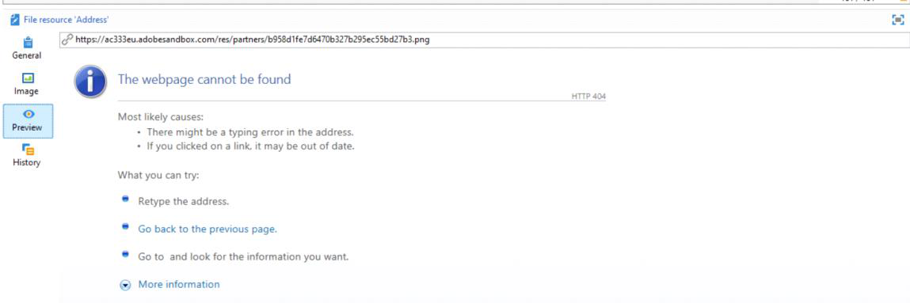

Practitioner Pointers Page 218

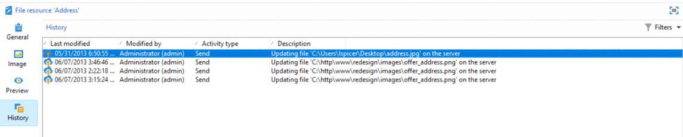

Practitioner Pointers Page 219

Organizational Entity   
Saturday, June 8, 2024 1:52 PM

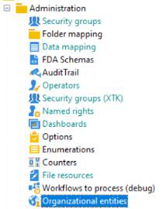

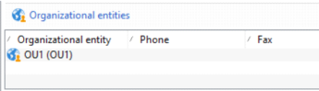

Set Notification Group / Order Approval Reviewer Group / Campaign Reviewer Group

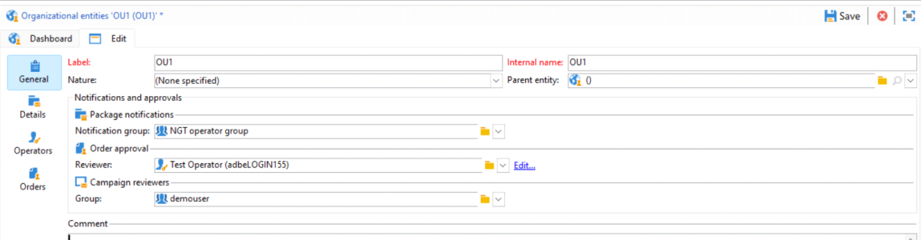

Following Operators are associated with This OU

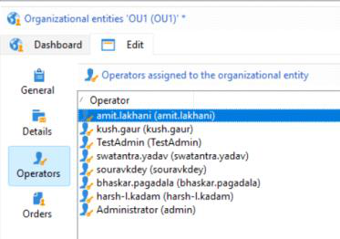

Practitioner Pointers Page 220

AEC Data Source   
Saturday, June 8, 2024 1:56 PM

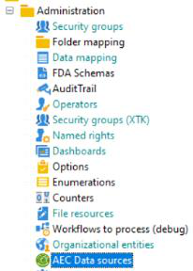



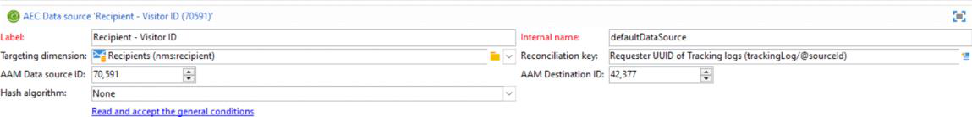

Practitioner Pointers Page 221

Dictionary   
Saturday, June 8, 2024 2:07 PM

**Translations of English Alphabet into multiple Language**

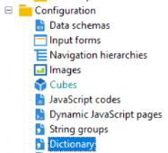

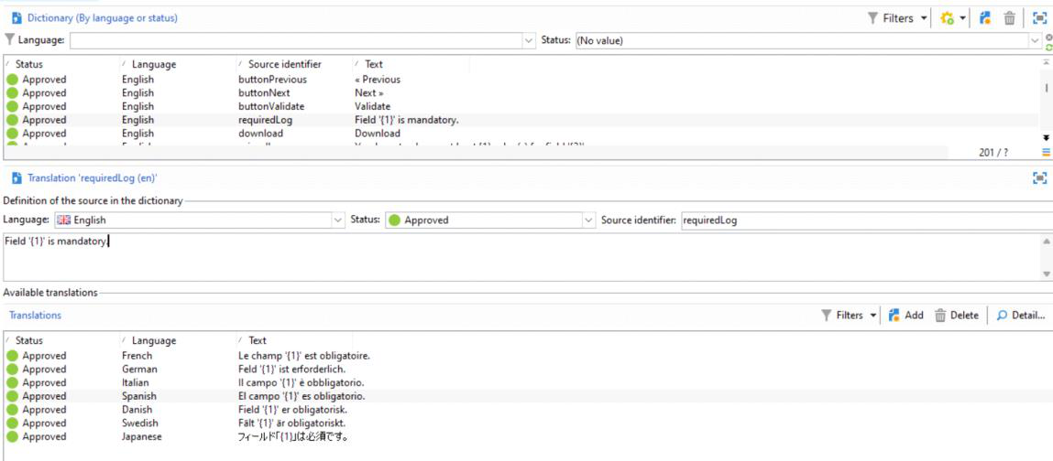

Field {1} is written in multiple Languages

Practitioner Pointers Page 222

Styles   
Saturday, June 8, 2024 2:11 PM

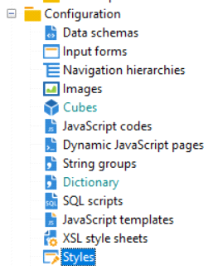

Each Label is associated with a CSS Content   
Entity can be used in Web Forms or Reports

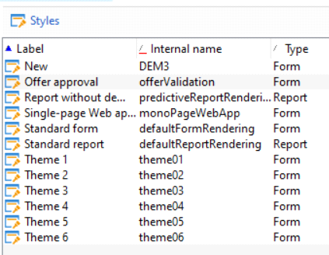

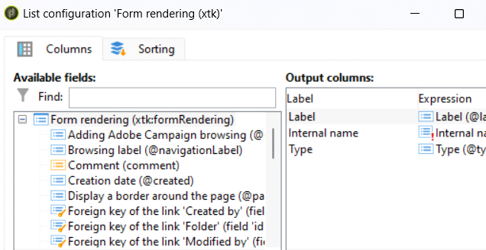

Form Rendering CSS Content

Practitioner Pointers Page 223

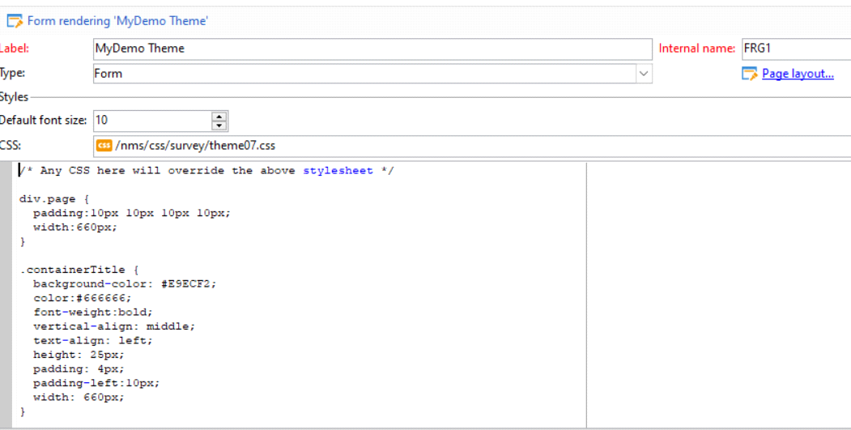

Types

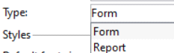

Page Layout Properties

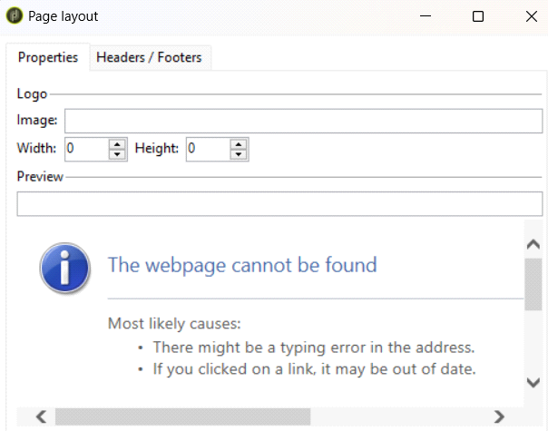

Page Headers and Page Footers Settings

Practitioner Pointers Page 224

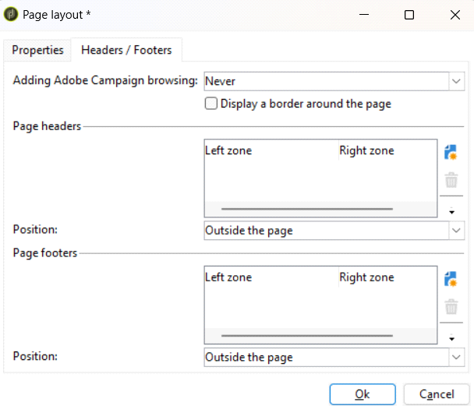

Practitioner Pointers Page 225